OS 1 – sheet 1-4
General assessment for Oral & Maxillofacial Surgery
- Personal details

  - Name of patient
  - Date of birth
  - Hospital number (if applicable)
  - Home address
- Chief complaint
- Pain
  - Nature
  - Duration
  - Frequency
  - Associated factors
  - Aggravating factors
  - Relieving factors
  - History of present complaint
- When did it start?
- Severity
- Treatment/operations
- Medical history
  - Anaemia
  - Bleeding
  - Cardiorespiratory
  - Drug treatment and allergy
  - Endocrine diseases
  - Fits and faints
  - GIT
  - Hospitalization
  - Infections
  - Jaundice and liver disease
  - Kidney disease
  - Likelihood of pregnancy
- Dental history
- Clinical examination
- Basic techniques
- Visual inspection:
- Palpation: (bidigital or bimanual)
  - Texture (defining the surface of the mass; smooth, rough, pebbly)
  - Consistency (compressibility; soft, fluctuant, hard, rubbery)
  - Dimensions
  - Temperature
- Probing
- Percussion
- Auscultation (TMJ sounds, bruit, BP)
- Aspiration
  - Extra oral examination
  - General appraisal of the patient:
    - Stature and nutritional status
    - Gait and posture
    - Upper extremity
    - Vital signs (Temperature, Pulse, Blood Pressure, Respiratory Rate)
- Examination of the head
- Facial form: position and presence of organs, symmetry, swelling, positions of the maxilla and mandible
- Skin and hair: pigmentation
- Eyes: pupils, ptosis, epiphora, ectropian, enophthalmous, dystopia diplopia.
- Ears: bat ears, malformation.
- Temporomandibular Joint.
- TMJ
- Palpation
- Auscultation: click, crepitation, popping
- Measurement of the mouth opening
- Deviation on mouth opening
- Parotid gland
- Nose
- Paranasal sinuses (palpation, percussion and trans illumination)
- Examination of the neck
- Muscles
- Lymph nodes: inspection, palpation, size, mobility and attachment to underlying structures.
- Carotid artery
- Trachea
- Thyroid
- Cranial nerves
- Examination of the neck
- Muscles
- Lymph nodes: inspection, palpation, size, mobility and attachment to underlying structures.
- Carotid artery
- Trachea
- Thyroid
- Cranial nerves
- Olfactory; anosmia
- Optic; blindness, visual field chart
  - Trauma
  - Iatrogenic
  - Benign /malignant tumours (bitemporal hemianopia)
  - MS
- Oculomotor, trochlear and abducent;ophthalmoplegias (diplopia), Hess chart.
III lesions lead to diplopia, ptosis and mydriasis.
- Trigeminal nerve; touch, pain, temperature. Corneal reflex. Motor function, palpating muscle tone

- Extracranial
- Trauma
- Inflammation; viral (HZ, HIV)
- Tumours
- Intracranial
- Trauma
- Inflammation
  - Viral
  - Sarcoid
  - TB
  - Auto immune disease
  - Disseminated sclerosis
- Vascular; aneurysms
- Tumours; schwannoma (acoustic neuroma)
- Disturbance in taste
- Bitter (quinine), sweet, salt and acid (dilute HCL)
- Loss of flavour vs pure loss of taste.
- Pure loss of taste;
  - Traumatic lesions of the lingual nerve
  - Bell’s palsy
  - Lower motor neurone lesions of VII
- Facial nerve; maintaining muscular tone, facial muscular activity, emotional expressions and taste.
- Facial palsy: (LMNL)
  - Head injuries
  - Iatrogenic
  - Bell’s palsy; most common, unknown,?HZ, 85% recover in 2-4 weeks.
- Auditory nerve; deafness (conductive or perceptive). Simple test, Rinne test or audiometry.
- Glossopharyngeal, vagus and accessory; afferent and efferent of the gag reflex. XI; trapezius and the sternocleidomastoid.
- Hypoglossal; dysarthria, tongue protrudes to the affected side.
- Lymph nodes of the neck
Regional lymph nodes:
Occipital; back of scalp
Retroauricular; scalp above auricle and post wall of extaud meatus
Parotid; skin above Parotid gland, anterior wall of the ext auditory meatus, lateral surface of the auricle, lateral part of the eyelids. Nodes deep in the gland receive from the middle ear
Facial (buccal); over the buccinator, close to the facial vein
Submandibular; on the superficial surface of the Submandibular gland, front of the scalp, nose, paranasal sinuses, upper lip and lower lip except the centre, anterior 2/3rd of tongue (except tip), teeth (except lower Inc), floor of the mouth, vestibules and gingivae.
Submental; tip of the tongue, FOM under the tip, lower Incisors, gengivae, centre of the lower lip, chin skin
Superficial cervical lymph nodes; Lie superficial to the sternocleidomastoid muscle. They receive lymph vessels from the occipital and the mastoid lymph nodes and drain into the deep cervical lymph nodes.
Retropharyngeal;
Laryngeal;
Tracheal (Paratracheal and pretracheal)
Deep cervical lymph nodes; along the anterolateral surface of the Internal Jugular Vein, embedded in the fascia of the carotid sheath. They receive their afferent lymph vessels from all other groups of the head and neck lymph nodes. Drains into the jugular lymph trunk then into the thoracic duct or the right lymph trunk then into the brachiocephalic vein.
Jugulodigastric; below the post belly of digastric, behind and below the angle of the mandible. Drains the tonsil and the tongue
Jugulo-omohyoid; related to the intermediate tendon of the omohyoid. Drains the tongue.
- Intra oral examination
- Buccal mucosa
- Tongue
- Floor of the mouth
- Palate
- Oropharynx
- Gengiva and periodontium
- Teeth

LEC #2
Cross infection Control
- Universal precautions
  - Should be followed by ALL personnel ALL the times on ALL patients.
  - This applies to ALL personnel performing invasive procedures.
- Hepatitis B and D are spread by contact with any human secretions.
  - Minute quantities of the virus have been found capable of transmitting disease (.000001 virions \ ml of blood)
  - The hepatitis virus is exceptionally resistant to desiccation and chemical disinfectants
  - Only about half of people infected with hepatitis ever have clinical signs and symptoms of the disease.
- HIV virus
- Few people carrying HIV secrete the virus in their saliva
- HIV loses its infectivity once desiccated
- Blood of HIV – positive patients has low concentrations of infectious particles
- TB
  - TB is transmitted primarily through exhaled aerosols, during breathing ,coughing ,sneezing and speaking.
  - Mycobacterial organisms are highly resistant to desiccation and to most chemical disinfectants.
  - The organisms are sensitive to heat, ethylene oxide and to irradiation
- Asepsis : Avoidance of sepsis
- Heat Sterilization
  - Dry heat
  - Bacillus Stearothermophilus is extremely resistant to heat, there fore its used to test the reliability of heat steralization
  - Moist heat: more efficient than dry heat
- Gaseous Sterilization
  - Ethylene oxide is the most commonly used gas , for its lethal action on bacteria.
  - Its highly flammable gas ,mixed with co2 or nitrogen to make it safer for use.
  - Used for sterilization of porous materials, large equipments, and materials sensitive for heat .
  - A need for aeration for 8-12 hours at 50 after sterilization

We haveblade handle or scalpel handle.
-Scalpel is the blade itself so don’t confuse it with the handle.
You should handle your blade carefully by which you incise the tissues.
The blade handle has many designs:
1) ruler like handle 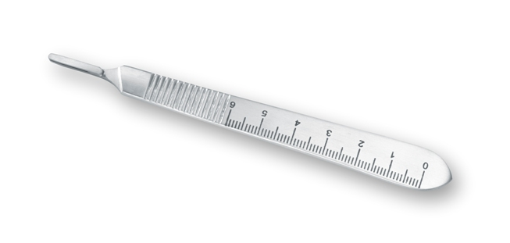
2) pin grip (cylindrical)
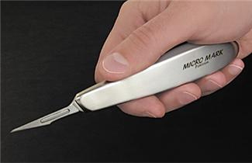
It helps us in some measurements while performing surgeries, for example osteoctomy .
BLADES :
- SIZE 15 BLADE
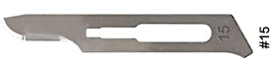
It is the most common blade used in the oral cavity.

- Size 10 blade
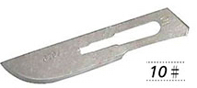
looks like size 15 but slightly larger which is used extra orally (on the skin)

- SIZE 11 BLADE
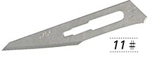
used for stabbing when we have collections or abscess, we need to open it this way.
- SIZE 12 BLADE
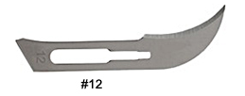
It has a curve for inaccessible areas ,for ex. Palate.

Instruments :
1)MUCOPERIOSTEAL ALEVATOR (FRYER)
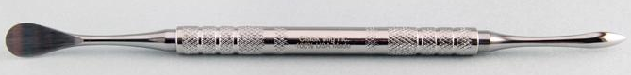
It has two ends ,one round end that has convex & concave surfaces. The other end is more or less triangular.
It raises the mucoperiostiumup , when I make an incision I need to raise flap up.
Convex part(which is delicate) is usually toward the periostum to protect it as you know periostum is the source of blood supply.
The flap should be intact so it won’t get necrotic.
The other end which is more or less triangular is used to raise up the interdental papli gently specially in the anterior area where aesthetics is of a major concern.
.
2) RETRACTOR
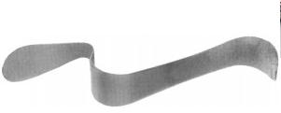

In the principles of surgery, we have to respect all the surrounding tissues that’s why we may need retractors.
Tongue retractor looks heavy because the tongue itself is a heavy muscular structure.
Instruments do make a difference in surgery, for a successful operation we need:
1) Skillful surgeon
2) Good planning
3) Good prepared instruments
-we can use the mucoperiosteal elevator as a retractor, especially if we have a small flap for gentle retraction.
3) FORCEPS
You should distinguish toothed from non-toothed forceps.
4) TWEEZERS
The final step in tooth delivery after luxation is done by tweezers or a mosquito.
We use it to hold the tooth firmly so the patient doesn’t swallow it; if the patient did the following might happen:
- It may go in most cases to the stomach & get excreted by the normal digestive pathway.
- It may go to the airway & suffocate the patient, ultimately causes death or it may go to the lung & causes foreign body reaction ultimately lung abscess.
-if a patient does swallow his tooth, we take two perpendicular radiographs to make proper tooth locating.
If it’s proven that it’s in the lung, we refer the patient to do endoscopy.

5)CLIPS
Used in major surgeries when we towel the patient for getting a sterilized field, we clip the towels with it.
The correct handling clip is when you have 3 points control..

6) BONE CUTTER (ROUNGEUR)
The middle part of it makes a special sound.
It’s used to cut the excess bone,when you perform multiple extractions sometimes the interseptal part is still there ,you need to cut it.
We have two sides cutter roungeur& one side cutter roungeur.
-For bone removal ,we can use hummer & chisel or a roungeur.
You should be extremely careful when cutting with the hummer not to cause bone fracture.
-Maxillofacial surgeons use the roungeur to do what’s so-called planned fracture/surgery for the mandible where we advance or set back the mandible.
-it’s preferred to use hummer &chisel under general anesthesia.
.
7)BONE FILE
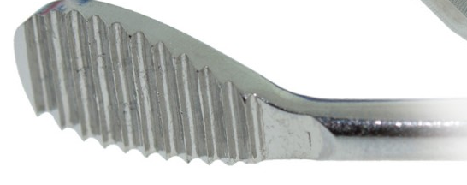
Bone file trims the bone or smoothens it.
-the most common method of bone removal is the HANDPIECE That has a specific torque & force to drill bone & have a calculated speed measured by rounds per minute (round & straight burs) that have many different sizes.
So we remove bone with rotary instruments with continuous irrigation whether internally or by the help of an assistant.
-you should not overheat the bone to above 47˚C, or you’ll end up with bone necrosis.
8) CURETTE
In many cases, tooth has a periapical granoluma or lesion so we need to do curettage.
You have to know how to perform it so you don’t cut through the sinus if in maxilla or through ID canal if in mandible.
-cysts have different management.

9) NEEDLE HOLDER
-you have to differentiate between it, mosquito & artery forceps because they have the same outer shape.
-needle holder working end is short
-artery forceps working end is long
-If we look at the differences cross-sectionally, we’ll find:
-needle holder has a criss-cross pattern so it holds firmly on to the needle.
-artery forceps has one type of striation so it clips the artery when we need to control bleeding.
.
10)MOUTH GAG
in cases of limited mouth opening or if I need an access to the mouth cavity in surgeries to open the mouth from one side & it has a stopper at the other side.
11)CRYER’S ELEVATOR
Most common elevator is the straight elevator then we have cryer’s elevator that has a triangular working end.
-cryer indications:
1)when I have remaining roots of lower 6 teeth
2)having a lower wisdom tooth with an apparent bifurcation that I can see (the only case where I can rest on the external oblique ridge)
-we usually cant rest on bone but here the external oblique ridge is a heavy bone so I can rest the convex part on it where by the triangular end will engage the bifurcation to extract the tooth.
12) STRAGHIT ELEVATOR
It’s an extremely useful instrument.
1) Detachment of the gum around the tooth.
2) Luxation
3) Extraction of remaining roots
it is useful but also dangerous if no good support used that it may slip and cause penetrating wounds..
-concavity in any elevator is usually toward the teeth, it should engage the tooth.

13) FORCEPS
we have two types of forcepses for the maxilla & mandible.
-mandible forceps have an angle at its hinge.
-maxillary forceps have no angle.
-Beaks should rest on the CEJ, you hold it very well then start the movements buccallypalataly& more labially because palatal bone is thicker so we usually move more towards the less resistant area.
-notch of the forceps should engage the bifurcation area.
-in upper teeth, notch located buccally. So we determine right or left according to that.
-if we’re extracting a lower anterior teeth ,body 7 working end is straight while premolars have curve so forceps are expected to have a bend.
-if beaks are closed then it a remaining root forceps, if bent then it’s for lower 4.

*Bayonet forceps is especially for upper wisdoms
*Warwick James’ is a specially designed elevator for luxating maxillary teeth. Could be straight or curved, amount of force.onbome is less, so less incident of bone fracture since the handle is flat
when we want to extract any tooth the whole surrounding tissue and structures must be well anesthetized ( from the buccal and the lingual / palatal side ).ex: the lingual and long buccal nerves and the whole surrounding structures should be numbed when extracting a tooth in the lower quadrant for example .
# There are many indications and contraindications regarding tooth removal ,contraindication could be due to systemic factors or local factors .
Systemic factors :
One of the systemic contraindications that limit the local anesthetic procedure as well as the exodontias is to have a severe uncontrolled metabolic disease such as :
- uncontrolled diabetes : these patients will have limited and inappropriate healing as well as the higher tendency to establish infections …
So what should be done when facing a patient with diabetes is to make sure that his/her diabetes is CONTROLLED by measuring the fasting blood sugar and controlled blood sugar ‘?’
- patients with end stage renal disease : usually those patients undergo dialysis so we as a general beginner practitioners should not be working on such patients ;they need special care and way of management and should be treated in special clinics !
- uncontrolled leukemias and lymphomas .
- uncontrolled cardiac and other ischemic heart diseases , so patients with such diseases must be treated in specialty clinics .
- bleeding problems : patients with bleeding problems and taking medications such as WARFARIN to control their bleeding problems should not be treated by us as a GPs in the surgery clinics instead they should be referred to special clinics where there is experienced drs ,check their INR , have proper consultation and do something that is called bridging which will be discussed later in more details ..
- Extra note : warfarin is an anticoagulant (blood thinner). It reduces the formation of blood clots ,it is used to the prevent heart attacks, strokes, and blood clots in veins and arteries.
Note : patients with prosthetic heart valve should be managed in a certain manner :
-if he/she want to do surgical procedure (for example extraction of his tooth ):the patient should enter the hospital before the surgical procedure in about one week .
-the situation will be different if the same patient want to undergo an endodontic treatment for example ..here he/she should be given prophylactic antibiotic to protect him/her before the procedure starts .
- Note : there is a difference in between a patient with a prosthetic valve and stent(شبكات قلب(;prosthetic valve is big story where as there is no problem of proceeding an endo treatment for a patient with a stent as the universal guide lines have implied but at least this patient should be given prophylactic antibiotic .
- Note :if the patient is under warfarin medications bleeding is what we are afraid of mainly so if the endodontic treatment is confined to the apex of the root as it should be then worries shouldn’t be taken into consideration (even if the endo treatment was a little bit beyond the apex it is not a big deal) but try always to ask your supervisor what is the best to do …where as this drug limits our SURGICAL PROCEDURE and special care as we said above must be given to the patient !
- Note : we should avoid working on a pregnant lady .. but if the circumstances have forced us to apply a treatment on her it’s important to get an approval from her doctor and to work during the second trimester (4th,5th,6th ) months .
- steroids : we can apply surgical procedure on a patient with steroidal consumption but he/she should be given prophylactic dose ; he should be given double or triple the dose before the extraction procedure.
So why should they be given a steroidal supplement before a surgical procedure ?
>>the surgical procedure put the patient under stressful condition ..so the adrenal gland of the patient will try to secrete and excrete endogenous steroids but this endogenous pathway has been inhibited in patients who has been taken exogenous supplements of steroids .. so if there wasn’t a prophylactic dose of steroids given to the patient he will drop and end up into something called adrenal(or steroid) crisis ..
Conclusion : giving him this dose is important before any surgical or stressful condition to compensate the endogenous inability of the excretion of steroids that has been developed since they have been on these drugs !
The amount of this steroidal supplement when giving a patient the prophylactic dose depends on the type of the procedure to be taken (one tooth isn’t as stressful as in the case of working on four teeth nor as applying surgery ,,thus more steroidal supplement must be given in the more stressful conditions ) and also depending on the amount of steroids he/she has been taken so far .
- Pay attention to the difference in between the prophylactic antibiotic and the prophylactic steroids :
>>prophylactic antibiotics are given in certain guidelines such as patients with prosthetic heart valve ,where as the prophylactic steroids as we said above is giving for patient who has been on steroids for certain time and has developed endogenous pathway inhibition so you have to supplement them with it!
Now what are the LOCAL FACTORSthat considered as contraindication for tooth extraction ?
- histrory of radiation :such as a patient who is suffering from cancer and takes radiation this should not be undergo tooth extraction otherwise he will be subjected to necrosis !
- teeth in the area of the tumor :even if the patient has a mobile tooth in the area of the tumor extraction procedure must be stopped to avoid dissemination of the cells while doing the tooth removal.
- pericoronitis around an impacted mandibular molar :pericoronitis is an indication of an active infection around the tooth that is going on so avoid doing extraction; instead the patient should be given therapeutic antibiotics (not prophylactic ) and irrigations to eliminate the infection .
- So if a patient came to your clinic with acute stage of infection and has the welling to extract his tooth .. you should wait and avoid extraction .. give him antibiotics and drugs to eliminate the infection ..then apply your extraction procedure later on !
BEFORE you do extraction you should evaluate 1-so for example we should have a good access to the tooth we want to extract and the patient’s mouth opening shouldn’t be limited …
2- mobility of tooth:
3-the condition of the crown
4-scaling is better to be done before extraction so that the load of bacteria and the microbes on the teeth will be reduced and prevent the patient from acquiring a post operative infections such as the dry socke5-try to avoid extraction of wisdom teeth at this stage , save these extractions for the 5th year !
6-retained deciduous teeth are not easy cases for extraction .
RADIOGRAPHIC evaluation of teeth :
things should be evaluated in order to give you a hint whether to start with the extraction of the tooth or not ..
- So it’s a must to have radiographs before you apply the work !!
You should evaluate certain things in the radiograph you have already taken such as :
- The configuration of the roots : the root might have dilacerations or curvatures that you have noticed due to the radiographs ..in this way you will prepare yourself to apply a certain extraction technique that suits these conditions .. these findings you will not be aware of in the case of not taking radiographs.
- Condition of the surrounding bone :whether there is resorption or not, presence of ankylosis ,and pathological features such as the presence of granulomas ,cysts,infections ..etc .
- Notice the bifurcation of the multi rooted tooth ..assist whether it’s an easy case to work on or not ,and the technique and the special way of management in the removal of the roots according to the radiographs .
-in the case of a tooth with dilacerations, radiographs give you an idea of what to do .. you should open a flap and remove the tooth surgically ..but if you didn’t take a radiograph you will apply the extraction procedure as if the tooth is normal thus leading to fracture of the tooth and extract the crown and part of the root where the other part is still impacted .. so you will need a further surgical extraction of this remaining fractured root ..wasting the time of both the patient and you .. so radiographs give you an idea of what to do !
-in case of ankylosis we should open a surgical flap and in order to gain an access to the root then you decide :
#either we remove the excess bone around the tooth and we extract it .
#or in the case we don’t want to remove bone we do create something that is called trough ( (نفق,or we create a hole or a window around the root and then extract it !
-isolated teeth specially in the maxilla are not easy to extract ( not as we expect )
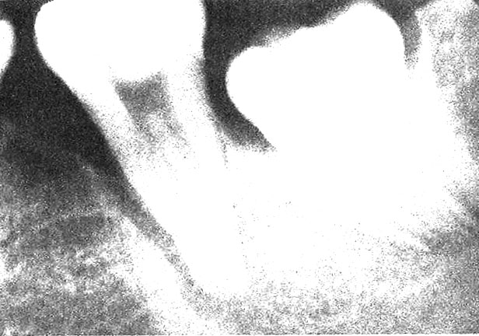this picture shows increase density of bone around the tooth thus it’s difficult to extract, where as the 2nd tooth there is a widening in the PDL space thus easier to extract .
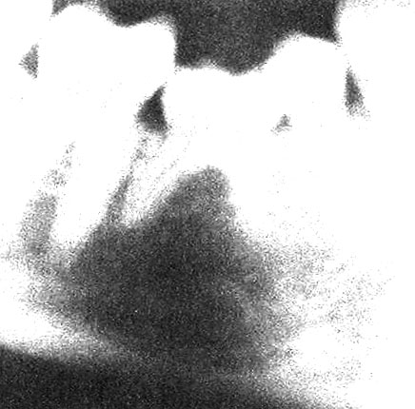this pic shows retained deciduous teeth ,which is hard to extract ,remember to notice any radiolucency or any pathological feature around the root .
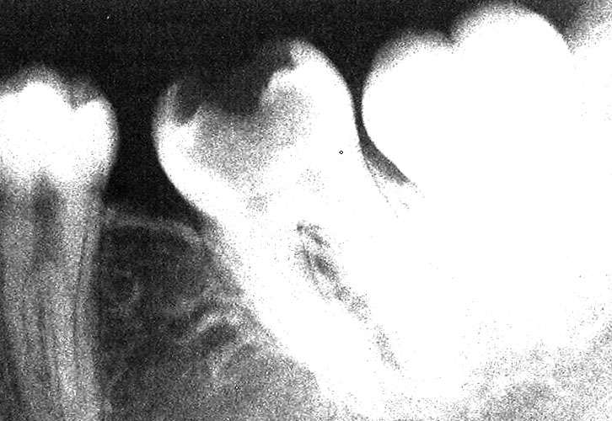this pic shows large carious cavity ,so as soon as I place the forceps on the tooth this will lead to its fracture ,
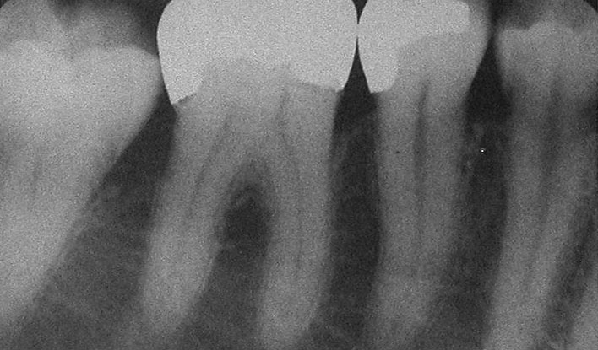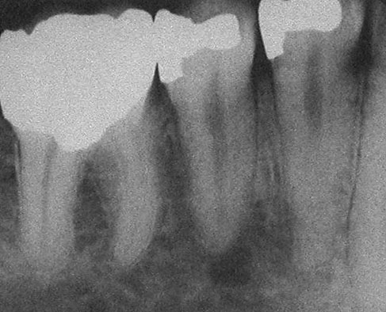 large restorations on the teeth thus you better not to extract such teeth ..and do surgical
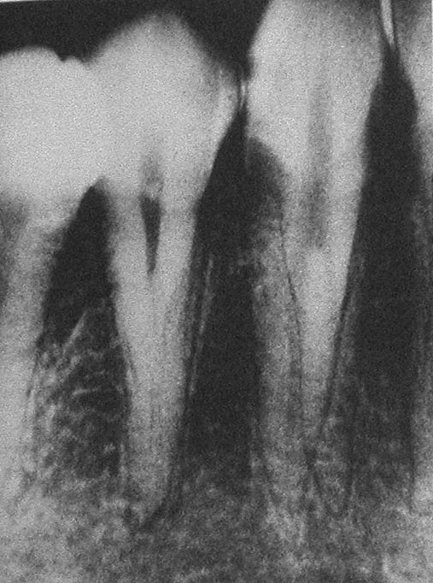root caries below the CEJ .(
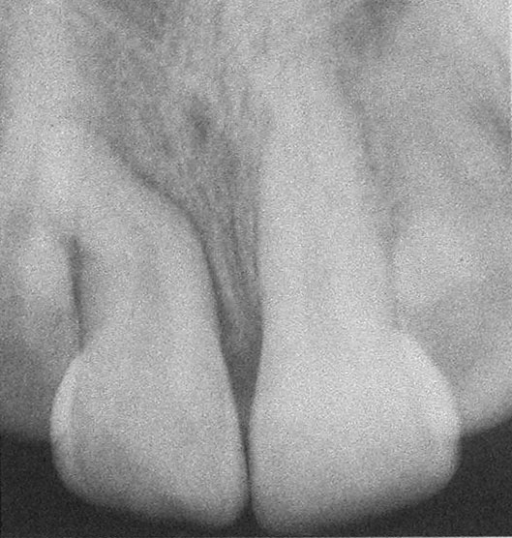dilaceration on the tooth.presents a difficult case to apply extraction on ..and it’s difficulty is due to two points :
1st :due to the bone surrounding the tooth (bone support ).
2nd :due to the presence of sinus which get larger when teeth are lost for a long time ,
- So this a case to be avoided to work on because the teeth and the alveolus might fracture when applying the extraction force using a forceps,and the maxillary sinus might be included and and perforated while applying the forces causing oroantral communication .
(in general any isolated tooth is difficult to extract specially if it was in the maxilla )
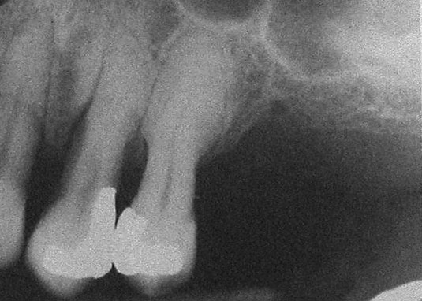 this pic shows hyper cementosis ,thus the tooth will get fractured from the half when you try to extract it , always pay attention to patients with behcet disease ,when the bone density increases and thus affecting the way of extraction .

- Maxillaysinus : don’t you ever push a root toward a sinus ,if this happened you and the patient will end up in a big problem that most probably will need operational (surgical ) intervention .. so the patient will come with a simple extraction case and end up with a surgical operation !
- Inferior alveolar canal :don’t you ever use an elevator and force it deep to the socket ,other wise you’ll cause injury to the canal ..the patient will experience numbness that was absent just before before the extraction, and you might cause any of the different types of nerve injury that will be discussed later (paresthesia, dysesthesia ,anesthesia ) .
- Closed versus surgical extraction : closed extraction >>using a forceps without any surgical intervention (the extraction we do now in the surgical clinics ),,,where as surgical extraction >>here you need to open a flap and apply surgical extraction of the tooth under a supervisor , and later on when you open your own clinic and faced such cases you are not a professional at you can refer the case to maxillofacial or oral surgeon !
- so as a conclusion :you should always be on the safe side ,so don’t you ever do anything you don’t know how to apply it or not sure that you are good at !
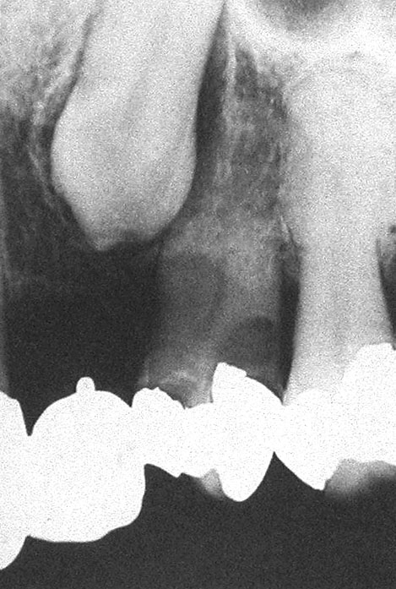here the pic shows an impacted tooth which can be removed surgically .
Notice the tooth the big restoration and internal resorption in the root here the tooth will get fractured if we apply simple extraction using a forceps !
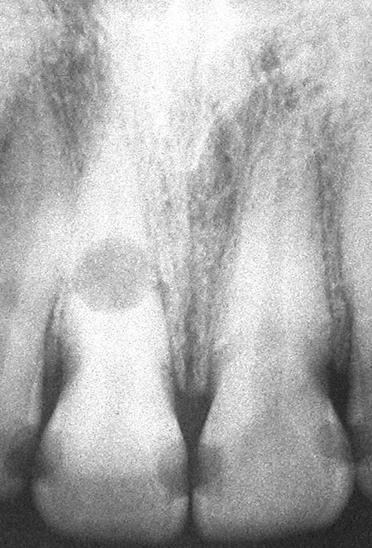 Internal resorption .

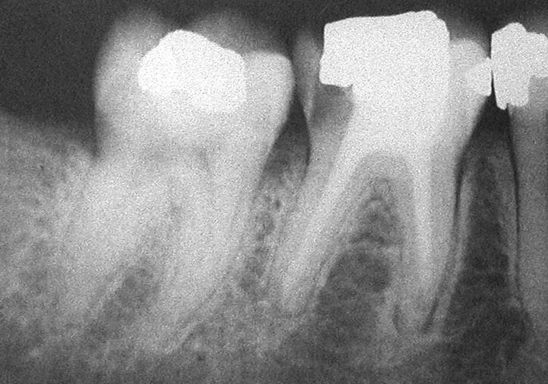 endo treated tooth it’s better if we do surgical extraction to remove it because the root will be brittle and upon extraction the root will be extracted chip by chip and still not fully extracted and this will lead to surgical approach either you do root separation or you open a whole flap and remove it .

- during the tooth extraction both the patient’s and your position must be appropriate and right .. so when the desired tooth to be extracted is in the maxilla the chair(maxilla) reclination should be 60 degrees to the floor ,where as in the mandible more up right position is recommended and the occlusal plane should be parallel to the floor .

;the patient’s shoulder must be at the level of your elbow, here in the picture the level of the patient is lower than necessary making the practitioner at higher risk of curving and tilting him/her self’s back during the procedure ..thus these multiple accumulated tilts and curves and wrong positions will lead to a higher risk of developing disc disease !!

-so being a muscular is not an indication of a good extraction with less effort and force ;on the other hand other practitioner might be thin but she/he was able to deliver the extracted tooth in a very smart way due to the understanding of the lever system principles ,and the choice of an appropriate fulcrum point that aids and help in a better elevation and delivery of the tooth .

-wedge action :beaks of the forceps must be directed and placed at the level of CEJ ,or below or above depending on the tooth your working on whether it’s upper or lower tooth ,and what you care about is to achieve bone expansion !
-we care about the bone elasticity because our aim is bone expantion first then the tooth extraction and delievery .
-elasticity and expansion of bone changes upon aging ,thus the younger the patient the easier the extraction .
-so while using the elevator and forceps try to expand the bone in a way your force be gradual and controlled .
-wheel and axle :this type of lever system is seen while applying the cryer in an appropriate way -cryer is triangular in shape ..
-when extraction and while handling the forceps make sure you go buccally and lingually several times then do rotational movement(you must feel it ) ..do it several times until the desired tooth is extracted .. always remember to go more and to move the forceps further toward the labial side because the bone is thinner and it’s density is lesser on labial /buccal side .
- so we go labially more than lingually except for the lower wisdom tooth or 7 here we go more toward the lingual side using the forceps because here in this case the labial side is denser due to the presence of the buccal shelf on the buccal side .
forehanded dentistry which is something is very preferable and helpful and in this way everyone helped will get some knowledge ,and many will help in the retraction ,access and support needed for the procedure which will result in a better easier work.
- ALVEOALR BONE ANATOMY
- - Buccal versus lingual movements
- Give the bone time to expand

