SUMMARY CROWNS AND BRIDGES SHEETS 1-4 1ST SEMESTER
- Fixed dental prosthesis: it’s any dental prosthesis that is luted or we screw it or mechanically attached
-luted cemented ; we bring a material in a flowy stage and we put it inside the crown
Screw bor3'e
Mechanically attached this way is used more in implants than in crowns and bridges
**Retention method in composite micromechanical retention (etching and bonding ).
**Retention method in amalgam macro mechanical method by preparing convergent walls.
**retention method used in roots posts
**While for indirect restoration or fixed prothodontics luting
screwing
mechanical (by friction)

** mainly we make crowns from centrals to first molar we usually don’t replace wisdoms because theyr'e not much needed
Usually patients come with missing teeth in the mandible more than the maxilla that’s due to not having enough primary support areas as in the maxilla .
* In order to make crowns we should know the dimensions of the teeth , so we have to memorize them all over again
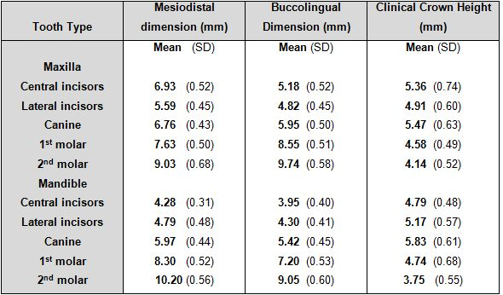
*1 of 10 of the prepared teeth for crowns and bridges will go under irreversible pulpitis changes if happened remove the crown do rct and replace the crown
* so do we need to make RCT for all teeth before preparing ? the answer is NO , we try to maximize the possibility of retaining pulp health
* the MAIN disadvantages when we do crown preparation, we remove( 50-60%) or even more of the volume of the crown
Walls of preparation should be convergent to accommodate cement and allow seating of crown
- we have two materials 1.inner material that has to be strong (metal or high solid ceramics) to withstand the forces
2.outer material ( ceramic ) which is more esthetic but weaker so it does have a fracture rate .
There's no such thing as a "permanent restoration" so we prefer to call it "definitive restoration"

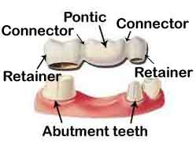

Pontic the part replacing the missing tooth
Retainer the part covering the abutments
Connector the joint between them
*types of bridges :
1. A traditional fixed bridge is comprised of a false tooth (known as a pontic) which is fused to two crowns. Traditional fixed bridges are anchored by the neighboring teeth and can also be supported by dental implants.
2. A Maryland bridge is often used to replace a missing front tooth and is anchored to the teeth on either side of the gap using metal bands. This type of bridge is used when the neighboring teeth are strong and healthy.
3. A cantilever bridge is used when there are healthy teeth on one side of the gap. The bridge is anchored by one or two healthy teeth on one side of the missing tooth.
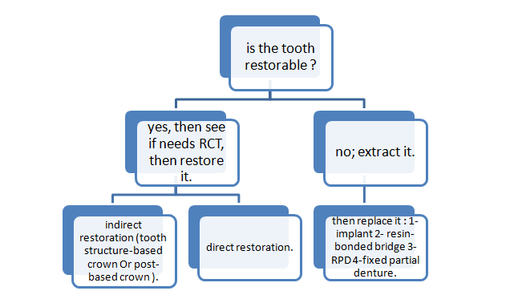
- Now lets talk about Support ; it is either from
1. the tooth structure itself
2. if there is no enough tooth structure we need a post that can be gold post or fiber post
3. support by implant if the tooth is extracted
.. life expectancy for a tooth structure-based crown is more than a post-based one.
- ** consult the patient before doing anything , its prefered to have it written and to have the patient’s signature on it .
- ** show the patient the final look of his teeth before we end up the treatment , nowadays we have digital system that can show him the final result before even starting the treatment .

In direct restoration (plastic restorative material) it's hard to lose the restoration by dislodgment forces because they are protected by the tooth, while in indirect restoration, retention is of a major value to prevent dislodgment by OCCLUSAL forces
* Between crown and the tooth we put luting agent or luting cement , this cement is the weakest part between the crown and the tooth so the space for cement should be minimal ( when the space decreases ,retention increases ) but not make it zero , because the crown will not be seated and will not reach the finish line .
* In full ceramic crown we decrease the occlusal surface by 2mm , because the full ceramic crown is brittle material , if we decrease less than 2 mm the crown will fracture , while in full metallic crown we decrease only 0.7-1 mm .
Retention : the feature of a tooth preparation that resist dislodgment of a crown in vertical direction or along the path of placement .
Dislodging forces :
- sticky food, toffee
- floss
- finger nails
- occlusal forces : because the occlusion is not in one direction , we have 2 vectors: vertical and horizontal specially in cuspal inclines .

factors of retention :
- cylindrical preparation is more retentive than conical , because in cylindrical shape we have one path of insertion while in conical shape we have multiple paths of insertion .
- ideal taper : ideal taper is 6 degrees , but we can't reach 6 degrees so in anterior teeth the average is 10-15 degree and in posterior teeth the average is 25 ,
Taper : theoretically it should be 6 degrees but up to 20 degrees it's acceptable . A taper of more than 20 degrees will result in debonding due to poor retention.
- surface area : retention in molars more than anterior teeth , longer preparation = more retention , length of molar stump (stump=tooth after preparation) at least 4 mm and the length of the anterior stump at least 3 mm .
- Roughness : we don’t want it to be total smooth and no excessive roughness(to prevent microtearing of light body silicone when taking the 2ry impression) so we need minimal roughness to get good amount of retention .
5-Cement type : adhesive cement more retentive , low thickness cement more retentive ( zinc phosphate cement have the lowest thickness and most retentive cement ) ,if enough length prep. conventional non resin based cement are enough , So if enough preparation features to achieve good quality retention, no need to use resin cements, Resin cements are used in: compromised retention, in cases where no full crown prep.(like veneers),Resin bonded bridges (minimal preparation bridges).
6-Types of alloys : gold alloys we can have better adaptation and retention .
Resistance : dislodgment along an axis other than the path of placement .
-Cement and modules of elasticity affect the resistance .
Modules of elasticity : number measures object resistance to deformation , and it's equal stress/strain , represents the steepness of the curve , when modules of elasticity increase the stiffness increase .
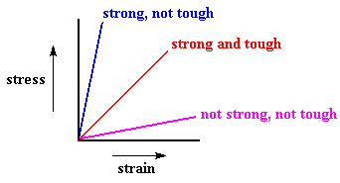
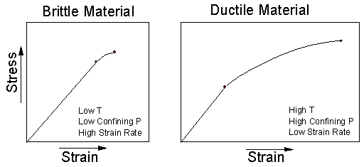
A typical stress–strain curve for a brittle material will be linear.
Forces :
-Biting force Avg bite 500N Max. reported 4000N .

-The patient close his teeth around 20 min/day so may reach 10 million of times per 5years
every restoration have a fatigue cycle .
- The ceramic material tolerate forces to certain limit after that will suddenly break.

-Full coverage crowns more resistance
partially coverage crowns less resistance.
Preventing deformity- Structural durability:
Depend on alloy type/material selection. Metals usually are perforated / deformation , in bilayer ceramo-metal crowns for ex in 6 unit bridge from canine to canine we place metal , If it wasn’t enough and with high forces deformation will happen and the above ceramic/ porcelain crown wont withstand deformation because it’s a brittle material, and will undergo fracture !
If we want to extend bridges gold is NOT the material to use , we can use nickel chromium alloy.

*preparation measures:
depends on the materials of the crown or bridge we mostly do occlusal reduction
Occlusally metal: functional cusp 1.5 mm
Non functional cusp 1 mm
PFM: functional 2mm
Non functional 1.5mm
Full ceramic : functional 2mm
Non functional 1.5mm
“Functional cusps: palatal in max. and buccal in mand.”

Labially all metal chamfer finish line .5-.8 mm
PFM shoulder finish line 1-1.5 mm
All ceramic shoulder finish line 1-1.2 mm

-Margin design (finish line)
Depends on the need for:
- Retention , which depends on the length of preparation so in cinically short crowns you may choose the subginigvsl finish line design
- Aesthetics as it’s a two interphaes so we try to move from visible area.
- biologic width

Biological width definition: it’s the length from the junctional epithelium to the crest of the alveolar bone.
It’s size varies from patient to patient and from tooth to tooth
On average 2.07 from (0 to 0.9mm)

1. Sulcus
2. Connective tissue
3.Junctional epithelium
In anterior teeth we do what is called Hollywood smile or smile design , for esthetics we put finish lines subgingival.
we shouldn’t place it more than 0.5 to 1mm (depth of the sulcus) so not to place our restorative margin on junctional epithelium
- Cases that force you to put finish lines subgingivally are :
1.Restorations subgingival 2.caries sub gingival 3.fracture subgingival
4. aesthetics 5. retention when short length preparation .

no gap should be present ,should meet in a complete seal (most failures in fixed prosthodontics are due to 2ndry caries)
Types of finish lines that help achieving good seal:
Shoulder finish line (in all ceramic crown), beveled shoulder finish line(used in metal joint), chamfer finish line (in ceramometal crown) or metal part if it’s a regular chamfer.

Biological principles
To prevent damage to :
-Tooth structure , adjunct tooth.
we start with occulsal surface then mesial and distal prep if you're doing a mesial and distal reduction you might hit the adjacent tooth , so how to preserve the adjacent tooth? we keep a thin lip of enamel.
- Soft tissue.
-Pulp, its contraindicated to make a full crown prep. to a pt less than 18 yrs old wide pulp chamber

NOTE: always use matrix band in class II cavities even when there is no adjacent to get a smooth surface and ensure condensation and therefore prevent any entrapment of voids
- Complete/full cast coverage/full metal restoration:
-simplest form of preparation.
- the material used is either silver alloy or gold alloy.
- silver alloy is cheaper
-gold alloy is more expensive; however its pour is of better quality and the burnishing of the margins of the end product is better, this is because the preparation for a gold restoration is minimal.
- The following is a photo of a complete gold restoration, a porcelain jacket, and a full porcelain restoration
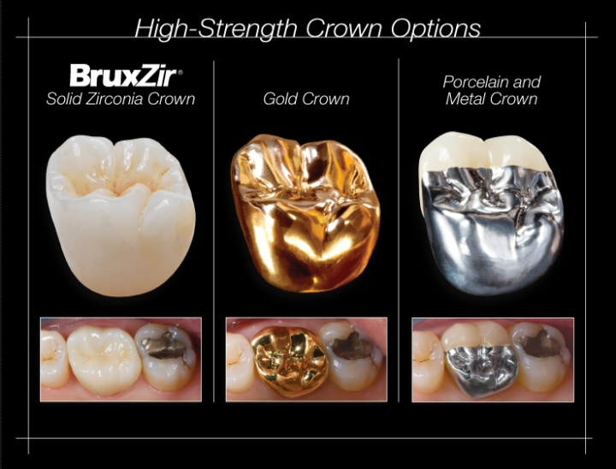
- Indications for a complete cast restoration:
- Extensive destruction/trauma to a tooth
- Endodontically treated teeth
- Replacing an existing restoration due to caries for example
- Necessity for maximum retention and strength and hence minimal reduction of the tooth
- Porcelain fused to metal involves both the metal and the porcelain thickness so the amount of tooth removed during preparation is more.
- RPD; on short clinical crowns or when high displacement forces are anticipated, such as for the retainer of a long span fixed dental prothesis, grooves should be included as additional retentive features.
- An over erupted tooth might need reduction if I want to construct an RPD or a fixed bridge to restore the occlusal plane.

- Contraindications for a complete cast restoration:
- Do not use metal restoration in an aesthetic zone(5 to 5 usually, sometimes to the mesial side of 6)
- If we need less retention (more preparation), we use porcelain instead.

- Advantages of a complete cast/crown restoration:
- No chipping as in ceramics
- Less preparation more surface area better retention
- Easy to obtain an adequate resistance form which will prevent de-bonding or rotation of the crown.
- Modifying the form of occlusion; since reduction is always greater occlusally than the axially.

Notes:
Finishing amalgam fillings : 1st use white stone then green stone then white stone then rubber/silicone tips
to modify a crown form : use diamond bur then green stone then white stone and finally rubber tip for polishing.

- Disdvantages of a complete cast/crown restoration:
- Removal of large amount of tooth structure ( regardless of the type of restoration, preparation of the tooth is needed)
- Because of the proximity of the margin to the gingiva; it is not uncommon to see inflammation of gingival tissues.
Note: Nickel is common to cause discoloration of the gingiva (more in females) due to abfraction, this usually occurs when the finish line sits on a restoration causing secondary caries. The finish line should ALWAYS sit on sound tooth structure.
- Cannot perform a vitality test.
Note: inlays and onlays are considered partial crown restorations and vitality test can be used on the teeth having them
- Aesthetics

Notes:
the ideal bur used for the lingual surfaces of anterior teeth is the flame shaped diamond bur. Not wheel bur
- In general, the bite force is greater in men than in females. It is measured by the unit Newton, every 10 N = 1Kg, Average bite of a female= 300, while in males=400 this is important when considering a high restoration which might cause a periapical lesion due to the huge amount of force applied on the root of the tooth while chewing. This problem is resolved by adjusting the height of the restoration.
the deep chamfer bur is recommended for preparation of the finish line since it gives a rounded angle between the axial wall and the margin and this minimizes the stress on the tooth. deep chamfer is like shoulder but with rounded corners.
- types of burs:
rounded chamfer
needle diamond used on the proximal side, typically, if the proper cervical placement of the margin has been selected with proper axial alignment of the instrument, a lip of tooth enamel is maintained between the diamond and the adjacent tooth that protects it from any damage.

parallel sided chamfer(gives a wider finish line)
- Coarse and fine burs are used for lingual surfaces for anteriors and occlusal surfaces for premolars and molars.

- Finishing of the preparation is important to avoid the entrapment of the wash (light body) in the micro spaces on the axial walls while taking an impression and hence avoid microtearing.

Preparation:
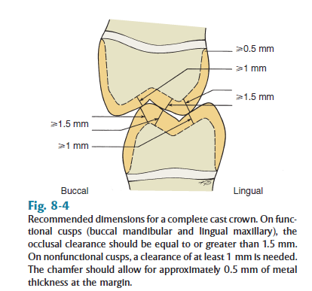

- While for a porcelain restoration we need 0.7mm for metal and another 0.5 mm for porcelain.

* always start occlusally/incisally because the cutting shaft of the bur is not always the same height as the tooth, so for the bur to reach the length needed axially, we always start with occlusal reduction.
- Always start with guiding grooves and then link them together.
- Ensure you have round angles.
- Resistance form: the SHORTER the preparation the LESS the resistance, and hence dislodgement of the crown upon lateral movement of the mandible.
-Age: you have to take it into consideration the age to estimate the position of the pulp horns and avoid pulp exposure during preparation especially with AXIAL reduction.

It’s important in preparation that the margin of restoration and crest of alveolar ridge must be at least 3 mm
The problem is that when the margin of the restorative restoration reach junctional epithelium this will cause irritation to the patient , it might lead to attachment loss of the junctional epithelium which would lead to attachment migration and pocketing

Biological zone : is the sum of free gingiva and biological width
Another terms used to describe this zone are :Dento gingival complex,dento gingival unit and Supra crestal Gingival tissue .
Sulcus , epithelial attachment and connective tissue attachment all of them equal 2.7 mm .

The Metal Ceramic Crown Restoration
(Porcelain fused to metal )

Indications:
- Esthetics : In esthetic zone we can use porcelain fused to metal or full ceramic crown .
- If all-ceramic crown is contraindicated this was in the past especially when using incerams (Aluminum oxide) because if you want to do full ceramic crown in this material when u prepare the finish line it will be thick ( you need to have a good thickness of the material) it was contraindicated in this situation like if you want to make six units bridge for lower anterior teeth so you should shift to porcelain fused to metal.
But nowadays there is no difference between all-ceramic crown or porcelain fused to metal crown , you can make the core zirconium dioxide (ZiO2) and fuse it with porcelain ( so you have metal core zirconia which is strong and have high resistance ).

3-gingival involvement :
It’s better to place glazed porcelain on margin subgingivally than placing metal
So when we have gingival involvement we should do all-ceramic crown or PFM crown rather than all-metal crown for two reason :
1-Allergic reaction from the metal.
2-Porcelain is a glazed material (smooth) rather than metal which is sharp even if we smoothing it will still be sharp and it will irritate the gingival and the smooth surface of ceramics means less plaque retention
CONTRAINDICATIONS :
1-Large pulp chamber (in young patient ):To avoid pulp exposure .
2-Intact buccal wall: in some cases when partial coverage restoration indicated and the buccal wall is intact so we leave it no need to prepare it because sometimes it’s difficult to simulate the normal color of the tooth.
- When more conservative retainer is technically feasible.
ADVANTEGES:
Superior esthetic in comparison with full cast crown

DISADVANTAGE:
- Removal of substantial tooth structure ( you will remove enough amount of tooth structure to allow sufficient space for metal and porcelain.
- Subject to fracture because porcelain is brittle( if the patient clench on his teeth for a long time it’s better to use full cast restoration) .
- Difficult to obtain accurate occlusion in glazed porcelain
So it’s preferable to do try in of porcelain in bisque stage before it become glazed .
- Shade selection can be difficult
- Inferior esthetic in comparison with all-ceramic crown .
- Expensive.

deep chamfer finish line is the best to use .
the incisal reduction is at least 1.5 mm so we leave enough space for the technician so he can simulate the translucent layer of the tooth to get harmony between the restoration and the adjacent tooth.
it’s important to leave 2 mm on the functional cusp as clearance and to measure it by wax or by a condenser with width of 2 mm and pass it while the patient is biting on his teeth to be sure.

In anterior teeth we have 2 inclination in the tooth surface which is “cervical third and the middle &incisal third together”.the incisal & middle inclination must be more than that on the cervical third so we can adapt the body of the restoration to simulate the adjacent tooth so we get a better esthetics .
cervical inclination must be along the long axis of the tooth but the incisal middle inclination must be more inclined lingually or palatally. even if the tooth is straight we have to do the inclination because we need space to get enough thickness of the porcelain to make it look like a normal tooth”.

** shoulder finish lines causes concentrated stress and can cause fracture on the cervical part of the restoration.

anterior teeth preparation for PFM:
winged preparation we prepare the labial surface with 1 mm reduction and we prepare the lingual surface with 0.5 mm beyond the contact area (leave the contact area intact and prepare the lingual surface) so we end up with a wing as a result, we don’t draw the wing it’s a resultant of the preparation.
wingless type we go gradually from the lingual surface of 0.5 mm reduction to 0.7 at the contact area portion and then to 1.5 mm at the most labial surface.
premolars can be prepared winged and wingless too

the reduction differs depending on the position of the tooth to be restored and the adjacent tooth position too, and that so we can mimic a normal look and harmony between the preparation and adjacent tooth.

