Sheet no. : 11 Basic suturing techniques :
(always remember in case you are doing suture , we have to make fine line scar)
the goal of suturing is to approximate the wound edges, and it is a methods to achieve the homeostasis
the preparation:
*plane the incision or the type of closure
*gather equipment : anesthesia , syringe , instrument , suture , dressing
* time out : time out should be clinically done by checking the patient name and a sign consent , check what procedure is to be done
* scrub gloves and rape
* prepare the skin
If you want to do a procedure on the skin of face , clean it with betadine ,if it new wound or old wound ( any cavity opened more than six hours called old wound ),time will affect your technique and if you need debridement or not
the mean of debridement :the superficial tissue or the non vital tissue you need to excise them , tissue that lost it vascularity and with time elapse more than 6 hours defiantly you will have dead tissue , so you do debridement , then irrigation to make sure there is no foreign body , then closure
( in head and neck the wound after 6 hours considered as secondary wound, not a primary )
*undermining and necessingis very important
For example maybe the wound edges are close so you only have to do stitch and suture , or could have lost in the tissue ( specially in RTA(Road Traffic Accident) ) so you have to do undermining to the tissue if the loss was minor , means that you bring the periosteal elevator and do undermining ( loosening for the tissue , you go to the sub dermal layer below the epithelium or the mucosa , you will gain tissue because one of the characteristic of the tissue that it has elastic activity , so you gain tissue then do a suture ), but if there is a large loss tissue , it need graft or take a flap according to how much we have loss

Wound preparation :
We have aseptictechniqueto clean the area very proper. as you know oral cavity is very dirty environment so we do intra oral irrigation , also you can wash it with iodine ( by technique called in out , not haphazardly to decrease the bacterial load , spreading the microbes out to the periphery ), this step is not a must but we do it to decrease the bacterial load
To do suture , must know the set of instrument: adison forceps, hemostat ( not necessary) , needle holder , scissor , suture scissor ( general kit as the clinic ), blade handle. Make sure they are sterile , the package not opened and check their expiration date , also eve the sterilization has an expire date , so we look for the indicator
The idea about doing a suture is to make a knot ,we have square knot , granny knot , slip knot ,
surgeon's knot which is the one we care about , it is will sealed at least not to slip until the day I want to remove my suture , in general doctors tell their patient to come to clinic to remove the suture after 1 week( because it is intra orally and we don't care about the scar unlike on the skin of the face which is critical to be done after 5 days , and if the suture was on the hand or leg we give 2 weeks , this different depend on the vascularity) , but the ideal to be done after 3 days , sometimes doctors ask for 5 days
about theknot , when we tie , we insert the needle from a side to the other side then do one tie then a second and third onein clock wise but the last tie will be anti-clock wise ( 3 ties clock wise and one anti-clock wise ) , then put the knot down in proper way ( sealed, can't be slipped ). . this a surgeon's knot . . commonly used in the oral cavity , which is cervical
if we use nylon or prolene ( commonly used in esthetic area ) , tie them 5 or 6 times because nylon is slippery , not braded , it is a monofilament . . but the silk is braded , and that what make a difference
rememberthe knot should never be on the incision line , because if it was on the incision line , it will cause knot abscess while you removing the stitches , leading to ugly scar
from where should you start the suture ? from the mobile side to the non mobile , you hold the mobile side and start insertion the needle from it to the other side (non-mobile ) . . in oral cavity , in general,from buccal to lingual , since the mobile part will usually be on the buccal side
surgical wound closure guidelines :
adequate debridement and homeostasis*
debridement more important in RTA and falling down for kids on soil or shatter of glass , if not cleaned it will have foreign body reaction , infection ,and no proper wound healing
atraumatic technique*
good alignment with relaxed skin tension lines *
do a good angle of incision*
onthe face it make a difference from where to start because it is an esthetic area , so we have to follow the skin lines
consider the vascularity and the tension of the wound *
key technique:
*dead space : when we have it ? if it superficial wound there is no dead space , it happens in deep wound ( opened mucosa and preiosteum and muscles ) especially in neck dissection , in suture you have to do most of this layers ( not the superficial and not all the layer , just as you can ) , do approximation then suture it , the knot should be upward to not have dead space ,
In the inner layer we use resorbable stitch material but it differ in orientation of the knot , because it might do collection of fluid and leads to infection or dead space , so upward knot make it easier to cut the ends (the 2 limbs) of the suture material , make it shorter in the inner layers , but there is no problem in the outer layer ( not too long , so the patient won't play with it )_ you never close the wound when there is bleeding, because if there is bleeding and I do stretching, sketching and suturing, this will result inhematomaand wound separation, and formation of hematoma will result in infection, so first I will control the bleeding then I do suturing .
_ We go with the tension line to choose the suitable area for the suture .(minimal scar)
Needles:
_ We should use the appropriate needle with appropriate gauge, as we talk there is inverse relationship between gauge and the diameter, if the number of the needle large the diameter will be small.._ the needle may be strait or curved needles ..

Curvature of the needle :

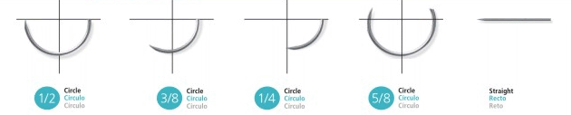

We have :
►3/8 circle
►5/8 circle
►½ circle(mostly used)
►¼ circle
►Straight we do not use it.
_we have different types of needle (size according to diameter)……determine where I have to hold it and for what (and where ) I can use it ( alveolar mucosa or attached mucosa ).
_ the cross section of the needle is very important >> it may be:
1 ) round, blunt and atraumatic needle ..
2 ) triangular, pointed and traumatic needle ..

_ conventional cutting needleuse in the oral cavity ..
_ reverse cutting needle used for skin surface usually .. ( the most important one ,easily penetrate tissue and it does not cause injury to tissue )..
in addition to tapered and blunt needle .
suturing technique
_ in the suture the needle should enter the tissue perpendicular and out the tissue perpendicular ..
_ it's important to bind/connect the two edges as everted edges, there is other type which is edge-to-edge but everted edges is the best, because it gives the best outcome and better healing(best epitlelization ) because we will close the two epithelium edges without any soft tissues, but if we cannot do everted we can do edge to edge .
- The most suture technique we use is simple interrupted suture, and it is very important to know how to do it and it is the most common suture to be used for laceration, closure, biopsies and lesion removal..
Simple interrupted suture:
_ most common suture to be used most common suture to be used ..
_ used to close the deep wound ..
_ give the best esthetic outcome and the most easy to do ..
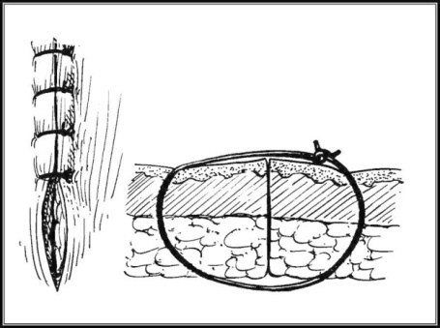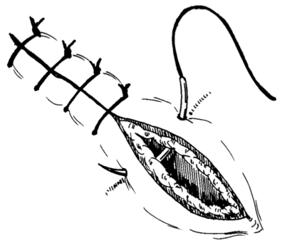
continuous suture:
_can be used but it has problem that if one side of the cord split the whole suture will destroyed and the wound will open ..
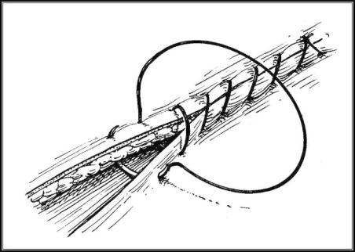
Continuous locked suture:
_ enter with the needle with both edges ( normal suture ) and before I do the next sketch, I enter with the needle from the beginning, so the suture will be firm and good tight ..
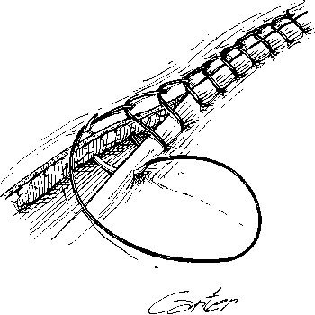
♦Mattress sutures: the tie is located buccaly not over the incision line; the needle enters 4 times ( facial linguallingualbuccal ) then tie it tightly.(give best seal / closure )
Horizontal mattress suture:(most commoly used in oral cavity )
_advantages: tightly locked, hard to open, it’s the best suture that give control to the edges and give firm and tight result ..
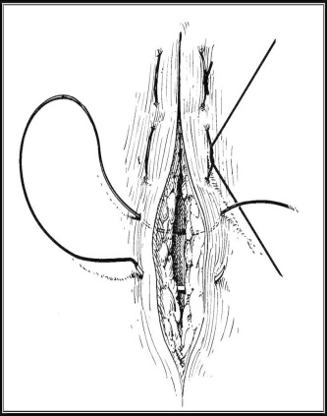
_ I enter and go out from the area then I suture (place the knot) at one side, so the edge is sealed.

- Vertical mattress: on the same line of horizontal mattress, used in cleft palate cases ..
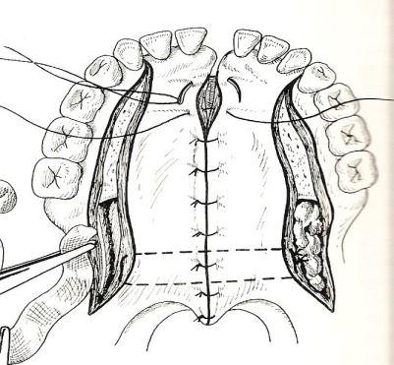
Subcuticular suture:الغرز المخفيه
_ used when there is big distance in abdomen or in the neck)neckline incision ), such in total thyroidectomy surgery ( remove the thyroid )
_ her there is one end and the other end, you enter with the needle under the skin (so skin itself does not have suture /knots) and you take bite of tissue from one site and other bite from another site where you grasp the subcutaneous tissue then you get out from the other site ( bring the two edges together with no cord on the surface of the skin ) .. Then we cower it by adhesive, then after week or 10 days we remove the knots by hold the cord and take it out.

The most important in this lecture is table that the doctor will ask us about it, the suture materialwith its types and classification ( absorbable or non-absorbable )..
الجدول موجد بالسلايد دكتورة سكينة الدكتورة ركزت وشددت على حفظ الجدول

_ Plain gut, chromic gut and Vicryl (Polyglactin) are absorbable materials ..
_ plain gut>>tensile strength is poor, retention is four days (that mean how much its stay in the tissue until absorption occur so this time is very important), also the type of filaments is collagen .
_ Chromic gut>> the retention is 10 days and the type of filaments is collagen .
_ Vicryl (Polyglactin acid)>> the retention is 2 -3 weeks, so you can use it in layers incision, in deeper layer in skin, that’s why I used absorbable suture, but for the surface of the skin we use non-absorbable suture and synthetic .
_ It is important to know the type of filaments .
_ surgical silk and nylon are non-absorbable .
_Nylon>> is monofilament, when I do the tie, I should wrap it 4 or 5 times, because the monofilament is slippery and the knot may separated (high cost ).
_ Silk >>wrap it 3 times which is enough, two wraps clockwise and one wrap anti-clockwise, low price, most common suture material that we use but the problem is tensile strength is poor and tissue reaction is highso you take it in the closest time .
_ Polyester, prolene suture and stainless steel suture .
_ Stainless steel suture is very good suture material, monofilament, non-absorbable and it has the best tensile strength (important information) .
_ the cost of them is important, the prolene is high and polyester is high .
_ Prolene and polyester is synthetic and used for face to reduce the scar (
_ the cost of the silk is low .
you should care about patient and the wound does not infected, so you need to give anti-biotics and its important to cover the wound by adhesive material in the skin to not get wet to get good result but in the oral cavity we do not have to cover the wound .

