Class III:
Smooth surface, involves proximal surface of anterior tooth
* it is an aesthetic restoration.
-There are two approaches Depending on caries location, extent of caries, access to carious lesion:
1) Facial approach depends on:
a) Caries location
b) Alignment of teeth
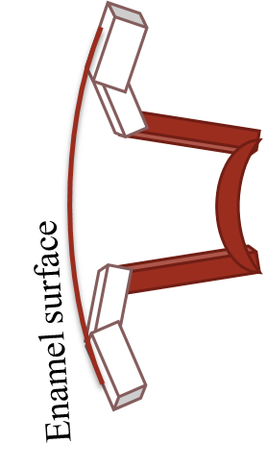
c) Replacement of restorations
2) Lingual approach:
more esthetic, conserves facial enamel
use unless it would remove excessive amount of tooth structure
staining less visible if it occurs
***cavity preparation***
-We have 3 types of class III cavity preparation:
1) Conventional, gives us mechanical retention.
2) Beveled conventional.
3) Modified conventional.
- Conventional
- Indication: restoration of root surface.
- Why? No enamel margin
- Design: Butt Joint margins.
- Walls = walls for amalgam
- Cavosurface margin=90˚
- External walls ┴ root surface.
- Uniform depth.
Note : for retention in this form we use retention grooves
Retention grooves can:
- increase retention,
- decrease effect of polymerization shrinkage,
- increase marginal seal by resisting tooth flexural forces.
- Beveled conventional
- Indication: restoration of large carious lesion or replacing defective restoration in the crown.
- Why? More retention/resistance are needed
- Design: some beveled enamel margins with conventional wall design.
- Cavosurface margin=45˚ on beveled, 90˚ on non beveled margins.
- External walls ┴ enamel surface
Note: undermined enamel can be left in non-stress area.
Retention is increased by:
- Enamel bevel or flare : All accessible enamel margin except gingival margin
, Avoid on lingual margin if the margin is subjected to occlusion
- Retention groves

- Modified conventional
- Indications: small and moderate lesions or faults designed to be as conservative as possible in the crown.
- Why? All enamel margins
- Design: scooped or concaved
- Cavosurface margin ≥ 90˚
- External walls = no shape.
- Only include caries or defective restoration
- Axial wall not uniform in depth.

Class IV
Involves incisal edge of anterior tooth.
***cavity preparation***
-We have 3 types of class IV cavity preparation:
1) Conventional.
2) Beveled conventional.
3) Modified conventional.
• Conventional
- Minimum clinical application.
- Indication: Restoring the portion of a cavity that extend to root surface.
- Why? More retention and resistance needed.
- Design: Butt Joint margins.
- Walls = walls for amalgam
- F and L Cavosurface margin=90˚
- Gingival floor ┴ long axis of the tooth.
- Uniform depth.
• Beveled conventional
- Indication: restoration of large carious lesion or replacing defective restoration in the crown.
- Why? More retention/resistance are needed
- Design: some beveled enamel margins with conventional wall design.
- Cavosurface margin=45˚ on beveled, 90˚ on non beveled margins.
- External walls ┴ enamel surface
Retention:
- Enamel bevel or flare:
Deep bevel for more retention (0.25-2mm).
- Retention groves.
- Undercuts.
- Dovetail
- Pins

- Modified conventional
- Indications: small and moderate lesions or faults designed to be as conservative as possible in the crown.
- Why? All enamel margins
- Design: No specific shape
- Cavosurface margin ≥ 90˚
- External walls = no shape.
- Only include caries or defective restoration.

