Sheet 13 fourth year dr rabab3a
Rana abbadi

Repair :if the failure is single piece pf restoration

redo : if the restoration has multiple defect

sometimes the restoration won’t be repairable then you have to extract the tooth.

- Signs of restoration failures :
overhangs
2ry caries
open contact
gingivitis
- symptoms:
pain like pain upon chewing
food impaction
discoloration
sharp edges
sensitivity
broken tooth or filling
loose tooth or filling
falling filling or tooth
muscle spasm
tmds

- treatment pathway :
we start with CC and symptoms , make sure to recapitulate these symptoms into clinical signs , so the idea is to reproduce the symptoms that the ptn has into a clinical signs that we can confirm from our own perspective as a dentists.
history > clinical examination > special investigation >sound clinical judgment >correct dx
if there is an odontogenic emergency it is always related to one tooth in particular
Remember that clenching and bruxism and other ptn habits may be the cause of restoration failure.
Note :
bruxism ptn with conventional crown >crown fracture
bruxism ptn with post retained crown > root fracture

- Defenitions :
success : 99 % correct
survival : below average
failure : needs redo
- failures related to tooth structure :
most commonly 2ry caries esp with amalgam more than composite, fracture could happen in amalgam or composite with high loading on restoration esp with undermined enamel,dentine margins failure ,loss of pulp vitality, split root .
note : post is the last chance to save the tooth as any failure to the post indicates extraction ; if we can do a foundation restoration without a post a longer restorative cycle will be achieved
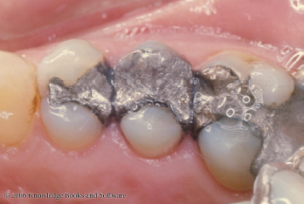
Ditching: Deficiency of amalgam along the margin, preventing the margin of the cavity preparation from being flush. It’s a gradual deterioration of amalgam at tooth-restoration interference.

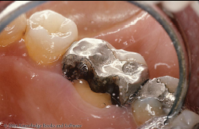
Tooth Fracture mostly occurs in case of undermined tooth structure under occlusal load .
it’s a failure with possible debonding of the restoration
The tooth needs a crown and as you can see the restoration extends to the pulp chamber so if there is a previous RCT we might need to redo it .

- when to repair & when to replace ?
this is determined under certain criteria :
- Ryge criteria 1973
Alpha:
Ex: sharp restoration that needs polishing , darkened composite
• Excellent, fulfilling all quality criteria; tooth
and/or surrounding tssues are adequately
protected
•
Bravo:
Ex: when we use burs to remove part of the cavity; caries in cervical margin of a composite restoration >remove caries and part of the composite > add composite and finish (repair)
• Sufficiently acceptable but with minor
shortcomings in areas where any
instrumentation may result in damage to the
tooth; no adverse effects are anticipated
Charlie:
Ex: fractured amalgam
Unacceptable but repairable

Delta:
Ex: root fracture
Unacceptable and must be replaced

fissure staining in low caries risk ptn> review every 6 months or one year
fissure staining in high risk ptn> fissure sealant and review every 3 months

