Hand Instruments:
- Production of the rotary instruments make the preparation or the cutting of the tooth structure much easier, faster and much more convenient to the patient.
-G.V black “ father of modern dentistry “ is accredited with the first acceptable nomenclature for , classification of hand instrument and Classification of dental carries.
Hand instruments are manufactured from two main materials:
1) Stainless steel: doesn’t rust.
It does not corrode with sterilization.
Disadvantage: Its softer, its cutting efficiency is not as high as the carbon steel.
2) Carbon steel: It’s very good, harder and can maintain the sharpness for the longer period of time so the cutting efficiency is high, however it tends to corrode with use.
Note: The best method in sterilization is using the autoclave; machines with a compressed water vapour, work in a high temperature for sterilizing the instruments and resist all the pathogens specially hepatitis (which resist boiling).
-amalgam manufactured from tin alloy silver, mercury mixed with some additions like copper zinc.
-when you burnish something you pressurize to adapt to something, also used to smooth the surface of freshly placed amalgam restorations.
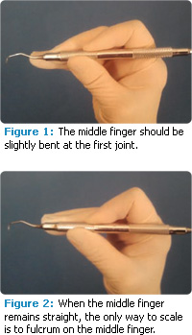
-There are 4 types of grasps for handling hand instruments:
1. Modified pen grasps

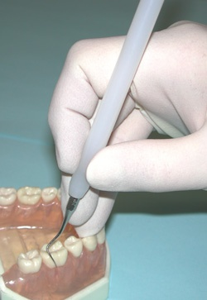
2. Inverted pen grasps

3. Palm thumb grasps
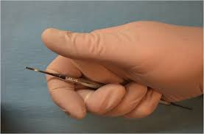

- Modified palm thumb grasps; the same thing of palm and thumb grasp but you set your finger on the same tooth not on the adjacent one.

-Conventional pen grasps is not an acceptable instrument grasp.

