Vital pulp therapy (VPT)

Vital pulp therapy started from kakehashi study in 1965

Kakehashi’s Conclusions: The presence or absence of a microbial flora is the major determinant in the healing of exposed rodent pulps.

If you expose the pulp under aseptic conditions and you seal it probably (prevent infection) the pulp should heal itself because it has a massive potential to heal.

Benefits:
1- To allow root development in immature teeth
2- To maintain sensory function
3- To maintain secondary and tertiary dentin.

Reaction of the pulp dentine complex to caries:
1- Narrowing the dentin tubule by depositing of sclerotic dentin
2- Deposition of tertiary dentine.
3- Inflammation: A pulpit is defense mechanism.

Dentinal caries:
1- Zone of destruction: very soft yellowish liquefied necrotic layer, no sensation and it is damaged. You can remove it with excavator.
2- Zone of bacterial invasion: the layer is caries infected. So when we remove caries, we should remove this layer.
3- Zone of demineralization: here no bacteria present.
4- Sclerotic zone: this slows down the acid advance and gives some sort of pulp protection, seen in x-ray as radiopaque.
5- Then we have tertiary dentine.
Inflammation: pulp reacts by inflammation by giving more blood supply, more white blood cells.
As long as this inflammation is mild and minimal, we call it reversible pulpits. As we remove the stimulus, the pulp can recover spontaneously.

Now if you want to perform VPT:
1- Make sure pulp is vital
2- No symptoms for irreversible pulpits.
3- X-ray examination (no periapical radiulucency or widing in pdl).

Favorable outcome depend on:
1- Removal of stimulus
2- You need to stimulate the pulp tissue (by using biocompatible material e.g. mta, biodentine…)
3- Prevent future micro leakage.

It includes:
1- Indirect pulp protection.
2- Direct pulp protection.
3- Pulpotomy.
4- Regenerative.

Indirect pulp capping

One or two stages, you should remove the caries completely.
Affected caries can be left. Restore with composite
** Recent study said that stepwise technique is not necessary.

In the stepwise caries removal technique:
Only part or all the soft and infected carious tissue is removed at the first visit during the acute phase. In the second step (second visit) 6 to 12 months later, a re-entry caries removal procedure is accomplished, complete removal of all carious tissue is performed and a definitive restoration is placed.
The purpose of this procedure is to arrest the carious lesion progression in order to allow the formation of tertiary dentin before final excavation, which makes the dentin tissue next to the pulp thicker and the pulp exposure less likely.

Direct pulp capping
It is placement of material on exposed pulp to facilitate formation of tertiary dentine.

Prognosis:
1- The length of the time the pulp has been affected: In our clinic, it is difficult to know.
2- Level of bacterial infection
3- Histological status of pulp
4- The size of breach
5- Achievable homeostasis: the most important! Because sometime when pulp is irreversibly damaged, and no
symptoms present , it will bleed a lot, so there is some sort of bleeding that is not control. Pulp exposure when caries excavation >> what is the best management? DPC vs RCT, there are no best answer.

THE OUTCOME OF DIRECT PULP CAPPING:
1- UNEVEANTFUL HEALING
2- PAIN / IRREVERSIBLE PULPITES (HERE THE CASE THAT YOU HAVE WAS ASYMPTOMATIC IRREVESIBLE
PULPITES)
3- NECROSIS, INFECTION.

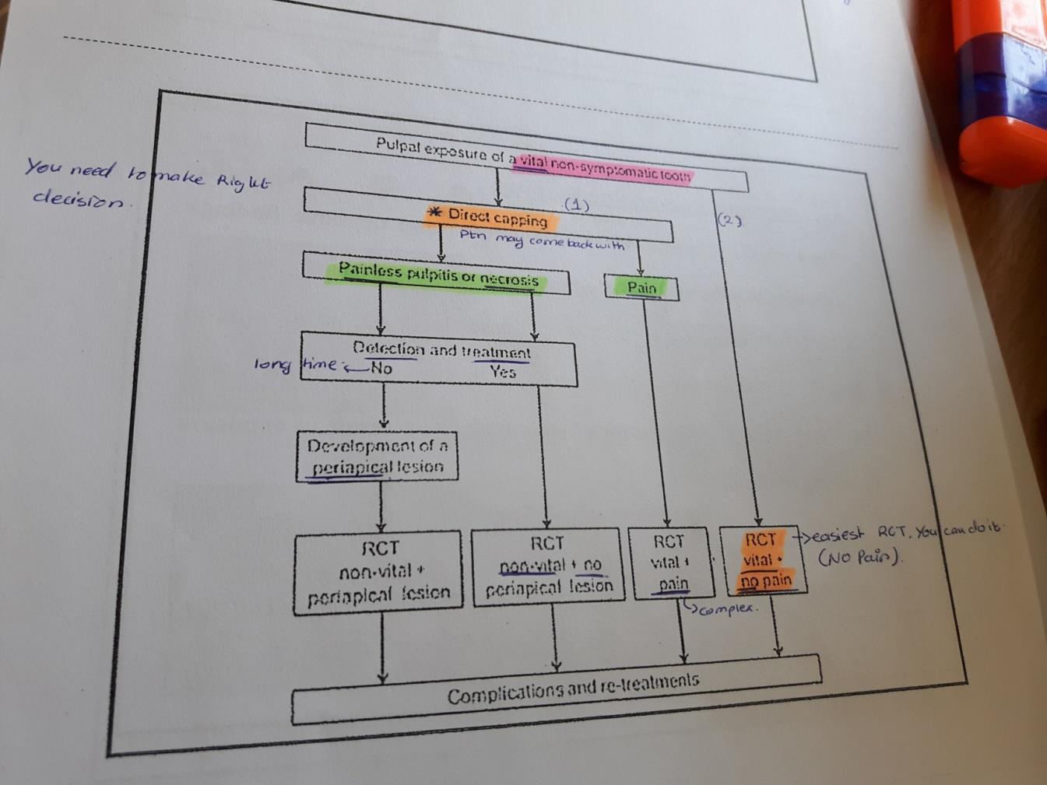

You don’t know histological status of the pulp until you section it and put under microscope. If the pulp is inflamed and you see inflamed tissue, and if YOU SEE microabcess then the pulp is irreversibly damaged. If ptn come to me with no symptoms and I do all my examination (Percussion, palpation. pulp test) no suggestion to irreversible pulpitis then I should preserve the pulp.

Asymptomatic irreversible pulpitis:
- No clinical symptoms.
- Respond normally.
- May had trauma or deep caries. (You remove caries> expose pulp> inflamed pulp> but no symptoms.)

Calcium hydroxide was the best choice for pulp cap:
a- Does not seal (microleakage!)
b- It resorbed
c- However it induces some sort of dentinogensis.
Then put glass inomer or zinc oxide eugenol

In 2008 >> study on direct pulp capping with mta on cariously exposed pulp.

Conclusion: MTA can be a reliable pulp-capping material on direct carious exposures in permanent teeth when a two-visit treatment protocol is observed.
97.9% had favorable outcomes on the basis of radiograph appearance, subjective symptoms and cold testing, all teeth that had open apexes showed completed root formation (apexogenesis)

To get favorable prognosis:
- Aseptic technique (always rubber dam).
- Remove the caries infected dentine layer.
- Control pulp hemorrhage: If you can make a homeostasis by using sodium hypochlorite within 5 minute, it does not matter the superficial part of pulp because it became necrotic, because it will neutralize, and the underneath layer will stimulate the differentiation of stem cells
Pulpotomy:
Next step after direct pulp capping, you expose the pulp (which the superficial layer is inflamed or necrotic), before you get rid of pulp, try to see what happen with radicular pulp.
It’s either partial or complete.
Partial Pulpotomy (not to remove the whole pulp) and the direct pulp capping can be viewed as similar procedure.

Success rate is high and No evidence of irreversible pulpits.
Survival rate was 82% (high :☺)

INDICATION AND CONTRAINDIACTION
- large carious teeth >> this what they say ,dr don’t know that the large and what is not. Dr do for all carious leasion.
- hemorrhage : irreversible pulpitis.

How to monitor?
AFTER 4-6 weeks if there is any symptom do RCT.
CHECK PERIAPICAL STATUS OF THE TOOTH

