The Dilemma of clinical diagnosis of dental caries.
- Why do we diagnose?
Because the treatment depends on the diagnosis.
Caries: is a minute of PH fluctuation as a result of metabolic activity in the biofilm.
Caries are not a unidirectional process.
PH ---> mineral deposition(minerals gain)

PH ---> mineral loss
We don’t actually see the white chalky appearance unless mineral loss exceeds mineral gain and reach the clinical detection.
Caries reflect the activity in dental plaque and can be modified by altering the biofilm.
caries are episodes of demineralization and re-mineralization rather than unidirectional demineralization.
- Why is the world is shifting toward preventive (non operative) treatment?
Because initially caries are reversible.
when ( I can see by the naked eye white chalky appearance) I can say there are caries .
Not seeing the white chalky appearance doesn’t necessarily mean that there is no demineralization and re-mineralization.
Modern clinical caries management concept:
- Caries detection
- Assess the process: in which part of tooth does it reach
- Lesion monitoring: give the patient oral hygiene instructions and take x-ray every 6 months, and every recall assess it, whether it is increasing or it became arrested.
- Caries activity measures: it allows us to know whether the lesion is active or arrested.
- Unfortunately till now we don’t have caries measures, we have crude criteria (blunt criteria not sharp (not accurate)).
- Diagnosis: to intervene or not.
- Prognosis: predict the result of the treatment
- My clinical decision : A. to intervene or not
B. operative treatment (OT) or non operative treatment
8. The outcome on long term after 6 months, one year … etc
- we have
- Sub clinical initial lesion: I can’t see any lesion so I can’t do anything for the patient.
- Lesion detectable only with traditional diagnostic aids : we see by special methods
- Intact lesion : white chalky surface Caries cavity
- A deep cavity that reached the dentine
- A cavity that reached the pulp
This classification is only for class 5 and occlusally caries.
In proximal caries if we see the caries lesion in the x-ray only if it is
- In the enamel it can be re mineralized by oral hygiene instruction.
- The blackness reached the amilo dentinal junction with lateral spread we have to intervene
How to know if there discolored lesion are arrested or active
We depend on 2 factors:
- Age of the patients if the patients is 60 years old then most likely its arrested caries (discoloration , pigmentation) if it’s a teenager we suspect it to be active caries
- Oral hygiene : if the patient with poor oral hygiene then most probably it is carries
- How to evaluate the tooth surface?
- Sound ---> we don’t intervene
- Filled or lesion : the lesion either active or inactive
Any very dark smooth shiny surface without any cavity its arrested lesion
Rough matte surface with cavities its active lesion
if the filling is defected we either remove it or remove parts of it .
Diagnostic tool
- Diagnostic tool requirements :
- Valid: the degree to which the measurements measure what it is purposed to measure.
- Reliable: gives the same result every time
- Accurate.
- Sensitive : true positive ( if I have 10 carious lesion then it should detect 10 carious lesion)
- Specific: true negative (if I don’t have any carious lesion then it shouldn’t detect any carious lesion)
Specificity low: when there is no carious lesion and the tool gives me carious lesion.
Sensitivity low: when there is a carious lesion and the tool doesn’t detect any.
- Potential negative aspect must be evaluated .
- Cost effectiveness.
- Detecting methods :
- Visual /tactile: we dry the tooth surface and examine it with probe and mirror under light and this is the traditional way .
Visual by the naked eye
Tactile by the probe
Opacitywith or without air drying is an indication of caries initiation.
Chalky matte and rough enamel surface indicate active lesion
Shinny and smooth surface doesn’t indicate any problem
Problems of this technique:
- Subjective: it depends on the person use it (unreliable).
- Visual sensitivity is very low (0.2-0.5) ,tactile sensitivity is better with (0.5-0.6) , but it has high specificity.

It is the best detecting method for occlusal carries.
Nowadays we still use probing, but some theories advise not to use the probing forcefully specially on the occlusalsurfaces, because we may produce cavities.
- Radiographs: it helps us assess the proximal caries
We only intervene when the radiolucency reach the inner half of the dentine and the pulp.

Restore surgically only when a lesion is seen clearly penetrate the amilo dentinal junction, but as long as it is in the amilo dentinal junction without lateral spread we don’t intervene.
Clinical examination is the best diagnostic method for occlusal caries with (75-82%) efficiency, while in detecting caries on proximal surfaces it has (22-32%) efficiency
Radiographs have high sensitivity and specificity.
Problems of this method
It can’t be used for pregnant ladies
It can’t be used for monitoring
It can’t be used as a preventive measure

** It has
  - Low sensitivity
  - Limited precision: the tooth may have hypocalcification lesion or any non carious lesion but we think it a carious lesion.

- Cervical burnout: is an area of apparently increased radiolucency in the mesial and distal cervical (neck) regions of the tooth. (it is due to angulations differences)

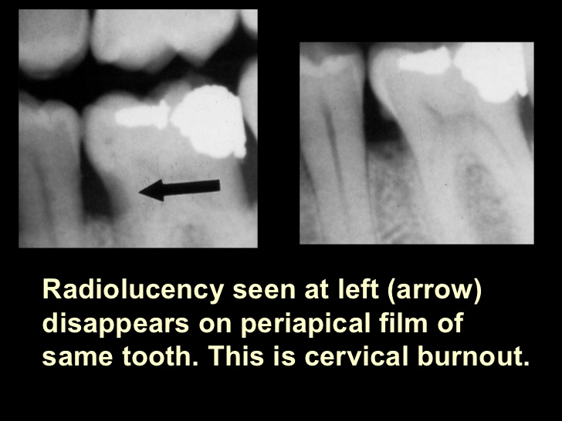
** amilo dentinal junction is hypomineralized in comparisons with the enamel and dentine .

- DIAGNOdent : it is a German invention from Kavo corporation

It is used on
  - Occlusal surfaces
  - Smooth proximal surfaces
  - For enamel and dentine

Prosperities of diagnodent :
- Not invasive
- High reliability
- Valid
- Accurate
- High reducibility
- High co-relation with histological lesions
- Reliable with both occlusal and proximal surfaces
- Reliable with both dentine and enamel .

- Quantitative light fluorescence (QLF): it depends on the tooth auto fluorescence
The lesion appears black
Used for smooth surfaces mainly class 5
Enamel caries only
High sensitivity and specificity
High reliability

- Diagnodent and QLF depend on minerals not on bacteria, histology or collagen.
if they detect a lesion it might be fluorosis or hypocalcification flakes

- Digital fiber optic transmission image :
For dental caries only
Not for occlusal surfaces because of their complex anatomy
It has low sensitivity in proximal surfaces but better than the naked eye

Radiograph > digital fiber optic > clinical diagnosis
No co-relation with histological lesion depth

Dental electrical conductance measure: it depends on the electrical conductivity of the tooth, which depends on minerals

Mineral content -----> electrical conductivity

So if we have a high electrical conductivity then there is a lesion
It has:
- High sensitivity and specificity
- Accurate
- Can be used for enamel or dentine
- Fissure caries in recently erupted molars
- Good for monitoring , non operative treatment

