Ortho 4th year first semester lec from 1 to 4

* Orthodontic definition :

Is that branch of dentistry concerned with facial growth and development of the dentition, occlusion and with the diagnosis, problems and intercept and treatment of occlusal anomalies.

* Orthodontic definition by ADA (American dental association):

It is the area of dentistry concerned with the supervision, guidance, correction of growing" mixed dentition and before the full eruption of the permanent teeth" and maturing of dentofacial structures and looking for the condition that require basically moving of teeth and correct the mal relationship between other related structures) and adjustment of relationship between teeth and facial bone, and we achieve that by the application of forces or simulation of the unidirectional and functional force.

* Occlusion in general: is the manner in which the teeth meet.

** So in the nature there is no ideal occlusion as the study says, there is what we call normal occlusion. The first person that observe this was Andrews.

* The six normal features are :

1. Correct molar relationship. The teeth must occlude in class I occlusion.

2Correct crown **angulations (mesio – distal tip ).**

3Correct crown **inclination (bucco – lingual inclination).** to position the teeth at right angel to the dental base (bone

4Absence of rotation.

5Tight proximal contacts.

6Flat occlusal plane (curve of spee). *There is something called reverse curve of spee, sever curve of spee.*

*\*\* In the sever curve of spee the lower teeth had a lot of spaces and in the upper they are constricted, and the opposite happen in the reverse curve of spee.* any deviation from these six features we call it a malocclusion.

* There were a lot of indexes that developed for dental health and aesthetic , in Jordan it is about 28% of people need help.
* We go throw the RISK-BENEFIT analysis :

1. Treatment need.
2. Potential risk. ** Malocclusion is not a disease it is just as spectrum in one end normal.

* **Aims of orthodontic treatment:**

1. the aesthetic of the dentition.99%

* function of the dentition. Patient with increase over jet (it causes trauma to anterior teeth-which will decrease by 50% after seeking a treatment).

3.Facilitate other form of dentistry ( cons, perio , ortho surgery )

**## orthodontic has nothing to do with :**TMJ dysfunction syndrome (TMJDS).

** But there is some problem might be associated with TMJDS:

1. Marked displacement.
2. Deep bite.
3. No posterior occlusion.

So irregular teeth doesn't necessitate that you have increase risk of caries or periodontal destruction, patient may has straight set of teeth with poor oral hygiene

* Will have high risk of caries, in comparison patient with malocclusion and good oral hygiene will not have high risk of caries.
* **Treatment:**First option: is to do nothing. Second option: treatment using appliances .Third option: treatment using functional appliances (growth modification). Forth option: surgeryfor the big skeletal abnormality .

the camouflage divided into :Removable , Functional , Fixed.

* **The limitations of orthodontic treatment:**

1. Dento- alveolar tooth movement (the most important one).** So the treatment takes long time to move the teeth (little influence on profile).
2. Stability/relapse ** The relapse is a fact, our arches are in constant change, we improve them already but if we left them after the treatment for a time the teeth back to its past situation.
3. Patient expectation after treatment and the general dental state.
4. The bone, the teeth are found in a thin alveolar bone, we can move them in all direction but to a limit not as we want, if we can't then surgery is recommended.

Lec num 2

**growth** it means increase in size, so it's an anatomic phenomenon **Development** on the other hand is a physiological behavior; it's an increase in complexity and specialization not in size.

The zygotic phase which occurs after fertilization (from day 0-14 "the first two weeks intrauterine"), where in this phase there are a small mass of cells which have an accelerated increase in size "growth".  
The phase which is from week 2-8 intrauterine is called the (she said intra-embryonic phase I think because I didn’t hear it, but I think it’s the embryonic phase that’s what Google says) where a very critical differentiation happens, then from 8 weeks till birth there will be an increase in growth and organ formation. So the fetus starts with a small mass of cells that will differentiate into three layers on the third week, we call this **gastrulation**. These three layers are the trilaminar disc "The ectoderm, mesoderm and the endoderm".   
  
After that what happens is a very important stage in the craniofacial development, where the ectomesynchymal cells found in the middle of the ectoderm layer will start to differentiate and grow inward forming the neural groove which will eventually form a neural tube, around this tube we will have a differentiated mesynchymal cells called neural crest cells that will start to increase in number and migrate laterally (they will travel to other places), as they travel to other places they start forming the pharyngeal arches which are derivatives to most of the craniofacial structures.   
 pharyngeal apparatus where we can see the pouch and the decrease in size of the arches as we go caudally, every arch has its own nerve, cartilage and artery. Each one is responsible for certain derivatives of certain areas in the body. The ones that concerns us is the branchial arch number 1 and 2   
Postnatal growth: we call the baby from day zero till the first year an infant and then the phase form 1-6 we call it the early phase of childhood, 6-10 middle phase of childhood, 10-15 is the late phase of childhood "10-15 roughly, due to the variability in the puberty stage", the adolescence phase for males roughly is from 14-20 and for females from 13-20.  
  
You need to understand the pattern of growth and the variability of growth between individuals and for the same individual over time.  
-We are going to start with the pattern of growth: Which is the spatial orientation of different parts of the body at a certain time, so the physical arrangement or orientation of body parts at any time we call it a pattern (the way things are oriented and related to each other).  
The doctor was referring to a graph/picture and said:  
The overall proportions of the body changes over time, before birth "2 months intrauterine" the area of the head accounts for 50% of the total body length (the area of the cranium will be more than half of the total head length) and then these proportions will change, the total length of the head will be about 30 % of the total body length and the cranium is less than half of the head length so it's actually reducing relative to the facial proportion, on the other hand the length will occupy about 1/3 of total body length.  
During adulthood the head will account for only 12% of the total body length.  
  
In children you can see the area of the cranium is dominant relative to the area of the face, this will gradually change over time and we will have about 50% or more of the face proportion occupying the head.   
  
The growth of extremities is less and with time it increases with time. This axis of increase in growth as we from the cranium all the way caudally is called the **cephalocaudal gradient of growth**.   
So as we go from the head to the foot, growth increases. The areas at the top will finish first in terms of growth and areas more caudally (downward) will finish later. This gradient is a part of the normal pattern of growth.  
If we apply the same principle "the same gradient" only to the head, then the cranium will finish first and then the maxilla and the last thing to finish is the mandible, so the mandible will continue growing for a longer time than the cranial part and the maxilla. This is a very important note to keep in mind.

**Scammon's curve**: is a curve that looks at different patterns of growth for a different type of tissues (lymphoid, neural, genital, somatic "general")

Neural tissues: Soon after birth we will have a peak of acceleration of growth, and then this acceleration will reach a plateau at about the age of 6-7 years. So by this time the size of the neural tissues is the same as that in the adult. The 100% of size of the neural tissues is reached at the age of 6-7 years.  
General tissues: This represents the muscles, bones, etc. Those tissues has actually two acceleration peaks "S-shaped curve", one peak occurs soon after birth and then you have a steady growth, then the other peak occurs at the pubertal age at about 11-12 years of age, where at the end they reach the 100% of the size of the adult's tissues.  
Genital tissues: Their growth actually starts very slow, then at the pubertal age we have a huge acceleration then it stops. So we have one peak of growth acceleration.  
Lymphoid tissues: They have a steady increase in growth and size all the way to 10 years of age where it reaches twice as the size of the adults lymphoid tissues and then eventually will shrink back to the size of tissues of the adults.   
The maxilla will be between the general and neural tissues but is closer to the neural tissues, and the mandible is also in between the general and neural but closer to the general tissues.  
  
The adolescent growth spurt is a very important stage in general where physiological changes will occur at that time. Spurt means a sudden acceleration of growth of many parts of the body. Why is this important in dentistry?   
Because during this stage (as this acceleration occurs), changes occur from the mixed dentition to the permanent dentition which is a very important stage in occlusal development, also its important because here in this spurt we will have a facial growth where the growth of the mandible and maxilla is accelerated too where the mandible will grow faster here. Knowing when this spurt starts can help you in occlusal treatment and in cases where occlusal mal-development occurs.   
When does that happen? When does this spurt start? Actually there is a biological variation, but we know for girls it's about "10-12" years and for boys its two years later "12-14", but does every patient follow this average? No, because we know that any curve that represent a population has a mean (where around it are the rest of the scatter of the population) and a standard deviation, where the mean +/-1 standard deviation represents about 68.5% of the population and 2 standard deviation represents about 97% of the population, so not everyone is following the mean, actually everyone is around the mean.   
The further we go from the mean, more abnormalities can occur. So there will be a problem if someone is above 2 standard deviation from the mean, so as far as people are within the area of the mean then that’s normal.  
  
Standard growth chart: This represents the age, height and weight. Every time the patient comes to the clinic you measure his weight and height and you put a mark. The dark line "the one in the middle" represents the mean, and one line above and one line below represents the standard deviation and then two standard deviation and then three.



that he is ahead of the other children where he is heavier and taller than the others but this is not alarming and there is no problem.  
At 8 years of age, the patient comes and again you measure his weight and height, although the measurements are above the mean, he's still following the same pattern (one standard deviation above the normal).

They usually have large number of children, they measure their weights and heights over time and then they have norms for those children in terms of weight and height and they collect the results so that they'll compare any patient that comes to the normal, you do your analysis, you have your own measurements then you compare them to the norms.

So, the line in the middle represents the mean, the above lines represent 1 standard deviation, 2 standard deviation and 3 standard deviation, also the lower lines represent 1 standard deviation, 2 standard deviation, 3 standard deviation. So that should include most of your population, as we said, we can't know what's wrong with the patient from only one visit, we have to follow him up, but at least from the first visit I can know that this child is ahead of his peers. The next visit he's still following one standard deviation above and the visit after also, that means he's heavier and taller than the other children but normal..

NOTE: the red line is the patient's growth pattern and the black one is the normal (AVERAGE).

Another example:

The doctor showed us a graph and said that the patient's first visit when he was 7.5 years old, the weight is a little bit below, the height is normal, the next visit, weight is still a little bit lower (a standard deviation), the height is perfect, then the next visit then the next visit, what's happening is that there's a deterioration of growth and development, there's a problem happening here; he's not following the same growth, it's not because he's above or below but because he started with a certain pattern and then the pattern changed, this is a standard growth chart, you compare your patients with other children( norms ) and with HIMSELF.

There's this another graph that the doctor showed, we have the age of the patient (at birth, 2 years, 4 years..), the black line represents the height (the total height) so when the patient comes you measure the height, what's happening over time is that the patient is getting taller, the red line represents the change in height, so if he comes and has gained 2cm relative to the last visit, I record them, so as you can see after birth we have an accelerated growth gaining cms is fast, but then we have a steady growth, and then at the pubertal stage there's what we call the peak height velocity (accelerated growth) and this coincides with adolescence growth spurt, so which one is more informative; the red line or the black line?

THE RED LINE, everyone will have the same black line +- but everyone has a unique red line because everyone has a special adolescence growth spurt, ..we call the black line : the speed curve and the red line we call it the velocity curve and this is called the peak-height velocity.

The doctor showed another curve and said, this is the age, this is the height (total height) so this is the speed curve and this is (pointing at the line) the change in height (the velocity curve) and she showed us the weight (total weight) and the gain in weight. (Note: the black line represents boys and the dashed line represents girls). These two speed curves are telling you that over time, children are getting taller and heavier, everyone is getting taller and heavier, it's not that informative, BUT, the second line is telling you how much CHANGE in height and in weight over time, here for example (she points at the graph) we see a peak soon after birth (accelerate growth) and then a steady growth and then suddenly we have another peak of growth, this the pubertal (adolescence growth spurt). Girl's growth spurt is earlier than boys (2 years on AVG).

Which is more informative ?the velocity curve

What do we call this peak ?peak-height velocity.

Which is more important, the biological age or the chronological age

The biological age, because each individual has a different age on terms of biological age but everyone has the same counting of years over time.

Again, chronological age is only counting of years, and not everyone is following the average years in terms of adolescence growth spurt, but the biological age will tell you more, for example, the dental age, we can have an OPG and tell how old the patient is dentally,for example by looking at the root tips of the erupted teeth, and it doesn't have to coincide with the patient's chronological age, for example the patient can be 10 years old DENTALLY, but 12 CHRONOLOGICALLY, sexual age is the sexual maturity, the skeletal age; not long ago they used to have a hand-

wrist radiograph for every patient with the small bones there, and they had an atlas (a standard atlas) that had different stages of development for those small bones and then they'll compare the patient with the atlas n terms of size and shape of bones and then you can tell roughly the skeletal age of the patient and this is important but we don't do it anymore (not justified) because its extra radiation the patient is exposed to.

Morphologic age; the peak-height velocity is important so if you use any of the standard charts you can actually reach to acquaint where is the peak-height velocity. So there is variability between individuals.

As we said, growth is an increase in size and number, the increase in number we call it hyperplasia and it is the most prominent procedure that happens in terms of growth, while hypertrophy is the increase in size and it's not that prominent (doesn't happen regularly).A third way of increase in size is extracellular secretions and fluids, this is important because we know that hard tissues they don't increase in size by increasing cells what they do is that they secrete extracellular fluids and then they become calcified and then another layer and so on (layer by layer), this is an important way of growing for the skeletal tissues (bone,calcified issues)

The difference between soft tissues and hard tissues is that soft tissues can grow at any point, at the same time, nothing can stop them, they just push the other components away, on the other hand the hard tissues can't, the only way to grow a bone is to have a direct appositionof bone on that piece (reshape, resorption, apposition) what we call bone remodeling. We can't have an interstitial growth, this is only for soft tissues, and as long as the extracellular fluids has been secreted by the osteoblast yet not calcified, this can happen, they can increase in size but as soon as they're calcified and rigid then that's it, you can't have interstitial growth, it's impossible, it's only a direct apposition of bone now.

More concepts to understand is bone formation, bone formation could happen by endochondral ossification or intramembranous ossification.

Endochondral ossification is the change of cartilage tissues into bone, first of all we have cartilage then this cartilage becomes infiltrated by blood and vascular elements, and then we have plenty of cells necessary to grow bone (most importantly osteoblasts) and then this osteoblasts will start secreting extracellular fluids that'll calcify. Then we'll have within the cartilage islands of bone, and eventually those islands of bone will become larger and the cartilage will continue getting smaller until it disappears and then we'll have a piece of bone, this is called ENDOCHONDRAL OSSIFICATION. For eg: the brain as we know is covered by the calvarium and it rests on the cranial base, the cranial base is formed by endochondral ossification, the floor below the brain used to be cartilage and then it eventually changed into bone so this happens to the cranial base, another example is the cartilage and bone of epiphyseal plates.

The other way of bone formation doesn't need cartilage we just have soft tissues (connective tissues)and then we have growth cells infiltrating these tissues and eventually we have plenty of cells necessary to build bone (osteoblasts,etc) and then we'll have secretion of extracellular fluids, calcification,…WE DON'T NEED CARTILAGE. For eg: the calvarium, the area that cover the brain and the maxilla and the mandible. It's called INTRAMEMBRANOUS OSSIFICATION.

-If the growth only happens in a certain location but we need distant areas to control this growth we call this SITE OF GROWTH.

-If the growth happens and is controlled in the same area (the genes and other controlling factors) , growth is happening independently, we call this CENTER OF GROWTH.

How do scientists know? They isolate the growing part and put in the lab if it continues to grow then it's center of growth, if not then it's site of growth. So this is how they understand what's happening and what controls what. And accordingly they classified the cartilage into two types ; the primary cartilage where growth center happens, if we take the primary cartilage , isolate it from the body and put it in the lab it will continue to grow. Secondary cartilage, like the head of the condyle for example, if you isolate it and put it in the lab, it will not grow, because it's a site of growth.

When we say bone remodeling it’s a continuous process of bone resorption and apposition. Why? Because once the bone is formed it's not a permanent process, for eg: a square piece of bone will not stay a square it will reshape and remodel according to the function and needs, it's a selective and continuous process of bone resorption and apposition like reshaping, a nice example is the brain : after birth, the brain will grow in size until 6-7 years of age, if the calvarium that's covering the brain is fixed in size and form then basically, the brain will grow and have no space but because the calvarium has a continuous process of remodeling then it'll accommodate the new size and shape of the brain.

-primary translation or displacement is when the growing part it is actively growing and it's the reason that it's moving because it is the one that is growing. It's changing position because there's growth happening.

-but for example if there is two pieces of bone one hanging with the other, one is actively moving and changing and the other is just hanging there, but because the first one is moving so the other is actually moving with it, this is called secondary translation so it is a reactive or a passive change in position as a result of change in the position in the surrounding tissues so sometimes there's a change because there is an ACTIVE MOVEMENT (PRIMARY TRANSLATION). And sometimes because of a REACTIVE/PASSIVE MOVEMENT (SECONDARY TRANSLATION).

For example the maxilla is sutured with the rest of the cranial bone, if the cranial bone is moving (growing) what happens to the maxillaa? It's carried with it (PASSIVELY). So we call this secondary translation!

The bone that is covering the brain like the calvarium and the cranial base we call it; neurocranium.

But the rest of the facial skeletal is called the viscerocranium.

Lec 3

The cranial bone consist of different pieces of bones :

* The Frontal bone .
* Squamous part of the temporal bone
* The parietal bone
* Squamous part of the Occipital bone

have two types of ossification :

Intramembranous ossification.

Endochondral ossification

The ossification of the cranial bones starts **8 weeks** intrauterine.

The type of ossification is **intramembranous**🡺 so we don’t need the presence of cartilage.

So only the soft tissue that is covering the brain will get invaded by blood vessels, bone formation happens then the formation of islands of calcification.

The outer membrane of the brain is called exominates??? that is where the first activity happens

These islands grow bigger (and the surrounding soft tissue will become smaller) forming the cranial bones.

**At birth** , these bones are not fused, they are separated by soft tissues called “fontanels”

We have 6 fontanels at birth which are :

* Anterior fontanel
* Posterior fontanel
* 2 Sphenoid fontanels
* 2 Mastoid fontanels

## why aren’t they fused ?

To make the infant head smaller during birth , thus having easier delivery.

**After 18 month of birth** , fontanels will be replaced by fibrous tissue called “ sutures”

Sutures are osteo-fibrous contact areas between adjacent flat skull bones , where majority of the blood invading occur.

## what happens to the brain after birth ?

It will keep on growing.

The type of growth is neural growth, which is determined by the growth of the brain along with the calvarium.

First we have rapid growth in early years then slows until **7 to 8 years of age** when growth is **complete** (completion of calvarium growth).

Since the calvarium is covering the cranial bones , and bone is getting bigger, the islands of bones will keep pushing apart because sutures are not calcified yet fused and these areas after pushing apart will be filled with bone.

So we will have bone formation at the sutures area and bone remodeling at the outside (deposition) and inside (resorption) surface 🡺 bone deposition and bone resorption “ active process” (why?) 🡺 to accommodate the new shape and size of bone.

## what type of movement does the calvarium do ?

It’s primary movement , active translation. “ primary not caused by other factors”

And as we said the pattern of growth of the calvarium is closely following the neural path of growth .

Cranial base:

It’s the part of the skull where the brain rests.

Consist of :

* Ethmoid.
* Sphenoid.
* Occipital.

The ossification starts **4 months intrauterine.**

**It’s the last part of skull to calcify .**

the type of ossification is **endochondral**.

* So a long line of cartilage ( formed form the membrane covering the brain at its lower surface which is called the ectomeric?? which will start to have an activity of formation of chondrocytes, chondrocytes will start forming cartilage, we will have a piece of cartilage extended from the nasal septum to the foramen magnum, and then we will have active areas of bone formation and we will have more islands of bone) these centers will get wider and wider, cartilage areas will get smaller and then replaced by bone.
* We will end up with main islands of bone: ethmoid, sphenoid, occipital bones.
* We will have remnants of cartilage in between them called “synchondroses” 🡺 primary cartilage (primary: because it is the centre of growth ) , continuous growth , hyaline type and it’s androcentric.
* The remnants of cartilage will turn into bone.

Synchondroses exists as :

1. Spheno-ethmoidal synchondroses
2. 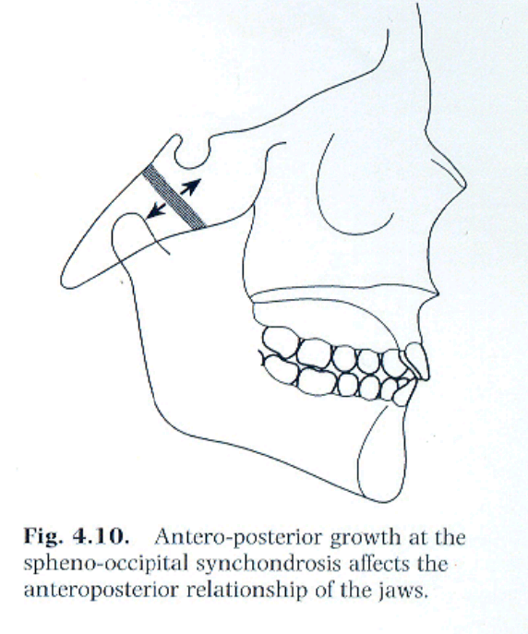Intersphenoidal synchondroses.
3. Spheno-occipital synchondroses.

* Then the cranial base will grow (active bone formation by endochondral ossification at the synchondroses) **longer**( why?) 🡺 because of **active bone formation** "not the remodeling" in the synchondroses. At the same time we have remodeling to accommodate the shape of the brain, spaces and according to the structures surrounding it.
* **Before birth** the inter-sphenoidal synchondroses will be closed.
* **Around 6 years of age ,** the spheno-ethmoidal synchondroses closes , after the brain finishes its neural growth.
* 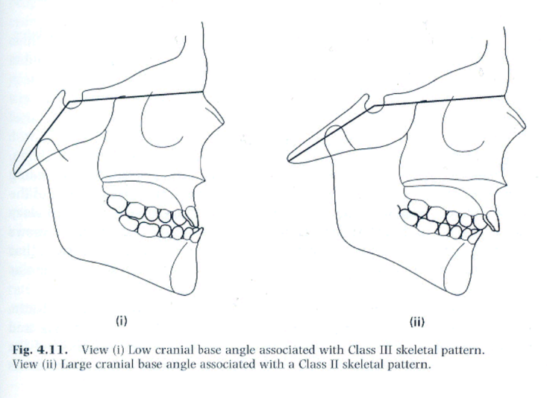**After the growth spurt (13-15 female , 15-17 male ) ,**  the spheno-occipital synchondroses starts to close reaching ossification at almost 20 . (why?) 🡺because it’s attached to the temporal bone, where we have TMJ which holds the mandible, so when the spheno-occipital synchodroses keep growing and elongating it will affect the mandible as well, so it affects the mandible position effecting the skeletal pattern of the patient.

We will end up having a cranial base angle, we call it sometimes **“suddle angel”** which has an average of 124

## if this angle becomes acute or the basal bone grows shorter 🡺 the mandible will grow forward and we will have class 3 and small posterior facial height . (protrognotic mandible )

## the angle becomes obtuse or the basal bone grows longer 🡺 the mandible will grow backward and we will have class 2 occlusion “ clinically looks like small mandible but it’s not” (retrognotic mandible )

So the length and shape of the basal bones will affect the position of the mandible .

Nasian to the sella torsica ((forms the horizontal line of suddle angle)) and the the articulary " an imaginary line between the condyle and the zygomatic bone" ((form the vertical line of the suddle angle))………..the suddle angle is an imaginary angle.

**Maxilla :**

it started calcification **7 weeks intrauterine.** So it’s the third bone to calcify ; we have first the clavicle and then the mandible then the maxilla

The type of ossification is **intramembranous ossification 🡺**so we don’t need cartilage.

It is start to calcify lateral to the nasal septum "nasal cartilage" where we have condensation to mesenchymal cells , and then this condensation will be invaded by blood vessels and then we have bone secretion and calcification …,but we have to remember that nasal cartilage by itself doesn’t contribute much to the maxillary growth or development it only guides it.

* **After birth :** the whole soft tissues that the maxilla is embedded in will grow downward and forward and that will CREATE MORE GAPS (sutures) needs bone to be closed ,This type of movement is primary, active translation (active bone formation by the maxilla), so the movement of the maxilla downward and forward will enhance the active bone formation at the sutures.
* We can see the shaping of the baby maxilla “ very small”
* Gradually we will have bone resorption at the anterior part, and bone addition at the posterior part (maxillary tuberosity) of the maxilla giving space for the molars to erupt as if it's moving backwards ( but the other factors will sum up the movements and we will end up with a forward movement of the maxilla )🡺 bone remodeling process.

The fact that the maxilla is part of the cranial bones and we know that cranial bones and the base are getting longer, carrying the maxilla with it forward 🡺 this movement of the maxilla is secondary “ secondary translation” (why?) 🡺 because it’s cause by cranial bones growth “ external cause”

## so we have primary and secondary movement in the maxilla :

1. Primary movement :downward and forward
2. Secondary movement: forward.

* Bone remodeling is done in the same direction in the palate, resorption at the base of the nasal cavity , bone deposition at the roof of oral cavity 🡺 as if bone remodeling is moving downward and as part of the maxilla it will also move forward , downward .
* In the midline suture of the palate it will be pushed apart by the transverse development ((an active bone formation will happen in the middle of the palate "the suture region" )) >>> so we can see the palate growing wider.
* This will start to slow down and stop at 15 f .m/17 m and it accelerates at the pubertal stage .

Why is this important ?

because if i am planning for a surgery I should wait after the growth finishes and if i am willing to do growth modification it should be done at the growth spurt time not before nor after .

**Mandible:**

First signs of ossification starts **6 weeks intrauterine.**

**Second bone to calcify.**

Here we have both types of ossification , intramembranous and endochondral.

* Here we have meckel’s cartilage 🡺 though it doesn’t have a part in the mandible bone formation its only a guidance ( remnants of it will form the small bones of the middle ear), **mesenchymal condensation** happens , then blood invade , centers of ossification forms, and here we have **intramembranous ossification** and formation of islands of bones .

So we have intramembranous ossification for the body of the mandible , islands are growing larger, meckel’s cartilage contribute some bone “ conductive ossicles” which has nothing to do with the mandible.

* We have the condyles separated from the mandible and later fuse.
* Condyles start condensation from cartilage 🡺 type of the cartilage is secondary (growth site ) which means growth is sideways **not centric (so not primary)**.
* 10 weeks intrauterine we will have replacement of this cartilage with bone.

So the body of the mandible 🡺 intramembranous

The condyle and the ramus🡺endochondral.

* Then they will fuse and the mandible forms, and remnants of cartilage will contribute to the TMJ capsule formation.
* After birth we will still have endochondral ossification ( at the condyle area ) of the mandible but the majority of the activity will be bone resorption bone remodeling

## so maxilla we have only intramembranous ossification, cartilage only involved in development not growth.

## mandible has both types of ossification , cartilage contribute to the formation of condyles.

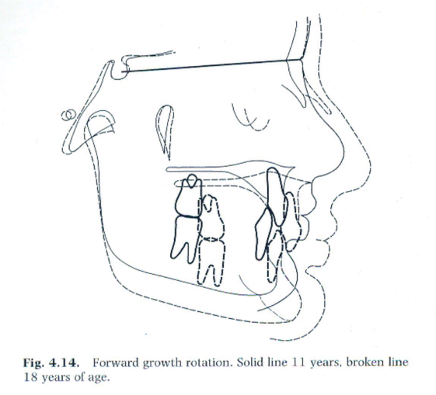

* the mandible is embedded in the soft tissues 🡺 which aids in movement, speech, swallowing ,eating and growth at the same time.
* When soft tissues move downward and forward, the head of the condyle moves downward away from the joint🡺 thus enhancing bone formation and endochondral ossification in that area.
* 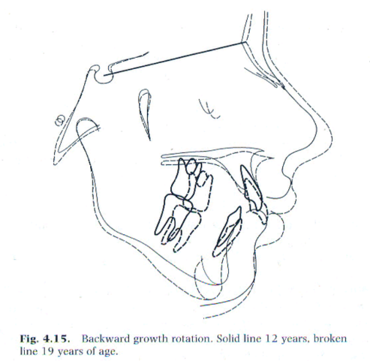The ramus is going to increase in height by active bone formation 🡺 primary displacement (why?) because there is active bone formation at the condylar end .in response to the surrounding tissues and structures.

## the dr. showed some pics of small mandible : after birth bone remodeling, this part which is used to be part of the condyle , later will be part of middle of the ramus, and later part of the anterior part of the ramus, and because of active process of remodeling , body of the mandible will grow longer to accommodate more teeth.

* In the transverse section we see deposition of the outer surface making mandible **wider**.
* The chin is inactive in early time.
* Remodeling brings ramus backward.

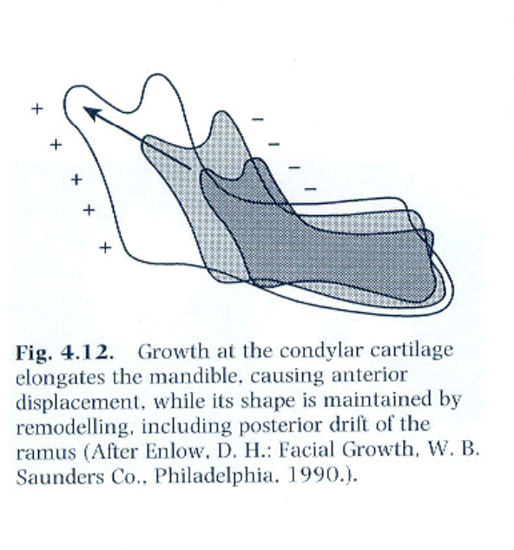

* This pic shows you how the mandible is getting higher in ramous and longer in the body region by displacement of the soft tissue , also you can notice active bone remolding where there is bone resorption at the anterior margin of the ramus and bone formation posteriorly so the mandible is getting wider
* We have another mechanism to move the mandible which is : when the cranial base (spheno-occipital synchondroses) is getting wider and moving backward, the mandible will move backward also 🡺this type of movement is called secondary translation .
* The area of the chin is inactive, and due to the downward forward movement of the mandible it will become prominent and this is a sign of maturing in the child.
* the ramus become longer by endochondral ossification and the body will become longer by bone formation and the mandible become wider by bone remodeling 🡺 this how the mandible gain its new size and shape during development🡺so at the end of this the mandible become forward and downward (why?) because it fixed there " forward and downward"…….the same happen to the maxilla, BUT THE DIFFERENCE IS the growth of the maxilla stops first and the mandible growth further (2 years in average) according to the sephalo-codal gradian of growth "differential growth" , AND this will affect the developing malocclusion or correction malocclusion if you interfere at the right time.
* Before puberty we have increase in height of ramus 1-2 mm/year and increase in the length of the body by 2-3mm/year , AT THE PUBERTY (the growth spirit) these quantities might double ((this is very valuable if you planning to modify growth of the mandible)).
* We reach the maximum size of the mandible at 17 years in girls and 19 in boys, so if a surgeon planning for a surgery to the mandible he/she will wait after these ages, although some surgeons prefers to wait further because these measurements are average.
* IF we look to the curve of the growth pattern, we'll notice that the pattern of the growth of the maxilla is closer to the neural growth, BUT the growth of the mandible is closer to the general growth.
* We also have the vertical growth; the ant. And post. Height. The differential change in the posterior and anterior facial height is what we called **ROTATION.**
* **We have** forward growth rotation (more posterior growth or less anterior growth) and backward growth rotation (less posterior growth or more anterior growth).
* In the MAXILLA we have rotation but it is very minimal and it almost completely masked by bone remodeling so it does not affect the overall pattern of skeletal development BUT in the MANDIBLE it is significant (80% of population has forward growth rotation and some will have a backward growth rotation).
* Posterior growth rotation it is the post. Growth height , it is affected by endochondral ossification of the condyle , the (spheno-occipital synchondroses bone formation) and the soft tissues "the muscles that inserted to the ramus",,, these 3 factors will determine the final **post. Height**. The **anterior height** on the other hand will be affected by development and eruption of teeth "occlusion" , the fascia, and the muscles "the suprahyoid muscles; their insertion is the spinal column" ; so it will be affected by the growth of the spinal column.
* THE RATIO BETWEEN the post. Growth height and the ant. Growth height in the sagittal plane (the differential growth) will determine the rotation.
* If a patient has a lot of forward growth rotation, the ant. Facial height will be reduced so the overbite will increase (deep overbite) .
* If a patient has a lot of backward growth rotation , the ant. Facial height will be increased so the overbite will decrease (an open bite will result).

**Craniofacial growth in the adult**

When does it stop??

The dr. want us to refer to table 4.1.3 to read about the craniofacial growth in the adult, she said ''if we do not have it she will give it to us''.

The control of craniofacial growth, where are the factors and where are the genes that affect the final size and the position of bone in the maxilla, mandible, cranial bones… There are 3 theories:

1. Some found that these factors are in the suture (in the bone itself): they try to take the calvarium away of the brain, it does not develop by itself, there is no active bone formation at the sutures isolated from the rest of soft tissue and the cartilage and the rest of structure , this theory is a little bit poor; it doesn't explain the growth of the craniofacial growth…. Some ptns. Have a lot of spinal fluids so the calvarium will be large (so this theory is weak cause it does not consider the soft tissues effect!).
2. The cartilage is controls the craniofacial structures: like the cartilage in the cranial base "which is a primary cartilage; so it can explain it there", but the meckel's cartilage in the mandible does not contribute , the condylar cartilage is a secondary cartilage and the cartilage of the septal nose does not contribute the growth of the maxilla>>> so it is a weak theory cause it doesn't explain the growth fully.
3. A functional based theory bone the soft tissues where the bone are embedded is control the growth of "maxilla, mandible, cranial base….ect" : growth of the soft tissues and its functional demand will determine and affect the growth of maxilla..mandible..cranial base..ect…

How we will be sure about this theory?

Some patients have mouth breathing "cannot breath from the nose" and they will develop (long face syndrome) , others have difficulty of swallowing, have weak muscles or very strong muscles, they will affect the developing bone and developing malocclusion….. studies said that the ptn my breath from his mouth because of a weak muscle (so it is a result not a reaction)…we do not know which is the result and which is the cause. So this theory explains a lot but it does not explain everything.We cannot predict growth, but if we want to do an effective treatment concerning the growth and the development, we must do it after the spurt of growth (as we said)!.

Lec 4

**Tooth development and eruption:**  
(you should memorize these numbers)

|  |  |  |  |
| --- | --- | --- | --- |
|  | Calcification (mIU) | Crown completion (m) | Eruption (m) |
| Incisors | 4 | 1.5-3 | 6-9 |
| Canine | 4-5 | 9 | 18-20 |
| First molar | 4-5 | 6 | **12-15** |
| Second molar | 4-6 | 12 | 25-36 |

-If you look in a new born mouth, you will see edentulous gum pads   
-Eruption begins at any time during first year  
-Primary is completed by 2.5-3 years (reassure parent)

-There is no significant data and differences between males and females. Females’ teeth don’t erupt quicker than males

-deciduous teeth are smaller, whiter and more upright than the permanent teeth.  
-Upright: in relation to the maxilla and mandible, they are more vertical, they look very straight, they appear to be at right angle with the lower mandible.

-Epithelial pearls: calcified nodules that appear on the gum and those don’t require any treatment.

-Natal teeth: sometimes the baby is born with teeth.  
Usually these teeth are the mandibular incisors.  
These teeth are not supernumerary or extra teeth; they are the original teeth but erupted very early.  
Sometimes they cause problems during breast feeding; in this case you should remove them. But if they don’t cause problems during feeding, you should retain them.

**Feature of the primary dentition:**

A. The distal surface of the primary second molar can be either:  
1)Straight/flush   
2)mesial step   
3)distal step

Normal primary dentition is either a straight/flush or a mesial step.

B. Incisor spacing  
if you have a child with crowded deciduous teeth this means that the permanent teeth will definitely be more crowded, therefore there should be a space

C. Anthropoid (Primate) space  
Distal to the lower canine and mesial to the upper canine.  
**Primary dentition from 3-6 years:**

1) Primary teeth are whiter that permanent teeth.   
Why?

-Organization of enamel prisms is different  
-the light scan is different   
-enamel is less translucent   
But the main reason is due to: higher inorganic content, there is more calcium, the enamel is more calcified, more hydroxyapatite

2) Attrition  
attrition is more in primary, because they are thinner buccolingually, you should **not** give the patient night guard.

3) Reduction in overjet and overbite   
overjet: is the extent of horizontal overlap of the upper teeth over the lower teeth  
overbite: is the vertical extent

4) Edge to edge relation

-we cant guarantee that there will be no crowding, unless the space is more than 6mm (Leighton 1971)

**Eruption of first permanent molar:**

-at 6 years  
**You should count number of teeth

Class 1 molar relationship:  
The mesio-buccal cusp of upper 6 occludes to the buccal groove of the lower 6

Class 1 molar relationship is achieved in 3 ways:

1. Directly on eruption if there is a mesial step
2. By closure of anthropoid space
3. By the use of the lee-way space

Lee-way space:

Sum of the width of the primary canines, first and second molars is greater than their successors (permanent teeth)

On average:  
- 1.5 mm per side in the maxilla  
- 2.5 mm per side in the mandible

This difference mainly came from the large size of E’s.  
Growth:

For the first molars to erupt; the mandible and the maxilla should grow posteriorly to provide space

Upper 6 will develop in the maxillary tuberosity  
Lower 6 will develop in the anterior border of ascending ramus of the mandible  
Thus; resorption will take place in the anterior border of ascending ramus, the mandible length will increase, the edentulous part of the mandible will increase.

**Permanent incisors:**

After all the 6’s come, the permanent incisors will start to erupt.  
Permanent incisors are much larger than deciduous incisors

Space between incisors is provided in 3 ways:   
1. Space between deciduous incisors   
2. Labial inclination of permanent incisors  
3. Alveolar bone growth (increase in intra-canine width)

Eruption:

-Right and left incisors are symmetrical in eruption, they erupt together.  
The upper incisors eruption is from 6-8 years for both (right and left), and it needs about 3 months to reach the occlusal plane.  
Delay in one side should be investigated by radiographs

Possible causes for delay in eruption of one of the incisors:

1. Supernumerary (dentin, pulp and enamel are mixed together)
2. Dilaceraton following trauma of overlying primary tooth  
   after the age of 4, if the child was exposed to trauma for the primary incisor, it will be transmitted to the permanent incisor.   
   How it happens?  
   The calcified part will move, and the non-calcified part won’t move. We will end up with a bended tooth   
   Trauma usually due to kickboxing.

Usually we have a gap between the two central incisors, laterals incisors will look funny.  
This stage is called the ugly duckling stage, and it’s normal.

When permanent canines erupt, they use the distal surface of the lateral incisors as a guide for them to erupt and close the space.

Sometimes we do provide treatment during the ugly duckling stage, early orthodontic treatment.  
Why to provide a treatment for something normal?

1. Because some children are teased at school, and his mother comes to the dentist asking for a treatment.  
   Some studies showed that early orthodontic treatment improves child’s self-esteem during this period (ugly duckling stage), but later on, both (who had the treatment and who hadn’t) will share the same self-esteem  
   At the end it matters only through these 2-3 years (ugly duckling stage)
2. Esthetics   
   The doctor does not prefer early orthodontic treatment just due to esthetics
3. Proclined or protruded teeth  
   increase in overjet   
   If the overjet is more than 6mm, it will increase the risk of trauma by 50%

Problems during eruption:  
-low frenal attachment (because of the diastema)  
-delayed in eruption of one incisor  
-lack of space

Lee-way space on average:

* 2.5mm per side in mandible
* 1.5mm per side in maxilla

**Eruption sequence: centrals and molars then lower 3,4,5 then upper 4 ,3,5 then 7 the last is 8**

**Curve of Monson:**Created by the upper buccal cusps, and lingual lower cusps

**Curve of spee:** Created by the occlusal plane.