First classification of malocclusion : skeletal (A-P, vertical ,transverse)/soft tissue /habit /dental and local factor
1 )A-P points
A :deepest concavity on maxilla B: deepest point on mandible
Patient should be at natural head position or Frankfort plan should be parallel to the floor
Values : A pointshould be ant to b point 2-3 mm ( class 1 ), >2-3 ( class 2 ) , < 2-3 ( class 3)
Convexity of the face :
glabella: most prominent part of the face and head
subnasal :point where nose meets upper lip
pogonion : prominantpoint of the chin
values : straight points :class 1 , convex face : class2 , concave face :class 3
class 2 causes :mandible retrusion (main ),max. protrusion ,max.teeth more proclined ,ant growth rotation
cranial base angle influncesthe position of mandible (ant growth rotation ,post growth rotaion )
class 3 causes :mandibular protrusion , max.retrusion ,ant growth rotation
2)verticle relationship
Take the readings from side view
Lower facial height
faces divided into 3 thirds from( hair line-glabella –sub nasal –menton ), the lower third from subnasal and menton also divided into:
upper lip height (from subnasal to the opening of the lip ),lower lip height (opening of the lip to the menton )
Frankfort-mandibl plan angle
Normally meet at the occipt bone (28 degree)if ant to it(increase lower facial height- angle > 28 )
If post to it (decrease lower facial heigh- angle <28 )
Ant open bite due to :habit, skeletal (post growth rotation ),soft tissue, localized failure of eruption
3)transverse : u have to take the readings infront of patient or above
Transvers( asymmetry of the face) oral manifestations
- Cross bite: lower posterior teeth buccal than upper
- Scissor bite: upper post more buccalythan lower
Most important words that describe transverse stage ( u have to determine if its ant or post /uni or bilateral /with or without displasment )

CEPHLOMETRY

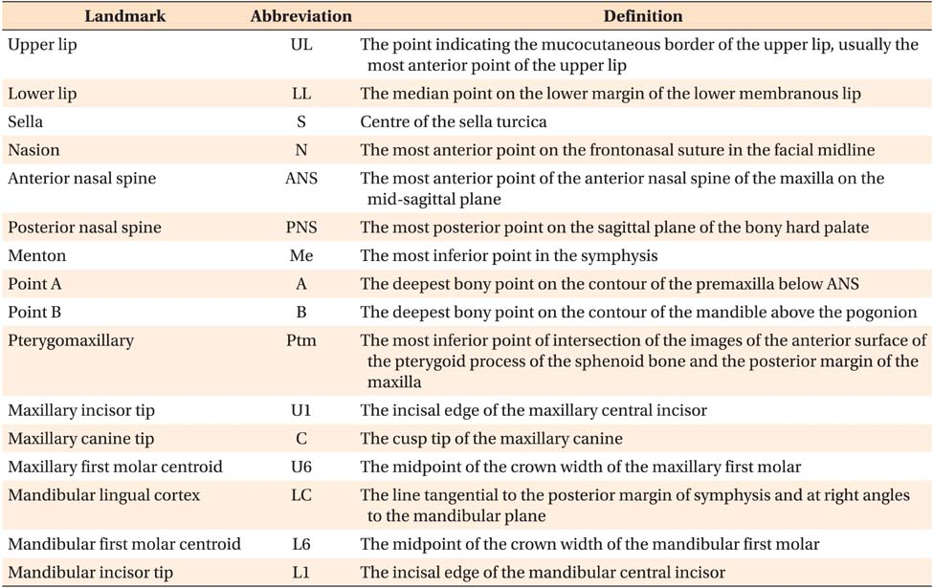

Type ofskull xray :
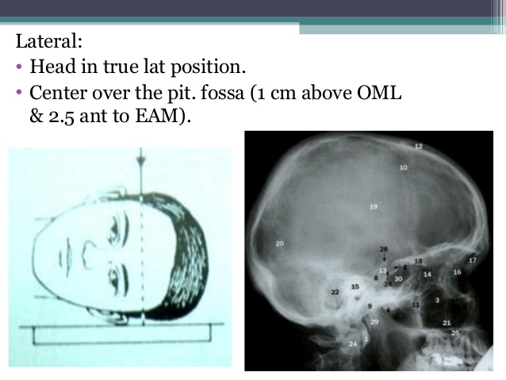

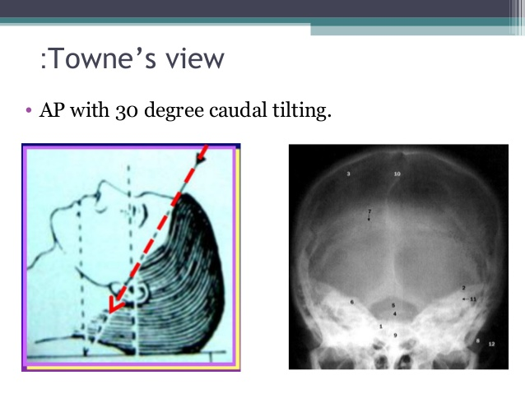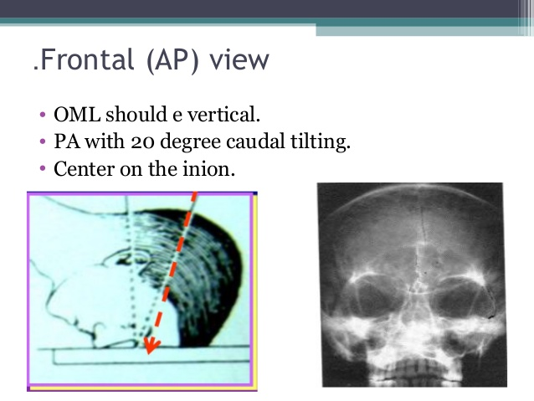

ROLES OF SOFTTISSUE IN MALOCCLUSION (worse-help-cause the malocclusion-increase the stability )
Equilibrium theory :natural zone affected by many forces
1)intrinsic forces : lip, cheeks, tongue 2)extrinsic by habits 3)occlusal forces ( important***)especially ant component of the force 4)pdl tissue
1)lip
Lip at rest : (contour –lip line –competence )
1)contour :everted decrease the activity of the lip proclined teeth والعكس صحيح
2) lip competence if incompetent lip mouth breather
3)lip linelower lip covers 1/3 upper incisor (if <1/3 low lip line retroclined teeth ) العكس صحيح
At function (ant oral seal- activity of thelower lip )
1)ant-oral seal (lipto lip )
Swallowing pattern (infantile pattern :lower lip with ant part of the tongue),
(adult pattern :teeth come to occlusion , lips together,posterior part of the tongue)
How to achieve the seal : circumoral muscular activity , forward mandibular positioning ,tongueto lowerlip seal
- Lower lip activity (hyperactive lower lip retroclined lower teeth )

2)Tongue
Tongue at rest most important than at function
At rest ( size and position ) at function (adapted tongue and 1ry endogenous )
3)Pdl
Is a stabilization factor that balance the forces between the tongue and lip
Digit sucking : a symmetrical ,localized to ant teeth ,upper teeth proclined
Adenoid : over eruption of teeh , increase lower facial height m mandible will move downward and backward

Roles of soft tissue in malocclusion
1)To reah the stability in class 2 div 1 u hav to reach : lip to lip –and stop habits
2)In class 3 the soft tissue will decrease the severity of malocclusion
3)Hyperactive lip +low lip line = class 2 div1
4)Hyperactive;ip + high lip line = class2 div 2
5)How to dx high labial frenum attachment ? 1.blanching test 2.PA radiograph
6)cleft after surgerythe fibrous tissue will grow and prevent the maxilla from continuing its growth

ETIOLOGY OF MALOCUSION skeletal –soft-localized(variation of number,size and position)
1)Variation of number (supernumerary –hypodontia- early loss of primary )
Supernumerary :
Conical : small ,cause spacing ,not preventeruption of teeth
Tuberculate :prevent teeth eruption , diagnosed by occlusal radiograph or OPG
Supplemental :normal shape of tooth
Odontom :it might becompound or complex
hYpodontia
eg .of interceptive tx when dentist noticed that lat incisor is missing :
early extraction of B ,C so 3 can easily erupt
when u have unilateral missing lateral inciso on the other side u will have peg shaped lat .incisor
- Result of missing centralsincisor :midline shift ,increase oj,mesial drifting for molars
- Early loss of D :will affect molar relationship and causes minimally midline shift
- Early loss ofE:6 driffting and causing 5 impaction
- Type of extractions :
- 1)compensating :extraction of the opposite arch to maintain molars relationship
- 2) balancing : extractin in the same jawbut R and L TO prevent midline shift
*Most common cause for preventing eruption : tuberculate >odontom >rare conical *Always when 1ry teeth are missing the permanent is missing too
*When permanent is missing primary might be infra occluded
*Infraoccluded teeth in the cases of 1) missing 4,5 2)1ry teeth ankylosed to the bone
*Clinical signs that indicates exiting of supernumerary teeth 1) existanceof extra tooth 2)delay in permanent teeth eruption 3) median diastema 4) asymmetry of eruption
*hypodontia usually associated with microdontia

