At the end of the primary teeth stage, they’ll start to shed and will be replaced by permanent teeth, shedding of teeth results from: the progressive resorption of the roots of teeth and the supporting tissues, and is accomplished by the multinuclear odontoclasts, part of the resorption happens to the bone and the other part to the roots of the primary teeth.
This process of resorption will undergo periods of rest and repair, but at the end the resorption will predominate and the permanent successor will erupt.
Causes of shedding:
- pressure from the underlying erupting
- Sometimes the pressure from the mastication will stimulate the resorption of the roots of the primary teeth ( in the absence of successor ).
Resorption pattern of anterior teeth:
Permanent teeth undergo complex movement before they reach their position from which they will erupt “pre-eruptive movement”, Permanent incisors and canines first develop lingual to the deciduous tooth germs, but as the child grows they will move to a more forward position until they become apical to the primary tooth, until they occupy their own bony crypts.
Regarding the premolars they also will erupt lingual to their predecessors and then they will shift so they are situated in their own crypts beneath the divergent roots of the primary molars.
*Chronology of eruption:
Lower arch: (6, 1), 2,3,4,5 then 7 and 8 will erupt.
Upper arch: 6, 1, 2,4,5,3, then 7 and 8 will erupt.
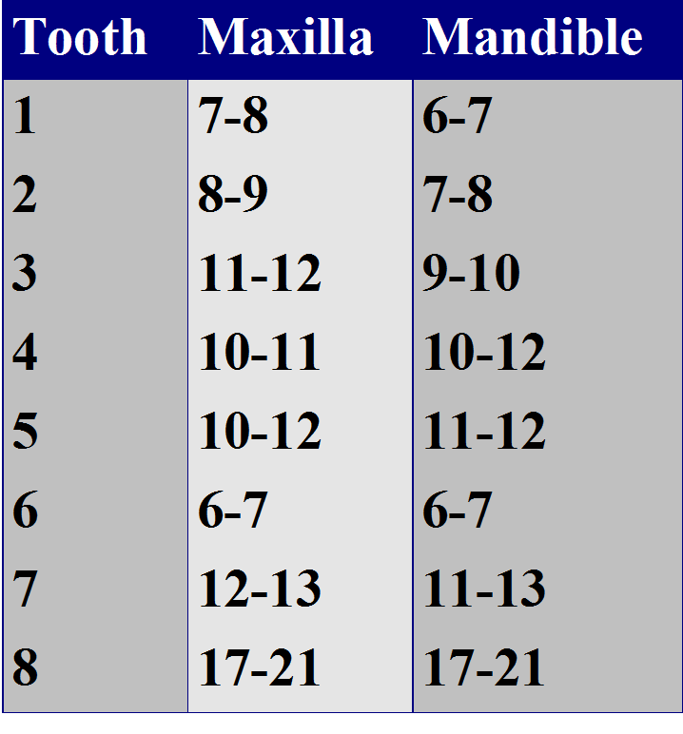

*The most likely tooth to become impacted in the upper arch is the canine and the second premolar in the lower arch; based on the eruption sequence.
What happens if the primary molars are lost prematurely?
3 aspects:
- If they are lost very early around 4-5 this will result in a considerable delay of eruption of the premolar teeth.
- If extraction occurs after the age of 5 years there is a decrease in the delay of premolar eruption; there is a delay but not as much as when we extract at 4-5 years.
- Extraction at 8, 9, and 10 years of age (before the physiologic exfoliation) will provide space for the permanent tooth and accelerate the eruption.
Variations in eruption sequence:
- Eruption timing in girls generally precedes that in boys by an average of 5 months, but this is not a rule.
- Alteration of sequence of eruption alerts the practitioner to potential problems, always count the teeth.
- No clinical significance to the eruption of incisors before first molars, if the incisors erupt before the molars that’s normal and acceptable.
- It is desirable that the mandibular canine erupts before the first and second mandibular premolars, this aids in maintaining adequate arch length and in preventing lingual tipping of the incisors.
- If the mandibular second permanent molar erupts before the second premolar, a deficiency in arch length can occur; if the 7 erupts before the 5 pushing of the 6 mesially will occur and the 5 becomes out of the line of the arch.
- Untimely loss of primary molars in the maxillary arch may allow the first permanent molars to drift and tip mesially, resulting in the permanent canine being blocked out of the arch.
Rhythm of eruption:
*Two stages:
Eruption of Incisors and first permanent molars: Early mixed dentition.
Premolars, canines and second molars: Late mixed dentition.
Third stage: third molars (full permanent dentition)
The rule of four for permanent tooth development; for every 4 years something happens:
- At birth, four first molars have initiated calcification.
- At 4 years of age, all crowns have initiated calcification.
- At 8 years of age, all crowns are complete.
- At 12 years of age, all crowns have emerged.
- At 16 years of age, all roots are complete, except for the third molars.
Crown formation completed at least 3 years before eruption
Crown is divided into 3 parts incisal/occlusal, middle, and cervical thirds, each third needs one year to complete the calcification; so 3 years in total and then another 3 years to erupt, 6 years in total.
Roots completed around 3 years after eruption and the teeth erupt when 2/3 to ¾ root development is completed.
Hard tissue formation (initiation of calcification) is important and is a considerable factor in hypoplasia
at birth 6s will start to calcify.
1 and 3 in the upper arch, 1,2,3 in the lower arch start calcification at 3-6 months of age
Upper 2s at 10-12 months of age
Upper and lower premolars and second molars at 1.5-2 years of age,
Upper and lower third molars at 7-10 years of age.
For crown completion add 3 years to the age at which initiation of calcification occurs for each tooth, 6s crown will be completed at 2.5-3 years of age, 1s,2s,4s, at 4-6 years of age, 3s,5s,7s, at 6-8 years of age, and third molars at 12-16 years of age.
Some variations and disturbances related to eruption of teeth:
- Lingual eruption of mandibular permanent incisors.
- Ankylosed primary molars.
- Eruption sequestrum.
- Ectopic eruption of 6s.
- Incisor liability.
- Leeway space.
- Late mesial shift.
1. Lingual eruption of mandibular permanent incisors:
*seen both in patients with an obvious crowding or spacing.
* Not related to crowding, it’s just related to the position of the tooth germ sometimes the germ failed to move apically and the incisors erupt lingually.
*All you have to do is reassure the parents because this is normal and can be managed:
A. if the patient is 7-8 and the primary incisors are not mobile or more than a half of the permanent incisors has been erupted then extract the primary incisors.
B. in majority of cases the primary incisors are mobile especially if the patient is around 6-7 years of age or if less than a half of the permanent has been erupted so we only reassure and observe because the primary incisors will eventually exfoliate spontaneously.
2. Ankylosed primary molars:
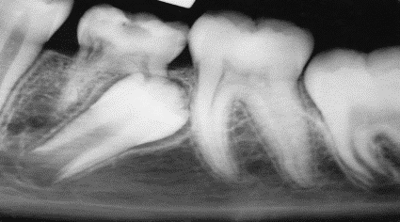
Ankyloses is the cause (pathogenesis), infraocclusion (submerged teeth) is the clinical observation.
PDL will no longer be there and the root of tooth will be fused to the bone and the tooth will be locked in place.
All the adjacent teeth will continue to grow so the tooth appears as if it sinks down.
Mandibular primary molars are the most commonly affected and the cause exactly is still unknown could be familial, sometimes they think that absence of the successor cause ankyloses but you can’t actually say that.
Ankylosis mainly diagnosed when the tooth is out of occlusion and by percussion (metallic sound).
The ankylosed tooth is not mobile even if the roots are resorbed; you notice in the x-ray that there is a break in the continuity of PDL (no PDL at all). Generally you keep the ankylosed tooth under observation the tooth may undergo exfoliation.
In majority of cases and as long as the successor is there you leave the ankylosed tooth in place and it’ll eventually exfoliate within 12-18 months so no need to interfere.
We only interfere if:
1. The tooth becomes severely subgingival.
2. If there is obvious malocclusion in the same arch or the opposing.
3. If the roots of the permanent tooth is almost complete.
When the permanent tooth is missing we consult an orthodontist and a prosthodontist because if the arch is crowded the orthodontist may need this space so we extract and put a space maintainer or we keep the tooth as a space maintainer.

3. Eruption sequestrum:
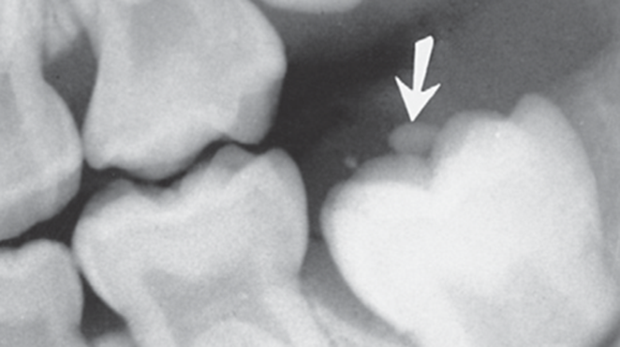
Is seen occasionally in children at the time of the eruption of the first permanent molar.
it’s a tiny spicule of nonviable bone overlying the crown of an erupting permanent molar just before or immediately after the emergence of the tips of the cusps through the oral mucosa, it develops from either osteogenic or odontogenic tissue mucosa
Some of these sequestra spontaneously resolve without noticeable symptoms.
It may easily be removed if it is causing local irritation after applying local anesthesia.
4. Ectopic eruption of first permanent molars:
* Occurs when the permanent molar becomes locked behind the distal root or the distal bulge of the E.
* There are two types of ectopic eruption—reversible and irreversible.
* in the reversible type, the molar jumps back into its normal position, it frees itself and erupts into normal alignment with the second primary molar remaining in position no need for any intervention. Most permanent molars in children with reversible patterns free themselves by 7 years of age, if delayed we start to think that it may be irreversible and needs interference.
* In the irreversible type, the maxillary first molar remains unerupted and in contact with the cervical root area of the second primary molar, and by the age of 7 and 8 years, any ectopic eruption of a permanent first molar should be considered irreversibly locked.
Prevalence is low, around 3% and it’s seen more frequently in boys than in girls and it occurs in more than one quadrant.
Most often observed in the maxilla.
Exact etiology is unknown but might be due to the lack of space in the arch or mesial angle of eruption.

Children with irreversible ectopic eruption have significantly:
A. large permanent first molars
B. more pronounced mesial angle path of eruption
C. tendency toward a shorter maxilla in relation to the cranial base.

- Irreversible ectopic molars that remain locked, if untreated, can lead to:
- Premature loss of the E with a resultant decrease in quadrant arch length and asymmetric shifting of the upper first molar toward class II positioning.
- Supraeruption of the opposing molar with distortion of the lower curve of Spee and potential occlusal interferences.

- If detected at 5 to 6 years of age, an observation approach of “watchful waiting” with appropriate monitoring is indicated, usually before 7 it’s reversible and needs no correction.

- With self-correction being unlikely approaching 7 years of age, continued “locking” of the first molar with advanced resorption of the primary second molar usually warrants intervention.

- Orthodontic elastic separators are the first choice if access is sufficient to allow insertion for engagement in the contact areas of entrapment, separating springs can also be used, metallic springs can be used. Elastic separators are easier to use.

- Brass ligature wire threaded between the contact areas of the affected teeth may facilitate distal movement of the permanent molar.

- Advanced cases (class 3 and 4) need a distalizing appliance; fixed or removable results in distal tipping of the tooth.

- If the condition is symptomatic and the pulp is involved we may need to extract.

5. Incisor liability:
Permanent incisors are larger than primary incisors, how does the body create enough room for the larger permanent incisors?
- Interdental spacing of primary incisors.
- Intercanine arch width growth.
- Labial positioning of the permanent incisors provides a larger arch.
- Favorable size ratio between the primary and permanent incisors, if primary are tiny and the permanent are large this causes a problem.

6. Arch length prediction from alignment of primary teeth:
Crowding of the primary: almost certain extraction to molars or premolars to allow the incisors to fit in the arch.
No spacing and the teeth are fit in the arch: extraction is possible.
Fair spacing: mild to moderate crowding.
Good spacing: no or mild crowding.
Excess spacing: no crowding/excess.
The more the spacing between the primary the better the alignment of the permanent.
Intercanine arch growth creates more room for the permanent incisors.
Mandibular intercanine growth occurs mostly during permanent incisor eruption.
Maxillary intercanine growth occurs during incisor eruption, and continues. This is unpredictable.
Labial positioning of the permanent incisors:
Permanent incisors are angled more labially, primary are more upright this provides larger arch space and more arch length.
Favorable size ratio between the primary and permanent incisors:
Favorable: large primary, small permanent.
Unfavorable: small primary, large permanent, this dictates a problem and the child is probably needs extraction.
Leeway space: MD width of C, D, E is more than that of 3, 4, 5. Primary molars are larger than the premolars.
Leeway space of the upper arch differs than that of the lower, 1.5 mm in the upper arch and 2.5 mm in the lower arch. This is related to final molar relationship.
Flush is preferred because it allows the 6s to drift mesially and result in class 1.
Distal step>> class 2
Mesial space>>could stay class 1 or could result in class 3.
Best occlusion in the primary teeth is flush terminal.

