Sheet no. 13 ,14,16

How to start diagnosis ?!
- Chief complain :
asking the patient about the chief complain and history of it which could be bleeding , halitosis “ bad breath “ , swollen or red gingiva , mobility of teeth , gingival recession , black triangles , sensitivity etc …
some times periodontitis is associated with dull pain but its unlikely to see a patient with pain as chief complain ..
- Medical history :
Why?1) how safe it is to treat the patient , 2) know the effects of the disease on the oral cavity , 3) to know if an oral disease will affect the overall health of the patient .. Some studies said that oral disease could have effects on cardiovascular health ,diabetes control , pregnant ladies , or if the patient was edentulous we will suspect having nutritional problems ..
high risks as prosthetic heart valves patients because it cause endocarditis so we should give the patient prophylactics before we start our perio examination
- as we know already we should ask the patient what drugs he takes ..
Social history :
“ alcohol and tobacco “
- Family history :
to know if some one of the family had a problem as teeth loss due to perio issues.
Dental history :
Asking about if the patient had perio treatment
- shows us how much the patient took care of his oral hygiene since that time .

Orthodontic treatment :
Ortho treatment sometimes affects the morphology of the soft tissues .

- Extra and intra oral examination;
In intra oral examination we look for caries , we check marginal ridges , open contacts , food impaction , pain upon percussion , fremitus ..
“ fremitus means movement of teeth during function which commonly seen in anterior teeth and could be seen in posterior teeth “
- The doctor said than when you find a mobile tooth , you should first take an x-ray , then you should check for fremitus by putting your finger on the tooth and ask the patient to bite then you do a lateral movement , if fremitus is existed you will feel the tooth moving .. this is very important because sometimes the reason behind the mobility is occlusal trauma not perio problem .
- Periodontal Examination :
visual inspection followed by periodontal probing .

- Visual inspection :
look for abnormal color ; red color , we look for swelling , recession , muco-gingival junction , plaque , calculus ..

-Gingival recession :
We have to classify it , Miller’s classification is for gingival recession ; we have miller class 1 , 2 ,3 and class 4 “
- Periodontal probing:
Probing depth : clinical measurements WHILE pocketing depth : histological measurements from the gingival margin to the most coronal part of junctional epithelium .

limitations of penetration of probe ; size of probe , the probe angulation.. The probe should slide on the surface of the tooth , we shouldn’t place it with the long axis of the tooth .
- , type of the probe, over hang restorations & subgingival calculus .
*Always remember that you have to probe under the contact ; because if you don’t do this you might miss a periodontal defect .. most of periodontal diseases start interproximally under the contact .

3) Furcation assessment :
- therapeutic challenge for the patient because its hard to clean this area & a challenge for the dentist because its hard to control the disease.
Hamp classification ; it’s the one used for furcation involvement , it has three greads “ grade 1 , 2 and 3 “
- Nabers probe : it’s the one we used for furcation areas , it’s a curved probe , with 3 mm gradings , because this classification is depending on 3 mm increments .

Grade 1 : penetration of probe up to 3 mm
Grade 2 : more than 3 mm but doesn’t pass through “ da5al la aktar mn 3 mm bs ma tele3 mn el jeha el tanyeh “
Grade 3 : passes through “ y3ni betl3 mn el jeha el tanyeh “

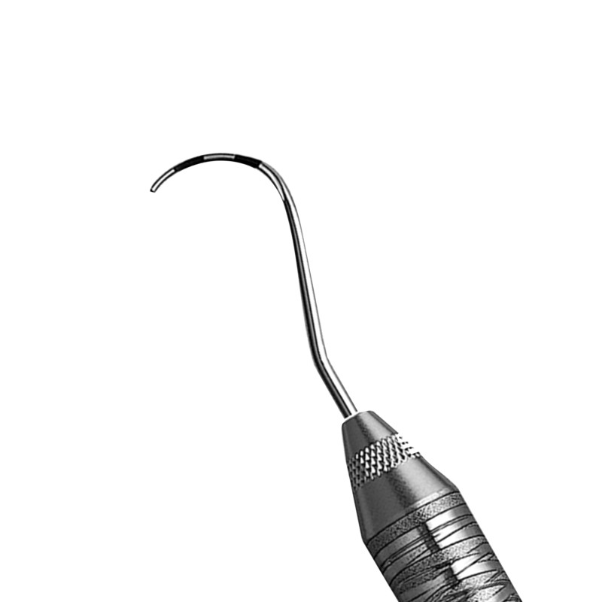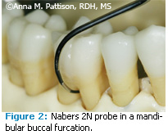

Upper molar it’s Buccal furcation from Buccal side
Mesial furcation from Palatal side
Distal furcation from Buccal or Palatal side
-Lower molar have two roots we have to examine buccal furcation and lingual furcation .

4)Mobility examination :
by the back side of dental instruments or by our fingers .
- Presence of Calculus :
use periodontal explorer or dental explorer “ cons probe “ .

6)Periodontal charting:

we measure six sides per tooth , three on the facial side and three on the lingual side , we start with probing measurements
If we have gingival recession Attachment loss = probing depth + recession
- Radiographic examination : Usually what we should do in perio is taking full mouth series , if we couldn’t get it we have to get anteriors periapicals and vertical bitewings not horizontal , plus panorama .

**At the end of this lecture the doctor said again that we have to keep in our mind the difference between gingivitis and periodontitis are three main things attachment loss ,
local factors such as plaque and calculus , and Inflammation “ bleeding and swelling “.

Note : recession due to aggressive tooth brushing is also called attachment loss but its usually only on buccal side , while periodontitis is usually seen in proximal areas .
ـــــــــــــــــــــــــــــــــــــــــــــــــــــــــــــــــــــــــــــــــــــــــــــــــــــــــــــــــــــــــــــــــ

a) alveolar bone
b)gingiva
c)periodontal ligament
d)cementum

treatment :
In perio : cause is plaque in supra gingival , calculus either supra or sub gingival >>> you have to remove them .

# in treatment :
- First phase :
We have to treat the cause and things that aggregate the cause like:
a)local factor : e.g :overhang , bad RPD , crowding .
b)systemic factor : e.g : smoking , diabetes .
- second phase : maintenance phase
( we have to do review to the pt ) .
Here we decide if I need surgery or not .
all phases have periodontal instrumentation .

scaling :
The process of removing biofilm and deposits either in crown or root , we have supra and sub gingival scaling .
#root planning :
The process of which you remove the deposits and you make sure that you have a nice smooth clean hard surface on the root . to have a new attachment and that’s the goal .
# most of instrument have a handle , shank and blade .
The working area is a blade , shank is an intermediate .

#periodontal probe : ( graduated tool )
Has a blunt end not cutting .-
- -WH probe : there is a small ball (.5mm)
#napers probe : its angulated , it has also light and dark bands (3mm) in every one of them .
#explorer : it can check the roughness .
We have different types of explorer .-
- usually sub gingival calculus is darker in color and harder , we try to dry gingiva then reflect it to see calculus but most of time you cant see sub gingival calculus , so we use the probe .
# the surface of the normal root should be smooth , for sure not the same of enamel ,but we should not feel any ledge or steps ( if any of ledge or steps were found that is either calculus or sub gingival caries ).
( caries : is a cavity on tooth ,calculus is a deposits
#chisel :for supra gingival , just push the calculus
# hook : remove sub gingival .
- all instruments are pull through , except chisel is push through .

#instrument we use in perio :
1)sickle scaler
2) curette .

1)skill scaler :
It has :-
1)pointed tip (triangular in cross section )
2)flat surface
3)two cutting edge (sharp edges both can cut )
-It uses supra gingival scaling not sub gingival , because it has 2 sharp edges (one do the work , but the other :
1) it will injure the gum .
2)pointed tip is very traumatic .
3) it is very large .
- it has different shapes … straight , curved shank <<< any thing curved use for posterior area usually to get more access because its access should be with long access of tooth ( shank with long access of tooth ) .

2)curette :
- most common used .
- most important .
- round tip .
- it is different from surgical curette .
- cross section is semi circular ( spone shape )
- the end not pointed , usually smaller in size , so can use sub gingival(the only one can be used sub gingival ).
- it can be used for sub gingival calculus , for root planning and for gingival curettage .
- new studies proved that gingival curettage is very traumatic and if we do it there is no effective result for it , so why so it !
- curette has tow types : (both of them spone shape )
a) universal :
you can use it for most sites and has tow cutting edges .

b)site specific :
- also called gracey curette
- for certain sites , means anterior teeth has specific type differ than posterior teeth .
- usually has only one cutting edge and another edge is blunt .
- has numbers indicate for a certain tooth
Plastic probe : is cutting but we use it in implant surface metal .
- we also use titanium because if I use stainless steel, it may cruch surface of implant , increase plaque accumulation .
- so we use some thing as hard as implant or softer either titanium or plastic sclaer .

-perioscope: we use it to see sub gingival calculus
-
It has a small camera , you put it inside calculus or pocket .-
You can explore a round .-

General principle : #
- your position : should in proper position , your feet should be flat on the floor , your neck should not bow more than 20 degree , other wise you will have a problem .
- Your elbow should be at the level of the pt mouth . you can move but not more than 30 degree.
- Dr. showed us a pictures of wrong and right position .
- the best position for pt usually supine postion .
- usually if you right handed you can set on the right , if you left handed you can set on the left .

: Instrument#
Your instrument should be sharp , if you clean with a dull instrument:
1)you will take more time.
2)you will take more force.
3)you will be very fatigue.
4)it wont remove calculus , it just do a burnishing .

When instrument is sharp , the cutting edge is usually a line .-
- pen grasp : the way we use to hold a probe as we hold a pen .
- modified pen grasp : instead of put middle finger underneath , you put it at the same level of instrument .
- palmed thumb :when we want to sharp instrument .

# if you want to activate instrumentation , you need to have a fulcrum area or finger rest .
Fulcrum : work as lever .-
Or (Fulcrum is the support about which a lever pivots. )
- As we be close to the fulcrum >> we need more force .
- as we be far away from fulcrum >> the lever become more easier .
- the motion always on the rest depend on the location of fulcrum .
- fulcrum can be extra oral or intraoral ( see pictures on the slide ) .
- instrument should always be with long axis of tooth , sometimes instrument can adapt on the tooth but not with long axis of tooth which is wrong .

# how to do activation of instrument ( how to remove calculus ) ?
1) adaptation :
2)when I engage the instrument , the angle must be zero or 10,20 degree .
- 16 ,18 angle are the best angle to remove calculus .
- if I increased or decrease upon this angle , we actually traumatized the tooth , or sometimes we just do burnishing and if the angle is very acute , you might cause gauging for surface .
- sometimes both ends of instrument can be used .
3) lateral pressure : once you engage instrument , you need to apply pressure against tooth ( we must hear scrubbing sounds on tooth , if you don’t do that , you don’t actually clean ) . and then pooling .
power scaler : which means it works by electricity
- there are sonic and ultrasonic .
- sonic : you can actually hear it , vibration 2500 to 7000Hz.
- ultrasonic : it is above of our hearing , it is from 18.000 to 45.000 Hz , it most faster that cant actually hear it .
- sonic and ultraconic : there is no difference in efficiency , but in furcation >> ultrasonic is better
- ultrasonic : the tip , face and back >> all are cutting .
- ultrasonic are two types :
1)magnetic
2)electrical

- contraindication of ultrasonic :
1) a pace maker with magnatic ultrasonic.
2)pts with HIV , hepatitis >> ultrasonic make aerosol , so clinic will be full of aerosol , so you need to wear glass and clean the area .
3)pt with asthma , cant tolerate H2O that come from ultrasonic.
4)dental implant .

# polishing : re orient enamel distribution , it give the pt fresh sensation . that’s the only positive feedback we have in perio ( it remove stain ) .
Non-surgical periodontal treatment periodontitis

, Emergency phase : uncontrolled medical problem /disease , dental emergency like abscesses
“cause-related therapy/nonsurgical phase”; (removing the causes of the periodontal diseases
maintenance phase , at this stage you can decide if the patient needs further treatment moving for the surgical phase or to the restorative phase then re-evaluation .

Non surgical:phase I therapy , initial therapy , cause-related therapy , etiotropic phase of therapy
The goals of None surgical therapy :
-get rid of the plaque
-gain an equilibrium between the bacterial plaque and the host response
-halt the progression of the disease
-restore health ,function and esthetics
Treatment planning for the non-surgical phase:
Non-surgical treatment steps :
1. Education & Plaque Control
2. Scaling & Root planing
3. Remove local factors
4. Treat/temporize carious lesions
5. Adjunctive aids
6. Re-evaluation

root debridement : is a new term replacing the term “root planning” which is the removal of plaque and/or calculus from the root surface without the intentional removal of tooth structure, because studies have shown that it’s not necessary to remove cementum to have healing.
-calculus is a secondary etiological factor for periodontal diseases, because it retains plaque ,
-the difference between sub-gingival calculus (harder,darker) and supra-gingival calculus (less hardness, yellow) is due to the difference of the source of minerals , crevicular fluid supplies the sub gingival calculus, and saliva supplies the supra-gingival calculus “that’s why the most common sites of calculus accumulation is beside the opening of the salivary glands’ ducts on upper molars and lower incisors”

Methods used for non-surgical root surface scaling and root planing/ debridement.
- Manual instruments
- Powered instruments :
- -piezoelectric scalers and magnetostrictive
-we use the most effective side to remove heavy calculus and the least effective sides to remove soft plaque…- the effectiveness of scaling is depending on the angleof tip(0-100), والعلاقة طرديه
-amplitude is about how much distance the tip moves which indicates the the power of each vibration/oscillation,.-water have many advantages other than reducing heat generated by the instruments , like flushing effect ,
-one of the side effects of using powered instrument is the production of aerosols which transmits microorganisms and diseases , we can minimize the effect of aerosols by 1-using good suction (high and low volume) 2- wearing masks and goggles 3- give the patient a rinse/mouthwash before treatment to reduce the microbial load
Working tips :
Use probing depths and radiographs as guides for ultrasonic activation
Use “Painting” strokes(light force)/Tapping Strokes for large deposits
Keep insert moving at all times
use light lateral pressure
Work from coronal areas apically to root surfaces
Precaution of ultrasonic
-children ( sensitive to ultrasonic scalers which causes pain for them , because their teeth have a huge pulp chamber )
-demineralized tooth surface
-hypersensitive areas ( some patients need nerve blocks for all their teeth to be able to have treatment without pain)
-veneers, crowns and implants ( If you were not careful you may break them)
Advantages of using powered instruments:
-increased efficiency ( saves time)-no need for sharpening-no need for force and pressure
-less chance of repetitive strain injuries-water lavage and irrigation-biofilm distruption
Disadvantages of using powered instruments:
- Less tactile sensation ( the main disadvantage)-more precautions and limitations
-aerosols-less visibility -potential occupational hazards ( noise and water)
Limitations of scaling and root planing:
- Meticulous and requires more experienced operator ,Time consuming,Ineffective as mono therapy in the treatment of aggressive periodontitis,Less predictable in deep pockets ,furcations and interproximal groove.
Post treatment complications :
- Pain (transient for few days ,
- Dentine hypersensitivity (transient for 2-3 weeks, -The extent of the sensitivity can be diminished through good plaque removal.
- Gingival recession.
- Mobility ( not proven),
- Which is more efficient , powered or manual instruments ?
( no difference ) , the difference is in the time required,
Why don’t we always use periodontal surgery to remove calculus since it’s more effective in removing calculus?
Because it’s very traumatic and may lead to loss of attachment more than the probable gain of attachment after healing, so we use it when the probing depth is above the critical probing depth for periodontal surgery ( 4.2mm ± 0.2)
* the critical depth for scaling and root planning is 2.9mm ± 0.4 and less than this depth root planning is traumatic.
c.laser therapy : works generally by drying tissues (dehydration and coagulation)
Advantages of laser therapy:
- It has bacteriocidal and detoxification effects.
- Can remove the epithelium lining and granulation tissue within the pocket.
- Removing plaque and calculus with extremely low mechanical stress and no formation of a smear layer on root surfaces.
- May allow access to sites that conventional mechanical instruments cannot reach.
Carbon dioxide lasers: only remove soft tissues which is not enough
Er:YAG lasers: can remove calculus, plaque and soft tissues
-there’s no evidence that laser is better than the usual scaling ,
Precautions:
-it’s not very safe since -can cause excessive heat generation > may lead to bone necrosis (if temp. goes above 47 degrees)-high cost
d.photodynamic therapy : they invented a photosensitive dye, that is injected in the sulcus and then this dye is activated by light and kills bacteria: no trauma ,no need for anesthesia or antibiotics
it can be useful as adjunctive aid after doing the usual scaling and root planning , especially in deep pockets and furcation areas.

