Perio sheet 6

Resective osseous surgery
Definitions:
- Osseous defect: is a concavity or deformity in the alverlar bone involving one or more teeth (it happened from migration of bacteria).
- Osseous surgery: is defined as recontouring and eradication of angular boney defect and crater.
- Recontouring: osteoplasty.
- Eradication: osteoctomy

When do we call bone defect as Angular boney defect?
When the resorption of bone happened interproximal area (mesial or distal).
When do we call bone defect as Crater bone defect?
When bone resorption confides to lingual and facial wall.

Morphology of bone defect
How we determine bone defect?
By 3 steps:
- Probing: we put the probe inside sulcus and we can sensate the bone defect but we can't tell that 1 or2 or3 or 4 sided.
- Radiographic Materials: by use sliver points easily bend inside the cavity so it takes the shape of the defect but still doesn’t tell about exact shape of bone defect.
- Visualization: at the time of surgery.

The classification of boney pockets based on remain number of walls:
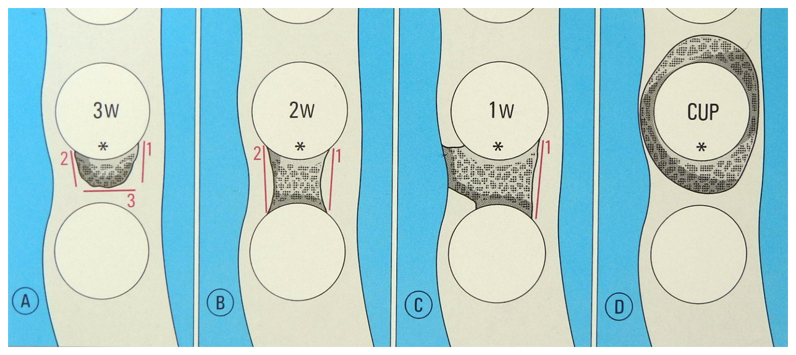
- 3 walls intact, most common defect and easily be treated. Why?
Because the walls are narrow and deep so we can regenerate bone by scaling and OHI.
- 2 walls intact, most revenant type with excellent prognosis because it is not deep If deep it needs bone graft.
- 1 wall intact, prognoses is poor.

Biological Width
Physiologic dimension of the junction epithelium and connective tissue attachment above the level of the alveolar crest.
The normal width is 1.97 mm

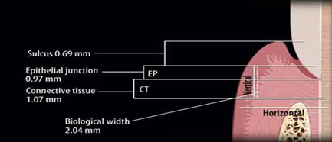

If we don’t achieve the normal relations of gingiva, we will have at end wrong healing which means wrong junctional epithelium so we end in pocket.

