Perio sheet 8

Mucogingival Surgery

What is the goal of osseous surgery? (what is primary object)
- Pocket reduction or elimination.
What the primary goal for periodontal surgery?
- Access for instrumentation.
What the goal regenerative procedure?
- Pocket redaction but in other way (by try to grow bone close defect (falling it by bone) to pocket redaction.

Mucogingival surgery:
surgical procedures for the correction of relationships between gingiva and oral mucous membranes.
Mucogingival deformities could be 3 involving attached gingiva such as:
- Recession.
- shallow vestibule.
- large frenum.
periodontal plastic surgery it’s a more encompassing term (wider):
the surgical procedures performed to correct or eliminate anatomic, developmental, or traumatic deformities of the gingival or alveolar mucosa. (not only between the gingiva and alveolar mucosa).
periodontal-prosthetic corrections such as:
- gingivectomies.
- crown lengthening.
- ridge augmentation: when there is a ridge deficiency vertically or horizontally we augment it (we enlarge it).
- esthetic surgical corrections.
- coverage of the denuded (exposed) root surface.
- Reconstruction of papillae.
- Esthetic surgical correction around implants.
- Surgical exposure of interrupted teeth for orthodontics.
What is the indication of mucogingival surgery?
- Lack of attached gingival: whether having actual gingival recession or just narrow zone of attached gingival.
- Shallow vestibule.
- Removal of frenum.

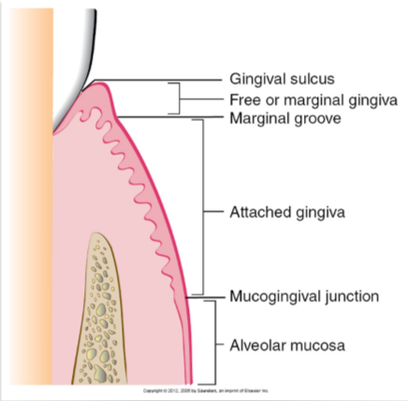

Free gingival margin (not attached): from gingival sulcus to marginal groove.
Attached gingival: from depth of marginal groove to mucogingival junction.
Attached to what?
- To cementum and bone.
How can we differentiate mucogingival junction?
- visual demarcation line between mucosa and attached gingival.
- mechanical by using cotton to push gingival and see where the fold is mucogingival.
- using stain: stain the keratin area.
the first indication is attached gingival
- Sometimes there is a very narrow zone of attached gingiva and this is seen mostly in canines and premolars.
- The widest zone of keratinized attached gingiva is usually in the upper lateral incisors.
- In the mandible, the narrow zone is found labially in canines and premolars if you go distally it become wider.
The attached gingival in maxilla wider than mandible.

why do we sometimes correct the lack of attached gingiva? Not every time.
- To facilitate good plaque control.
- To improve esthetics.
- To reduce inflammation around restored teeth.
- To have a gingival margin that binds better around teeth and implants.
(Pt having difficulty to brush in this area and it’s very tender and uncomfortable is one of indication to grafting).

Gingival Recession

When the marginal gingiva is located apical to the CEJ.
- In cases of recession the root surface must be exposed to consider it a recession.
Causes of gingival recession:
- Mechanical trauma:
- Aggressive tooth brushing.
- Iatrogenic: Aggressive finishing of class5 composite restoration by the dentist.
- Factitious: which means self-induced
Regarding Occlusal interferences or malocclusion or bruxism you should know that it's per say does Not cause recession.

- localized plaque induced lesions
Usually will be localize buccally
- generalized destructive periodontal disease
Here you will also have attachment loss proximally because periodontitis starts interproximal.

Predisposing factors
Other factors that can lead to gingival recession.
- Thin biotype associated with:
High scalloped gingival margin.
Long cylindrical teeth with triangular taper.
Very thin buccal bone
- Prominent roots
- Orthodontic therapy
- High frenal attachment

Classification of gingival recession:
Miler Classification help us in prediction of the successful of the tx of gingival recession (prognosis)

Miller 1 class | Recession does not cross the mucogingival junction & no proximal bone loss (no attachment loss), best prognosis | 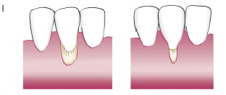
Miller class 2 | Recession goes pass the mucogingival junction & no proximal bone loss (no attachment loss), best prognosis | 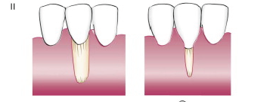
Miller class 3 | Proximal bone loss (attachment loss), But the level of proximal attachment loss is still coronal to the buccal recession. Less prognosis  Tooth are rotated also | 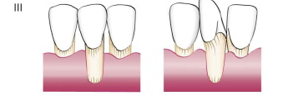
Miller class 4 | Proximal bone loss (attachment loss), But the level of proximal attachment loss is at or apical to the buccal recession. Poor prognosis | 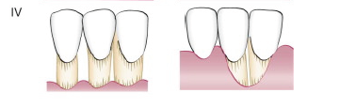

Shallow vestibule

- impede proper plaque control.
- interfere with prosthesis.

Large frenum
- Interfere with the gingival margin.
- Interfere with prosthesis.

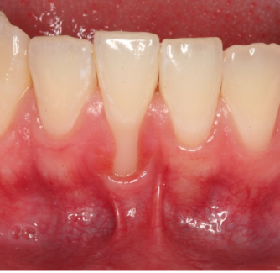

A case where the frenum attachment is on the gingival margin and this could be predisposing factor for gingival recession & may prophylactically recommend to remove it.

Now Surgical technique:
- Augmentation apical to the gingival margin:
Increases the width of keratinized gingival.
- Augment coronal to the gingival margin:
Achieves root coverage.

