PRINCIPLES OF EXAMAING AND SELECTING CANDIDATES FOR COMPLETE DENTURE TREATMENT.
prosthesis : an appliance which replaces the lost and congenitally missing tissue.
prosthetic :is the art and science of designing and fitting an artificial substitute to replace lost or missing tissue.
Dental prosthetic “prosthodontics “: fitting of appliances in the oral cavity.
“spending more time in examining and planning than doing, doing becomes much easier.”
The basic requirements for impression making1*Anatomical landmarks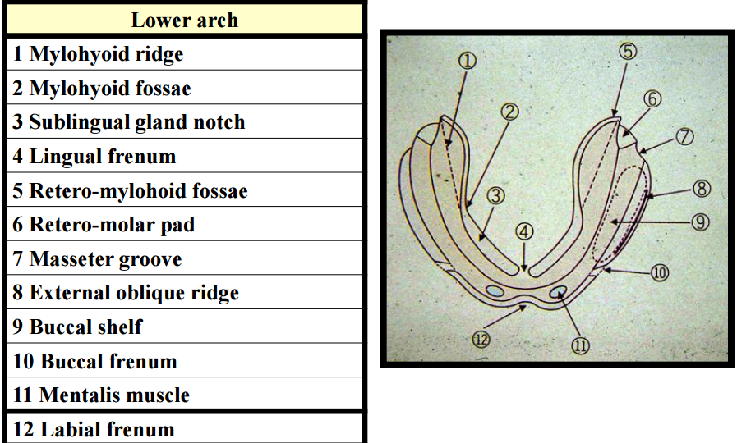
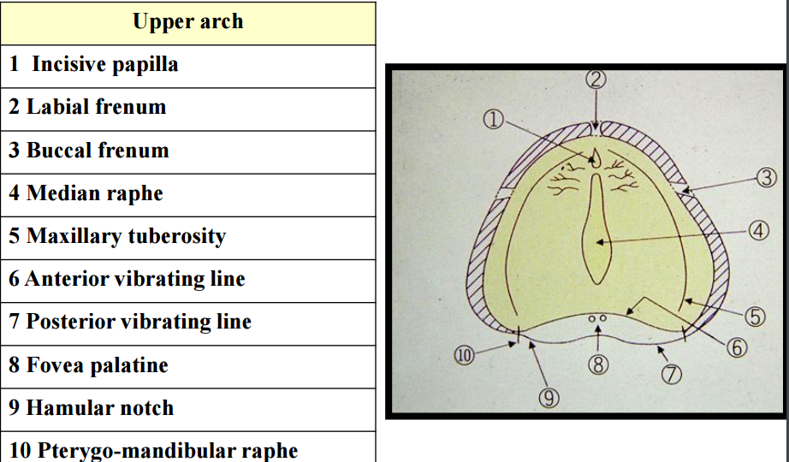
Median raphe: only bone no submucosa
Fovea palatine: opening of minor salivary glands
History taking
A. Patient’s personal details:- (name, age, gender, address, phone number )
B. Chief complains or the reason for attendance: You should write the Patient his/her own wards e.g. function, uncomfortable, loose and aesthetic.
C. Patient’s past dental history: The reason that cause the patient edentulous (caries, periodontal disease or traumatized past experience).
D. Medical history : This may affect the prosthetic patients in different ways:
I. Direct action on the oral cavity e.g. Dry mouth after radiotherapy for the treatment of oral cancer.
II. Effect of drugs: such as anti-depressed (tri-cyclic), anti-hypertensive saliva flow ↓, steroid drugs which may lead to low tolerant mucosa.
III. Systemic diseases such as: a) Anemia (sore tongue and palate)” mouth burning syndrome” Vitamin B12 & folic deficiency b) C.V Hemorrhage (Stroke) muscles and bite registration. c) Diabetes: Slow healing, prone to secondary inflection and ↑ of bone resorption. d) Epilepsy and Parkinson’s diseases (Loss of muscle coordination). e) Rheumatoid arthritis (TMJ). f) Blood diseases: may reduce the resistance of oral mucosa to trauma and oral infection.
E. Patient’s attitude toward CD: evaluate the psychological impact of wearing a complete denture on the selfconcept of individuals. wearing a denture reminds me that I’m growing older.
H. patient’s age and Occupation:- generally speaking the adaptation process of individual tends to deteriorate with increasing age.
j. patient-dentist relationship and the socioeconomic status: - They should be an empathic interaction between any therapist and patient in all kind of treatment. It is the clinician responsibility to build up such as a positive relationship → Low class people rarely concentrate on aesthetic, while the upper or high class just the opposite “level of education”.
J. patient’s psychological make-up or personality: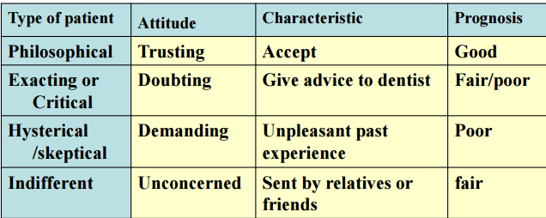
I. Extra Oral Examination.
A. Extra Oral Examination of patients:
1. Appearance and patient’s personally i.e. if the patient well groomed (smart)? Aesthetic? The psychological traits e.g. introvert extrovert, aggressive or calm.
2. Clinching or grinding habits.
3. Facial color and any obvious swelling or asymmetry.
4. Palpation of submandibular and cervical lymph nodes.
5. TMJ (clicking, pain or crepitus), any deviation during closure or Limitation on opening. 6. Skeletal base relationship (Class I, II, III)??!
B. Extra Oral Examination of existing Dentures
1. Degree of acrylic teeth wears.
2. Oral hygiene → degree of cleaning of the denture.
3. Type of denture → design and materials used in construction (flangeless denture, clear acrylic, nylon, etc).
4. To select the custom trays, size and color of acrylic teeth….etc.
II. Intra Oral Examination.
A. Visual Examination (Naked eye). B. Digital Examination. C. Radiographic Examination. D. Specific tests.
A. Visual Examination (Naked eye).
1. Color of the oral mucosa: Any variation from normal must be investigated i.e. whitish, reddish patches. It may due to:
*Mechanical causes:
a. Over-extension of the denture periphery: In new denture wearer →red line → if continue →ulcer. While in case of old denture wearer due to bone resorption in particular the lower ridge→ overgrowth (denture fissuratum).
b. Ill-fitting dentures: Continuous irritation → food debris→ bacterial growth→ calculus deposition→ denture hyperplasia.
c. Continuous wearing of an upper denture:Day and night wearing may cause chronic inflammation called (denture stomatits) in form of granular or papillary hyperplasia.
d. Faulty occlusion: Inflammation or ulcer over the crest of the alveolar ridge due to failure in recording the retruded contact Position (RCP). Or on the side of ridge due to cuspal interference.
f. Small spicules of the alveolar ridge: Due to traumatic extraction.
g. Miscellaneous: such as systemic diseases which may show an oral manifestation e.g. lichens planus, white lesions and pre-cancerous lesions
2. Size and shape of the alveolar ridge: this classification dr.nesreen asked us about it in clinics 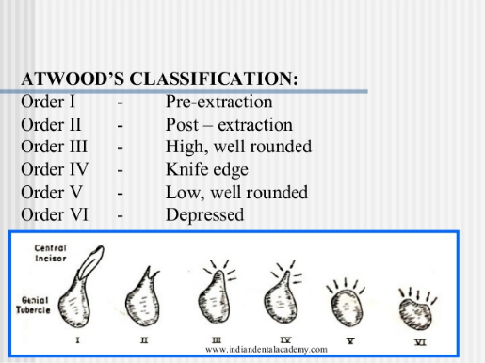

3. Shape of the hard palate: For early prognosis
4. Depth of the sulci: For peripheral seal.
5. Interference factors: Such as the size of the tongue, muscle attachments, freni and the tightness of the lips.
6. Buried roots: usually associated with inflammation and should be confirmed by X-ray.
7. Sinus tract: usually an infected area in bone either from a buried root or sequestra (X-ray).
8. Unilateral swelling: Abnormal swelling is more likely to be pathological. Bilateral bony existosis.
B) Digital examination (Palpation) Using the index finger pressure over the examined area.
1. Firmness of the ridge: Usually the alveolar ridge is firm and the normal one is composed of bone covered by a thin layer of pink mucosa. In resorbed ridge → think fibrous mucosa→ flabby ridge.
2. Irregularities of the alveolar ridge: Sharpe spikes nodules and knife-edge ridge. * Management: If painful on pressure →pre-prosthetic surgery after X-ray. If recent extraction wait for complete bone remolding (at least 3-6 months). Relief the denture at that area if not severe or contraindicated to surgery.
3. Maxillary tuberositites: Should be confirmed if it’s hard or soft one. Severe bony undercut →Surgical removal ¬ Bilateral bony undercut →Remove one side , Fibrous pendulous one →little inter arch space → Remove surgically. •
(4) Mylohyoid ridge: Relief the denture at that area if surgery is contraindicated. if Sharpe prominent → Remove surgically •
(5) Tone of facial muscles “Age”. •
(6) Tendency to retch. •
(7) Presence of Tori:
Mandibular Tori: Between 1st and 2nd premolar ,Maxillary Tori: Hard palate, single or multi-nodular.
(C) Radiographic Examination :OPG or peri-apical radiographs Ideally a panoramic radiograph should be taken routinely for every edentulous patient before starting any treatment plan to look for any: Buried roots or impacted teeth. Localized infected area, swelling. Irregular sharp ridge. (D) Specific test: Blood test, biopsy, saliva flow ……… etc.
STEPS OF COMPLETE DENTURE CONSTRUCTION
Objective of primary impression:
- to record denture bearing areas of each arch.
- To record the full depth of sulcus.
- and obtain an study model to fabricate custom try.
  - Impression materials :
      - Composition compound
      - Alginate impression
      - Combination of both “Alginate wash“
- Requirement of the stock tray:
  - rigid enough to carry the impression materials.
  - cover the whole denture bearing area
  - easily modified
  - Procedure of selection:
  - Trying one by one.
  - Using the divider.
  - Utilizing the existing denture.
- There should be enough space for the impression materials.
- If the selected tray is too small, (metal) it can be modified by pliers to widen it and it can be trimmed if plastic by burs. wax or compound can be added if it’s too short from the periphery.
- Impression Compound
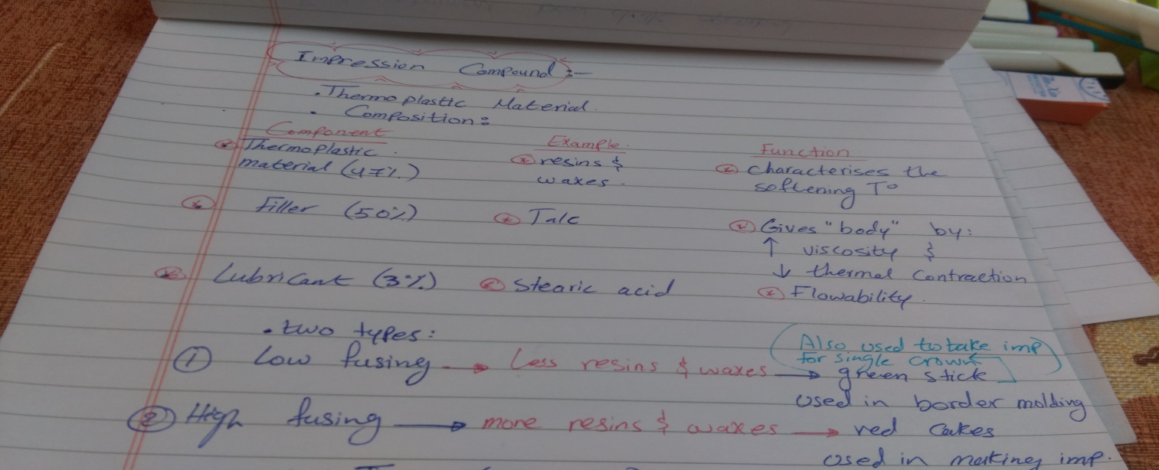
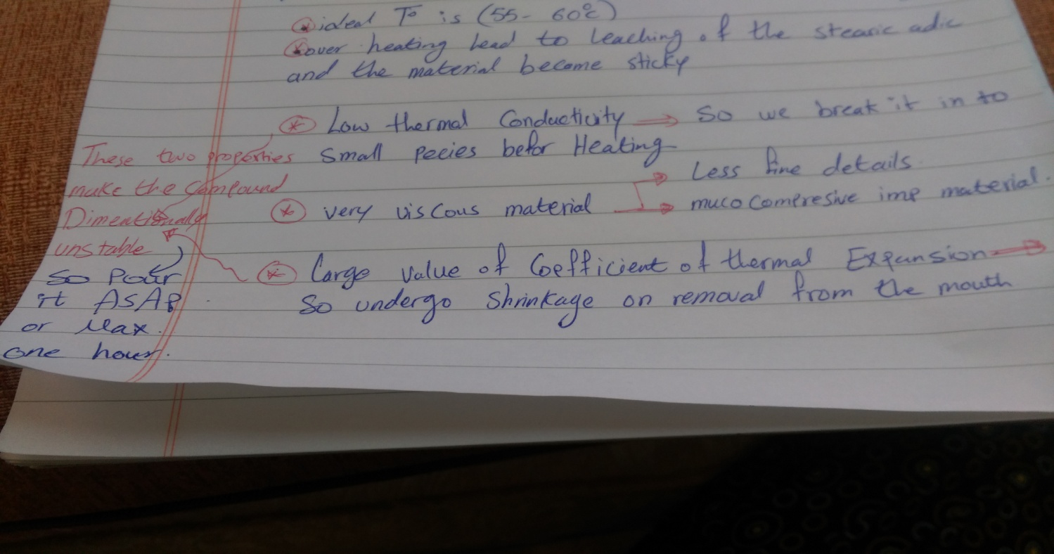
- Advantages:-
  - It can be added and re-adapted.
  - It is mucocompressive impression material.
  - It can be used with other impression material as alginate.
Dimensionally stable and poring could delayed(in comparison with other materials ex.alginate)
- Disadvantages:-
It cannot be used in presence of server undercuts.
It doses not reproduce fine surface detail
- Indications:-
  - As primary impression.
  - Mucocompressive impression.
  - It can be used to modify the stock tray if short.
other materials that can be used in primary impression:
Algenate used in case of sever undercuts.
heavy body sillicon with non-perforated tray to achieve the mucocomprensive tech.
- Algenate
- Advantages:-
  - It produce fine excellent details.
  - Dimensionally stable if poured directly.
Used in the pressure of severe undercuts
- Disadvantages:-
  - Incapable for addition.
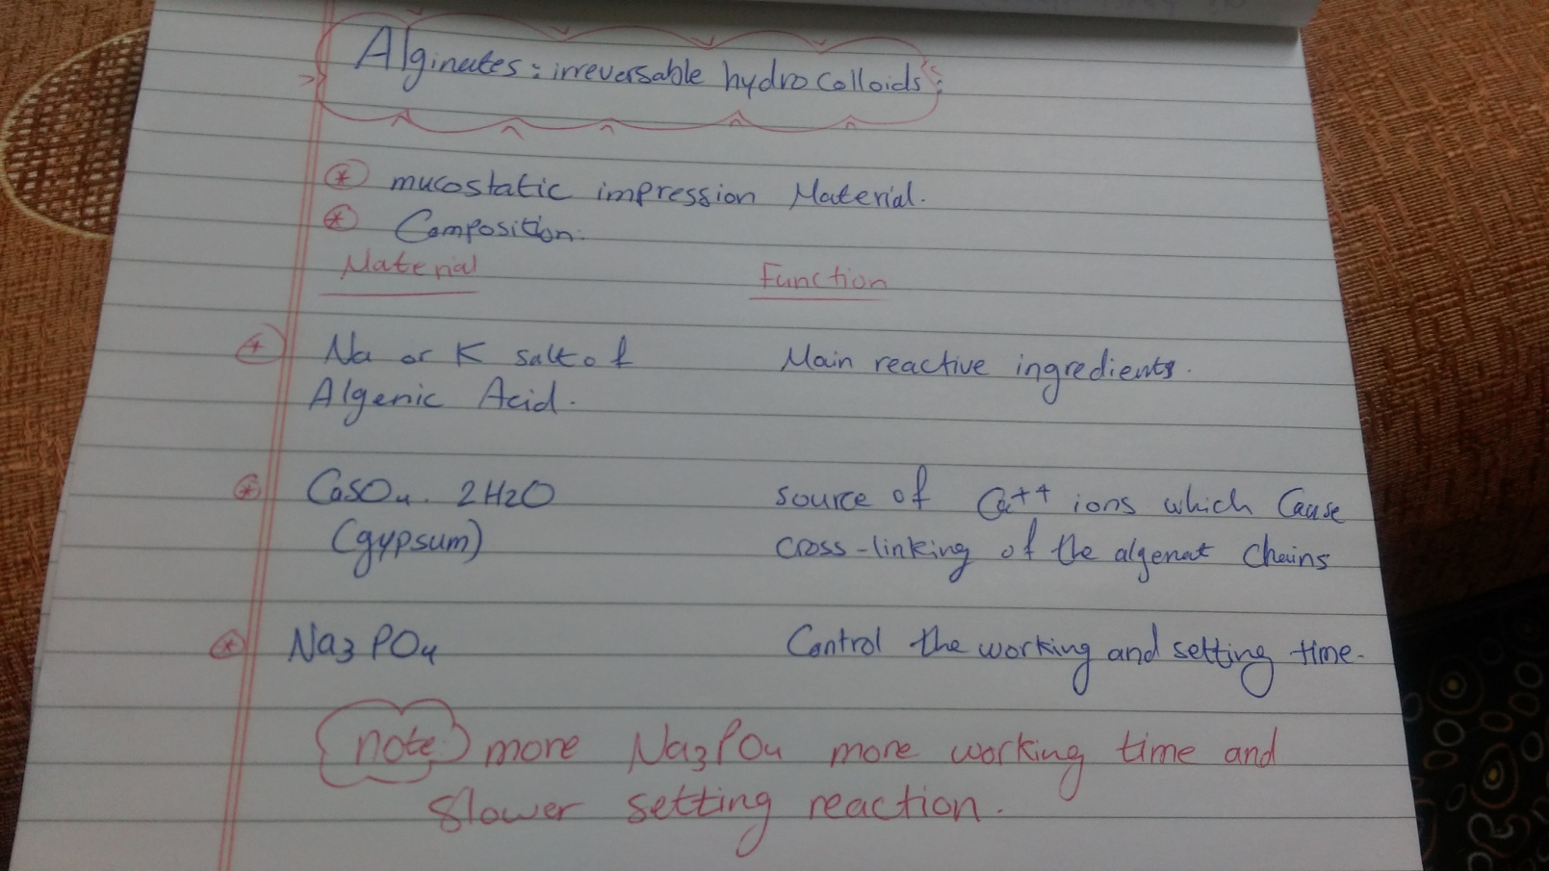
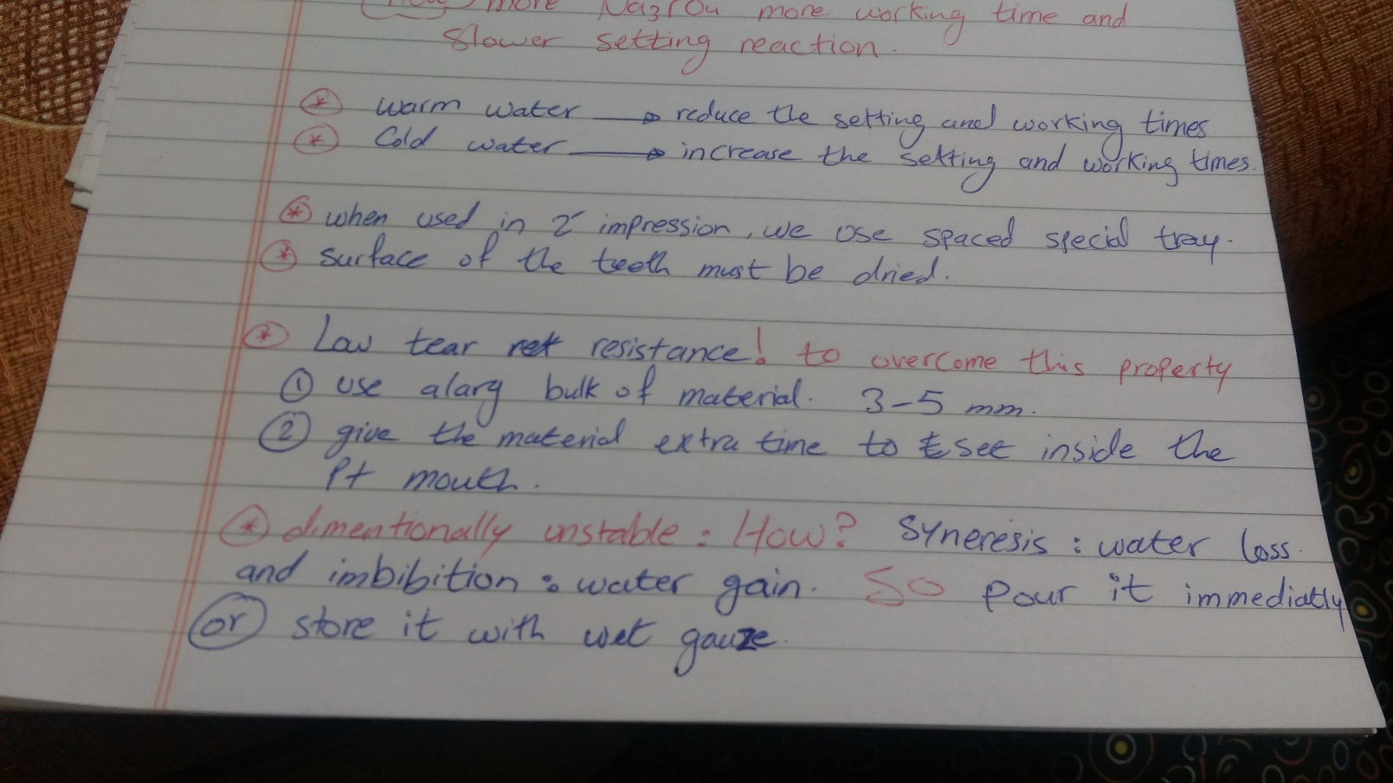

MASTER IMPRESSION FOR COMPLETE DENTURE CONSTRUCTION.
Special or individual tray
2-3 mm “shorter than the functional depth of sulci.
The lower tray should cover the middle part of the reteromolar pad to ensure good peripheral seal.
- The posterior edge of the upper tray should be trimmed by “2 mm “ posterior to the fovea palatine
Carry out whole tongue movement as following :
  - Ask the patient to lick the lower lip , if the tray moves or left from its place that means it’s overextended in lingual pouch “palatoglossus muscle comes forwards “.
  - Ask the patient to roll his/her tongue back to the soft palate, if left it is overextended from the lingual frenum.
  - Let the patient relax his/her muscles and left the lip and the check upwards to check for any over extension in the labial and the buccal side.
  - Always during these procedures try to hold the tray with slight pressure in the premolar areas.

Materials
  - Acrylic resin self or heat cure.
  - Shellac base-plate.
  - Light cure acrylic resin.
  - Night guard sheet.
Acrylic base materials
Requirements
- It should be rigid but not thick “shellac need double layers “
- Easy to construct.
- Dimensionally stable.
- Capable of modification , trimming and smoothening .
Type of special tray
  - Conventional tray .
  - Biometric tray .
Impression materials
- Zinc oxide eugenol paste “ close fit tray no spacer “.
- Impression wax “close fit tray no spacer “.
- Plaster of Paris “2 mm spacer “.
- alginate impression with performed tray adhesive “ 3-4 mm spacer “
- Elastomeric impression materials“ polysulphide and silicones” (low ,medium and heavy bodies ).
- Border molding procedure:
its importance : to record the full functional depth and width of the slcui.
the tracing should appear as “continuous , smooth , matt (not shinny ) and rounded edge “
why we ask the pt to open his mouth widely ?
to record the coronoid proceses and ptyrgomandibullar rapha
after border molding the tray must be retentive and give sucking sound.
importance of trimming of post dam area:
1- determine the posterior border of the denture
2- retentive factor for upper jaw
3- to allow excess arylic material to go there and form the post dam area
