Principles and steps of cavity preparation

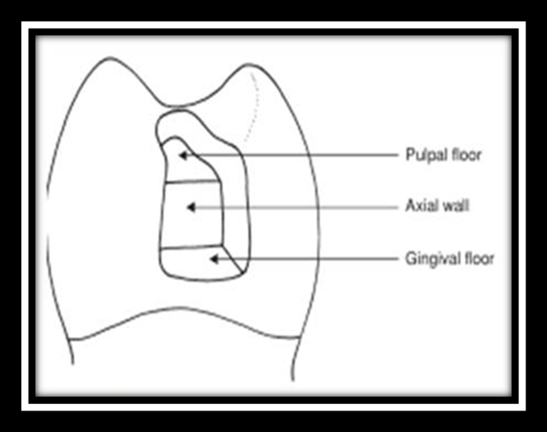

Line Angle: + the Junction of Two Walls or Wall and Floor
+They are Named According to the Walls which form them.
Point Angles: + the Junction of 3 Walls or 2 Walls and Floor
+ They are Named According to the walls which form them

Tooth Preparation that Relates to Amalgam, Gold, or Ceramic Restoration is considered Conventional preparation Need Specific Form, Depth & Marginal Form

Tooth preparation for Direct Bonded Restoration (Composite or Glass ionomer) is considered Modified Cavity Preparation Has Less Need for Specific Depth, Wall, & Marginal form

The Principle of Cavity Preparation
1- Obtain the Outline form:
A. Extend the Cavity Margin to include all the carious fissure.
B. - Extend all Margins into Sound Tooth structure
- Extend preparation until No Unsupported Enamel Remains
C. Two Separate Cavities should not be united unless the Separating Ridge is Less than 0.5mm
D. Extend the Cavity Margins to allow Sufficient Access to:
- Proper Cavity Preparation
- Proper Placement the Restoration
- Finishing Procedures
E. Extend the Gingival Margins Apically of the Contact to Provide Clearance between the gingival Margin & the Adjacent Teeth.
F. Extend the Buccal & Lingual Margins in Proximal Cavities into the Respective Embrasures to Provide Clearance between the Prepared Margins & the adjacent tooth
G. Extend the Preparation Margin to include all the Fissures that cannot be eliminated by Enameloplasty (Using flame shaped bur)

2- Obtain the Resistance form
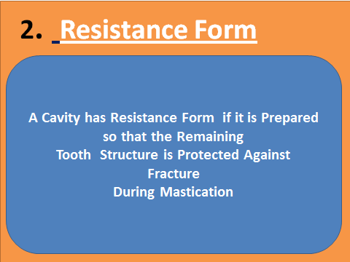
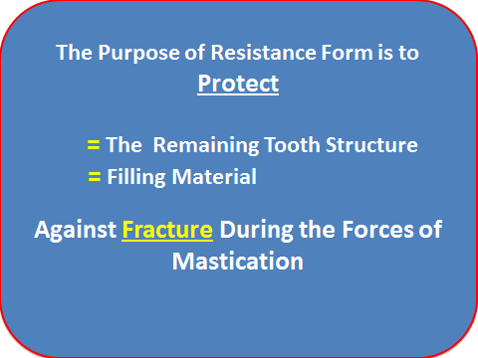
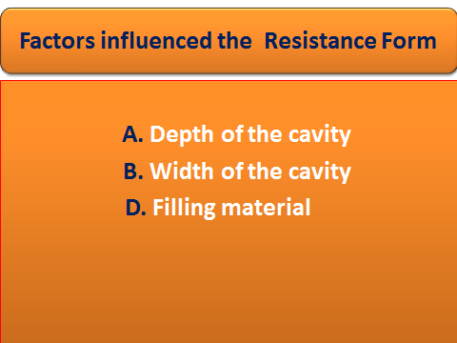
A. Flat Walls and Floors and
B. Cavity walls Meeting Cavosurface Margins at Right Angles
C. Restrict the Extension of the Cavity walls to allow Strong Cusp & Marginal ridge to Remain with sufficient Dentin Support
D. Slightly rounded internal Line Angles to Form a “box”
E. Provide Enough Thickness of Restorative Material to Prevent its Fracture under Load
*The Minimal Occlusal Thickness for Amalgam is 1.5mm to Provide Resistance to Fracture & Longevity in Relation to Occlusal wear.
*The Minimal Occlusal Thickness of Cast Gold Restoration is 1 – 2 mm Depending on the area
F. Rounded Axiopulpal Line Angle = Increase the bulk Thicknesses of Restoration, Increase the Resistance against Fracture, Increase the Retention

3- Obtain the Retention form
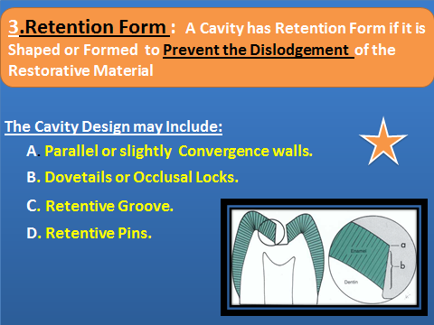
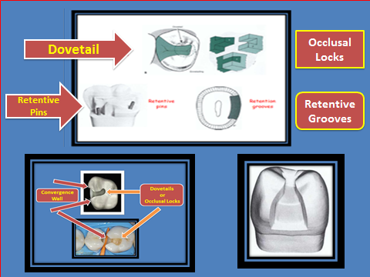

- The Retentive Grooves Prepared by Small Size Round Bur in Low Speed
*Pins: -Cemented pins - friction locked pins - self threaded pins
4- Obtain the Convenience form
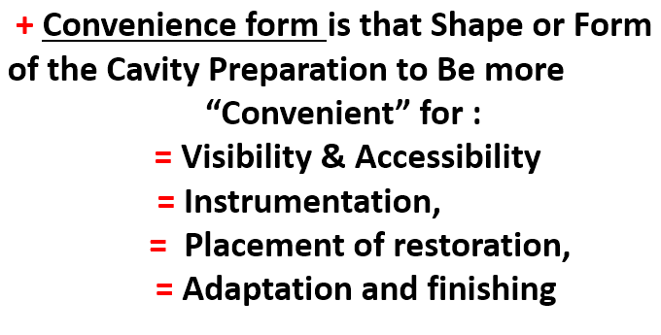

5- Remove any Remaining Caries
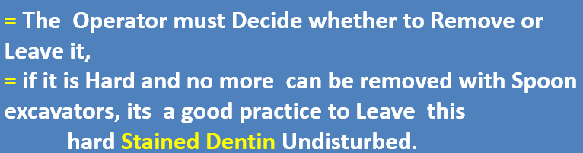
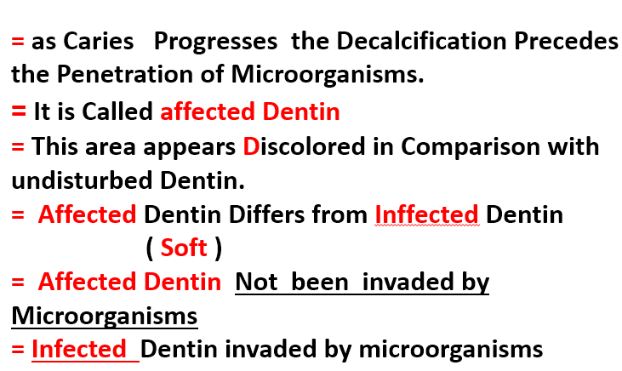
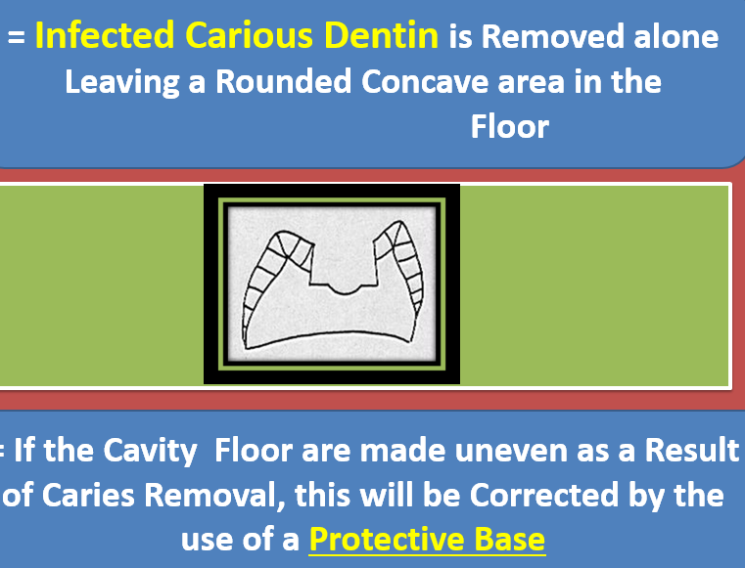

6-Finish the Cavity walls
The Purpose of Finishing Enamel walls are to get the Best Marginal Seal Possible between the Restorative Material & Tooth Structure
A- To Obtain a Smooth Marginal Junction
B- To provide maximal strength of both the enamel & restorative material at the Margin.
C- Cleanse & Medicate the Cavity

