Occlusion
-please make sure you understand this topic really well since they ask about it a lot in the VIVA.
- defined simply as the contact of teeth.
-According to this simple definition CR is not an occlusion.
Occlusion could be: 1- Static: it means the relation between teeth when the jaw is not moving.
2- Dynamic: the relation between teeth when the jaw is moving. (teeth are gliding against each other). Also called Articulation.
Some books refer to the Static occlusion as Occlusion and the Dynamic one as Articulation.
-Centric Relation: bone to bone relation.
Centric Occlusion tooth to tooth relation. (maximum intercuspation)
-coincide in 10% of people.
-Balanced occlusion (articulation): to have on both sides and antero-posteriorly contact on the teeth all the time. During jaw movement there would be contact on the right and left side, anteriorly and posteriorly.
Balanced Static Occlusion: of the patient bit on his anterior teeth and there was contact on the posterior teeth.
-In edentulous patients wearing a complete denture we call it Artificial Centric Occlusion that is coinciding with Centric Relation.
Centric Relation: is defined according to three aspects, first anatomical, second conceptual and third geometrical. Starting with the
1.anatomy: glenoid fossa has an anterior, posterior and superior areas. The condyle in CR is in the superior area. Superior area is further divided into three compartments anterior, middle and posterior. The condyle is in the anterior compartment of it when in CR.
2.Conceptual: when muscles are in the least strain position(most relaxed).
3.geometric: when the condyles ONLY rotate around the terminal hinge axis (an axis that passes through the centers of both condyles. Mandible can open 20-25mm while still in the Centric Relation.
-Perfect Arc > 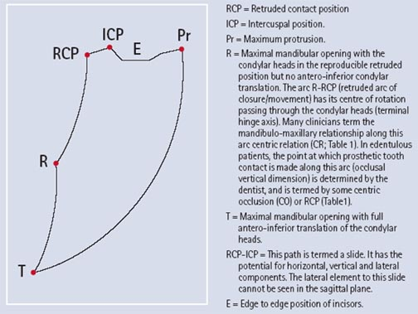
-Centric Relation is important in complete dentures because its reproducible.
-Freedom in Centric (Long Centric Occlusion) is 1mm of lateral freedom during maximum intercuspation.
This is important in complete dentures because if they were locked any movement will dislodge the denture.
-When the mandible moves we have three factors to consider: 1) muscles 2) condyles 3) teeth
-Posterior Guidance System: the Condyles.
-Anterior Guidance System: Anterior and Posterior teeth.
We have a working condyle and a non-working condyle. Working is the one I work food on; this is why it’s called working. The Working Condyle moves less than the non-working condyle.
The non-working (Orbiting condyle) travels forward, downward and medially.
-When condyles move they create angles.
1) Anterior Posterior Condylar Guidance Angle (AKA Condylar Angle): between the horizontal plane and the path created from the forward downward movement of the condyle (condylar path) ,usually its 30”-45”.
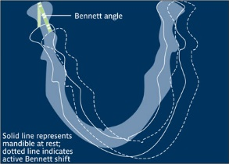
2) Benette angle AKA Mediolateral Condylar Guidance Angle : in a frontal view. Non-working Condyle moves forward downward and medially thus it is angle created between the path of movement and the sagittal plane.

anterior guidance could be
1) a Canine Guidance
2) Incisal guidance [or could be both incisal+canine which is called anterior teeth guidance]
3) a group function guidance.
-During Lateral excursions it could be canines or incisors or both(anterior teeth guidance or a group function). HOWEVER during protrusion only anterior teeth coincide mainly incisors, canines could be involved but if posterior teeth were in contact we call this an ‘interference’.
-An interference could be defined as something that interferes with the movement of the mandible.
-if I was chewing on the ‘working side’ and there was contact on the non-working side this is called a non-working side interference.
-working side interference when only one cusp on the working side is touching.
-Protrusive interference: when in protrusion posterior teeth contact each other this is an interference because during protrusion there shouldn’t be any contact posteriorly.
-In artificial teeth I need those interferences and they are called Balancing side contacts. In Complete dentures I should have contact all the time anteriorly and posteriorly. If they weren’t present the denture will dislodge.
-In natural teeth most of the occlusal loads are on the 7s. Whereas in an artificial dentition it’s on the 5,6s.
-why on 7? Because it is the closest to the masseter muscle.
-Also in an artificial dentition there will be balancing contacts on the non-working side.
‘Occlusal Schemes’
Recall:
-Retention: is the resistance of movement of the denture away from the tissues.
-Support: is the resistance of the movement of the denture towards the tissues.
-Stability: is a function of everything else. Other than the support and retention.
*Occlusion is very important in providing stability.*
We have 3 Occlusal Schemes:
a) Balanced and Non-Balanced articulation (occlusion)
b) Monoplane occlusion
c) Lingualized occlusion
-Balanced Occlusion is the minimum provided for the Complete Denture patient. There should be a harmonious simultaneous bilateral contacts when the patient is biting on centric occlusion (Artificial centric occlusion).
- Artificial centric occlusion = CR
-Christenson Phenomena: is when the patient occludes on the anterior teeth and there was a space between the posterior teeth. No balanced occlusion.
-How to overcome this phenomenon? By adjusting some factors.
-We have two compensating curves: a) Curve of Wilson b) Curve of Spee.
Curve of Wilson (Horizontal) we have 3:
1) if we are talking about the 4s both buccal cusps are touching the occlusal plane while the palatal cusps aren’t. So it’s concave downward. 2) When it comes to 5s it produces a straight line since both cusps are touching. 3) 6s however produce a convex downward line since only the ML cusps are touching
-If you want to establish a balanced articulation in a complete denture you should have minimum: 1- facebow registration 2-semiadjustable articulator 3-(couldn’t hear it)
* 5 Factors that maintain a balanced occlusion (Hanau’s Quint)
1) Condylar Guidance that you cannot change.
2) Incisor guidance (modifiable up to a limit dictated by function and esthetics)
3) Occlusal Plane (modifiable up to a limit dictated by function and esthetics)
4) Angulation of teeth (can be adjusted to a higher level)
5) Compensating Curves (can be adjusted to a higher level)
-Theilman’s Formula
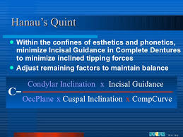
-Factors that affect the condylar guidance angle:
1) Eminence slope (superior wall of the glenoid fossa) the steeper the slope the taller the cusps that I need to use. (Tall cusps have narrow fossae whereas short cusps have wide fossae)
2) Medial wall of the glenoid fossa. Again the steeper it is the taller the cusps I must choose.

-Topic is to be continued in the next lecture.

