- Taper & convergence angle
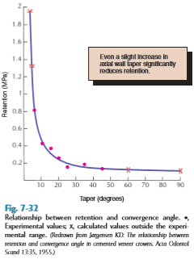The taper is defined as the convergence of 2 opposing external walls of a tooth preparation as viewed in a given plane. ]
The extension of those planes form an angle described as the angle of convergence.
Theoretically, maximum retention is obtained if a tooth preparation has parallel walls. However, it is neither desirable nor practical to prepare a tooth this way. It is nearly impossible to prepare perfectly parallel walls manually without creating undercuts, and even if you do so you are preventing the cement from escaping which will affect the crown seating; it will be high because the excess cement will get trapped under the crown. Previously, the dentists tend to make grooves buccally on each prepared tooth for the excess cement; they were called “escaping channels”. This ended in the 70’s.
The optimal taper = 3 degrees and the convergence angle = 6 degrees.
A study shows that the retention would be satisfactory in a single unit bridge when the taper increases up to 20 degrees, then it drops dramatically when the angle exceed that; as shown in the figure. But this not the case when preparing multiple units bridge as any change in the taper will affect the retention.

- Partial coverage crowns:
These are indirect restorations: they are made in the lab.
The prepared walls for indirect restorations: are divergent to allow the seating and cementation of the partial coverage crown.
The prepared walls for class II amalgam cavity: convergent to retain the amalgam.
- Three-quarter crowns:
The reason why it is not covering the whole tooth is aesthetics. For example, when restoring an upper premolar with metals they used this kind of restoration to keep the buccal enamel in order to show a natural color of the tooth when the patient smiles. In the past gold and palladium alloys predominated the partial coverage, but now with introducing ceramics, it is optional to do full or partial coverage crowns.
Indications: | Contraindications: | Advantages: | Disadvantages:
Clinical crown with average length, because if the crown is short it will not provide enough retention (less surface area --> less retention | - Short teeth, not enough retention. So we go for full coverage as it provides more retention. | - conservative | - Less retentive than complete crown.
- Intact buccal surface not in need of contour modiﬁcation and well supported by sound tooth structure for esthetic concerns. | - High caries index because we will have caries around the restoration margins | - Easy access to the margins because they are always supragingival and the assessment and modifications of the preparation is easy. | - Some display of metal.
No conflict in axial relation ex: rotated or tilted teeth | - Poor alignment ex: rotated or tilted teeth that do not allow the placement of the crown. | - Less gingival involvement. | - Limited adjustment of the restoration because any change of the shape of it will lead to loss of retention due to its limited size unlike the complete crown.
 | - Bulbous teeth. | - Vitality test is feasible.
 | .  - Thin teeth because of pulp exposure during preparation. The doctor doesn't prefer to place partial coverage for endo treated teeth. | - Easy escaping of cement and good seating.
 | Extensive destruction

Partial coverage crowns preparation for upper premolars

*Notes on preparation:
-The finish line must be supragingival.
-The lingual reduction is just like any other crown but as we come closer to the buccal side, we make a groove on each side “proximal grooves”; look at G on the fig 10-3.
- The floor of this groove should be higher than the finish line by 0.5 mm at least (fig10-10). The lingual line angle of the groove is made a sharp angle and the buccal line angle is rounded, it looks like the handle of an umbrella.
- Those grooves act as stops to aid in the insertion and with drawl of the crown, as well as increasing the retention by increasing the surface area.
- We do a bevel on the functional cusp and we do flaring of the buccal wall of each groove (fig 10.8) and we connect them with “controbevel” on edge of the buccal wall (the flaring should be continues with the buccal wall). This is done with metal restorations ex: gold, for metal burnishing, but we don’t do controbevel in ceramics.
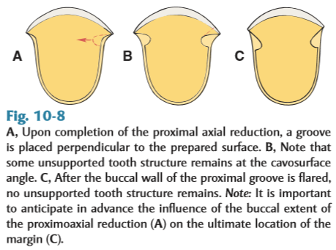
- Partial coverage crowns preparation for upper canines:
The flaring here is different than in PM; look at fig 10-29. If we extend the flaring in the canine like in PM then we will lose the contact and the restoration’s margins will show on the labial surface on the canine so we have to preserve the contact.

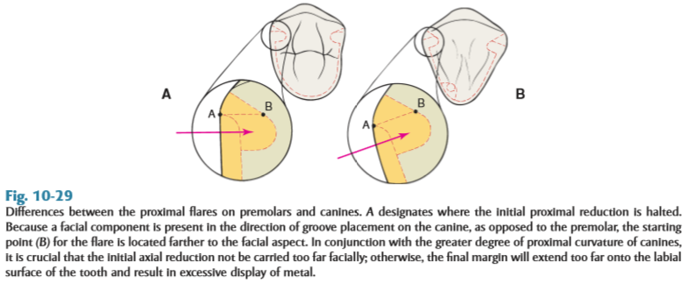

- Partial coverage crowns preparation for lower premolars:
In lower we do extension of coverage for buccal cusp tip, why? .... Because it is the functional cusp and it should be protected from the occlusal load (any occluding point should be covered). As a general rule; the joint between the tooth structure and the restoration should be free of any occluding points. By preparing in this way, the restoration will be shown from the buccal side and that’s why the doctor doesn’t prefer the 3/4 crown on lower premolar and he prefers to go for full crown. Steps of preparation are in (fig 10-20).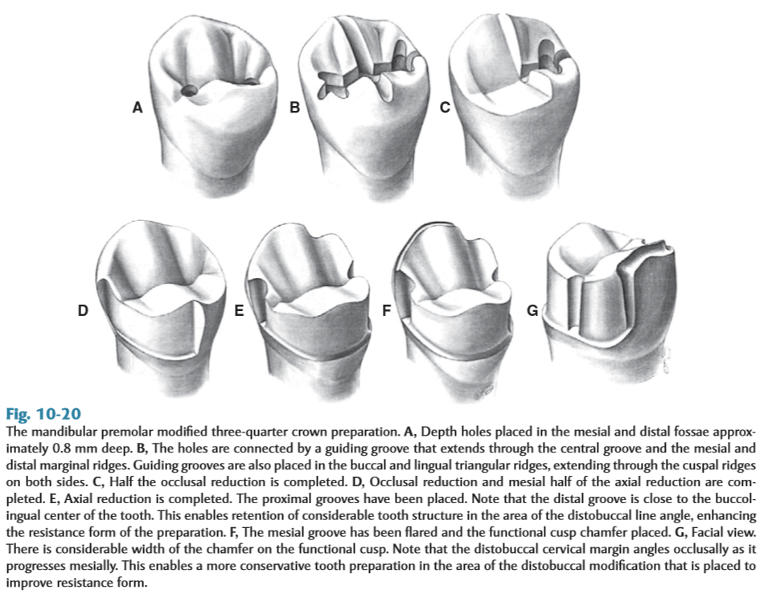
- 7/8 coverage crowns :
The only indication for this preparation is for upper molar. The disadvantage of full coverage (metal crown) is esthetic, so in 7/8 coverage we prepare the entire crown except for the MB cusp because it appears upon smiling.
- On lower molar, we don’t need to prepare 7/8, here we prepare complete coverage crown.
The steps of the preparation are the same but difference is the groove that we prepare it on the distal proximal side we prepare it here on the buccal groove, between the MB and DB cusps.
The insertion of 7/8 is very difficult.

