The University Of Jordan
Faculty of Dentistry
fourth Year
2016-2017

handout
slides
sheet
Website:
http://dentistry2018.weebly.com/
Ljneh Asnan

Dental.c2013@gmail.com

Contact Us:
Dental Correctionn

D.correction2013 @gmail.com

ABC Books – مكتبة تلاع العلــي

شارع الجامعة الأردنية – جسر كلية الزراعة
عمارة العساف – 235 داخــــل المجمّع

هاتـــف :
0797121818
06/5336475

LECTURE # : 6

DOCTOR :
NAME

DONE BY :
NAME

CORRECTED BY :
NAME

DAY & DATE :
DAY, MONTH, DATE, 2015

PRICE :

- Candida associated and other forms of Angular cheilitis:
• Bilateral erythema & fissuring at the corner of the mouth with burning sensation.
• 30% of patients with denture stomatitis, here the pt's are elderly with old denture with loss of vertical dimension then folding at the angle of the mouth with Candida infected saliva get out ,so continuous wetting of the angle of the mouth and adjacent skin with candida containing saliva.
• Some pt's do wetting of the angle of the mouth by their tip of the tongue leads to Angular cheilitis.
• May due to bacterial infection e.g. Staphylococci , Beta hemolytic streptococci .
• May due to both Candida and Bacterial cause.
• In Dr's who wear masks منطقة رطوبة, the bacteria come from the nose and infect the angle of the mouth leads to Angular cheilitis.
• seen also in Nutritional deficiencies pt e.g.: anemic pt’s.

- Chronic mucocutaneous candidosis:
• Not only seen in the oral cavity, it can affect other mucus membrane and in the skin, hear and nails. • Persistent & refractory candidal infection looks like chronic hyperplastic candidiasis.
Persistent = chronic ,, refractory = the lesion recur even after drug treatment.

Five types: (refer to our reference book for more details)
1.Familial limited type localized type.
2. Diffuse type (Candida granuloma) affect skin , organ or even the oral cavity.
3. Candidosis endocrinopathy syndrome Hypoparathyroidism, Addison’s disease, hypothyroidism, DM.
How to differentiate between m Chronic mucocutaneous candidiasis) and candidal leukoplakia?
Here the pt is Young with family history, skin & nails lesions and endocrine disease.
4. Late-onset type (Thymoma syndrome) deficiency in cell mediated immunity.
5. CMC associated with primary immuno ↓ deficiency in immune system.

Deep mycosis

• Rare fungal infections.
• Deep fungal infection.
• Cryptococcosis, Blastomycosis, Histoplasmosis, Aspergillosis.
• Nodular lesion then ulcer lesion.
• causing granulomatous infection containing the fungus that can be demonstrated using biopsy and special stains.
• Other deep fungal infections affecting respiratory tract or internal organs.

Good Luck
Hind Alabbadi

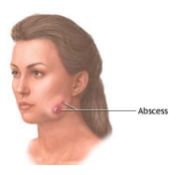
Figures
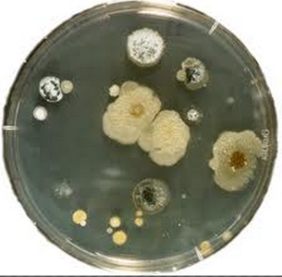
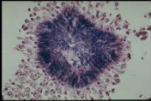

Fig3
Fig2
Fig1

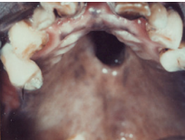
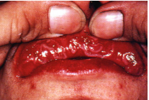
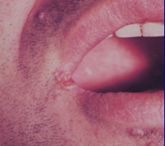

Fig6
Fig4
Fig5
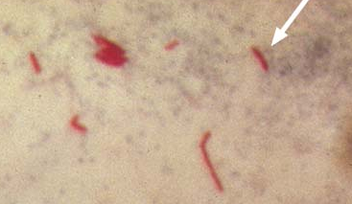
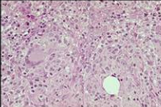
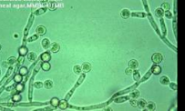

Fig9A
Fig8
Fig7

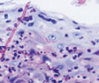
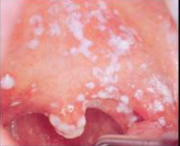
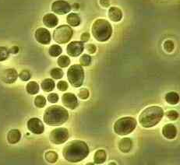

Fig10
Fig11
Fig9B

HIV and AIDS
HIV virus mainly affects lymphocytes,macrophages and certain nerve cells.It affects mainly T lymphocytes.
The normal CD4 count/mm3 = 800-1200 and T4:T8 = 2:1
In AIDS patients the CD4 count/mm3<200 and T4:T8 = 1:2
AIDS prevalence:
In our region it is still low.It occurs mainly in South Africa but in our region the prevalence is less than 0.1-0.5 %.
After exposure and getting the infection,there will be presence of antibodies against HIV virus(HIV seropositive) and then there is latency period –which can be few months up to 10 years in some patients-.During that, some features may appear such as persistent generalized lymphoadenopathy(PGL) or AIDS related complex (ARC) including fever,malaise,lymphoadenopathy and diarrhea.In the end,all patients will have full-blown AIDS which is characterized by :
#Bacterial,viral and fungal infections
#Tumors mainly Kaposi's sarcomas and lymphomas
#Neurological manifestations
AIDS is a fatal disease so HIV patients eventually will die.

Oral manifestations:
No unique condition specific to HIV disease but there are categories of lesions associated with AIDS such as:
- Candidal infections
Candidiasis is the most frequent oral lesion in HIV patients.It occurs in 20% of those seropsitive patients and 70% of those who have full-blown disease.
-persistent infection, resistant to treatment and refractory .
-not localized to oral cavity.It can appear in GIT and other mucous membranes.
-not only Candida albicans is involved,other species such as Candida tropicalis and Candida glabrata can be found.
Forms :
# thrush like on upper lip
#chronic erythematous candidiasis (red lesion on palate )
#chronic hyperplastic candidiasis(plaque-like)
So any form of candidiasis can be seen in AIDS patients and any form can be associated with angular cheilitis.
2- periodontal disease: a-Linear gingival erythema: appears as red line on marginal gingiva.
b- Necrotizing Ulcerative Gingivitis (NUG) and Necrotizing Ulcerative Periodontitis.
So periodontal diseases in AIDS patients are more destructive compared with normal patients.
4-Hairy Leukoplakia
It is called hairy because it is a white lesion with hair-like projections. It appears on the lateral border of tongue not on the dorsum of tongue.
Note: do not mix it with hairy tongue that develops on dorsum of tongue.
-usually bilateral
-not always hairy; sometimes it can be flat white lesion
-not restricted to the lateral border of tongue; it can be found in other sites such as buccal mucosa.
-precursor of AIDS; when hairy leukoplakia is seen in a HIV patient it is a bad sign as it indicates that CD4 count is very low and the patient will develop full blown AIDS soon.
Question: Does HL affect mucosal sites other than the mouth?
Is HL specific to HIV patients or not?
No, it can appear in other categories of patients.
What is the differential diagnosis?
**Traumatic Keratosis: as the lateral border of tongue is a common site for this lesion.
**Leukoplakia
**Squamous Cell carcinoma
**lichen planus
Histologically, how to confirm the diagnosis of hairy leukoplakia?
Traumatic keratosis | leukoplakia | Lichen planus | Squamous cell carcinoma
Hyperkeratosis, hyperplasia and inflammation of lamina propria | Hyperkeratosis, hyperplasia, ± dysplasia | Parakeratosis, damage of basal cell region and inflammation of lamina propria (band-like) | Invasion of lamina propria
But Hairy Leukoplakia appears histollogically as:
a-Hyperparakeratosis,acanthosis and the surface might have hair-like projections.
B-koilocyte-like cells in upper part of basal cells which are features of viral infection appear as small nuclei with large cytoplasm.
Note: koilocyte-like cells is a feature in HPV infection too.
Do we expect to see inflammation in lamina propria?
No, because HIV virus damages the cell-mediate immunity.
Also, in the epithelial cells we can see the causative organism (EBV) and can see secondary infection with candida; invading the cells as a result of reduced immunity.
Question: what is the source of EBV virus? Is it from another patient or the patient himself?
Why HL affects the lateral border of tongue in specific? Why not the dorsum of tongue, floor of mouth or buccal mucosa?
Special stain (in situ hybridization) by looking for RNA of the virus reveals the presence of virus in upper parts of epithelium (EBV). PAS stain reveals candidal invasion of the superficial part of epithelium; it is a secondary infection not part of the etiology).
5-Kaposi's sarcoma:
It is the most common malignancy of AIDS patients (25% of patients).
It was found in the past in Africa in an endemic form but with good prognosis (not fatal).
But in HIV it is a common tumor. It affects mainly males (M:F=20:1)
-more in whites and homosexuals.
-affect skin and mucous membranes including the oral cavity.
-can be multiple; affects many sites in the skin.
-Painless
-the nose is the most common area in head and neck to be affected.
-color is red, brown or violet.
-it starts as macules then nodules then ulceration and destruction of the region.
-in oral cavity, most commonly affects the maxilla; palate and maxillary gingiva
Differential diagnosis:
kissing lesion, erythroplakia, vascular malformation, hematoma and hemangioma, and SCC.
Histologically,how to confirm diagnosis?
In early stages, it looks like pyogenic granuloma so we see proliferation of endothelium,extravasated RBC's ,hemosiderin,inflammation and spindle-shape cells.So it maybe misdiagnosed with pyogenic granuloma or hemangioma.
In late satges,mainly composed of spindle-shape cells and abnormally-shaped vascular spaces.
How to confirm? It is difficult to diagnose and you have to do immunohistochemistry for the Human Herpes Virus-8 which is associated with Kaposi's sarcoma .
6-Non-Hodgkin lymphoma:
The second most common tumor in AIDS patients,mainly in maxilla (upper palate and gingiva)
Features:
features of malignancy >>lesion causing mass and destruction to the adjacent structures.
-mainly B-cell lymphoma and associated with EBV.
Lesions less commonly associated with HIV infection :
1-atypical ulceration:
ulcers refractory to treatment,resemble major aphthous ulcers.It can be present in the oropharynx causing problems to the patient.
It is caused by mycobacterium o CMV or herpes virus or other microorganisms.
2-idiopathic thrombocytopenia purpura:
bleeding spots in the oral cavity and any trauma can cause heavy bleeding.
3-salivary gland disorders:
-chronic porotitis
-Sjogren's like syndrome (enlargement of parotid gland with xerostomia)
-parotid lymphoepithelial cysts.
4-viral infections such as:
- recurrent severe herpes simplex and herpes zoster
-CMV and HPV infection which appears as warts in oral cavity.
Lesions possibly associated with HIV infection :
-bacterial infection other than NUG :syphilis and TB
-fungal infection other than candida :deep mycosis.
-melanotic hyperpigmentation :appears as a result of drugs taken by AIDS patients or because of damage of adrenal gland which leads to pigmentations like Addison's disease.
-neurological manifestions(sensory or motor) such as facial paralysis.
Oral Ulceration :
a-infective
b-traumatic
c-associated with systemic disease or a sign of undiagnosed systemic disease such as:
-hematological deficiencies;anemias
-GIT disease
-Bechcet's disease
-HIV
d-associated with a dermatological disease:
-lichen planus
-chronic discoid lupus
-vesiculobullous disease: autoimmune disease.
e-neoplastic: SCC
f-idiopathic ; Aphthous Recurrent Stomatitis.
.

