Sheet 11-13
Cleft lip and palate
It's the most common craniofacial anomaly
Clefts of the lip are more common in males, clefts of the palate are more common in females, and cleft lip and palate is equal between males and females, with
Unilateral cleft lip is more common on the left side -Incidence shows racial differences: Far east > Caucasian >

stage of primary palate development is between 4-6 weeks (problems during this time leads to cleft lip and/or anterior palate
stage of secondary palate development is between 6-8 weeks (failure of fusion, or any problem in elevation of the palatal shelves during development leads to cleft palate
upper lip forms by the fusion of medial nasal process, lateral nasal process and the maxillary process on both sides.
. -submucous cleft is a variant of CLP not involving soft tissue, only the bone, which makes it difficult to diagnose
Etiology
most recent reviews shows that it's multi-factorial were genetics and environment interact.
# genetics: it has a strong family history but it's not a simple mandelian inheritance pattern; mode of inheritance is not completely understood. mutations in chromosome number 6 are thought to cause CLP.
#enviromental factors: • nutritional deficiencies (most common) mainly folic acid and Iron
• radiation • drugs • hypoxia • viruses (EBV) • vitamin deficiencies
Consequences of CLP:
1-feeding problem
2-speech problem the most difficult to fix (The right time to correct the defect is before 2 years old )
3-hearing problems mostly due to ear infections and middle ear fluid accumulation. This will further complicate speech problems.
4-esthetic problem
5- psychological consequences
6-Dental problems: (least imp to worry about
>>hypodontia ( most common, specially on the side of the cleft) lateral incisors are the one most commonly missing, then the centrals
>>microdontia
>>impaction mainly the permanent first molar, also the canines get impacted due to absence of bone >>hyperdontia
The main cause of maxillary deficiency is early surgery to fix the CLP. It would lead to healing by secondary intention and scar tissue formation, also binding of the maxilla to the pterygoid processes, this will prevent the downward forward growth of the maxilla. patients will have: >Anterior and posterior cross-bites (very common) > class 3 incisal relationship (due to maxillary deficiency) > also teeth will tend to tilt towards the area of the cleft

Oslo Team protocol
Management sequence
- at birth > records are taken, social counseling and trained nurse to treat the mother how to feed her child
- 2- from 2 weeks - 3months > closure of cleft lip (lip repair) its usually not done at birth due to high risk of bleeding, since liver function is not complete. Yet, we can give medications to decrease bleeding and do the surgery at birth. Its recommended to be done as early as possible to assure the parent, mostly before 6 months.
- 18-24 months > closure of palatal cleft as late as possible to decrease impact on maxillary growth but before 2 yrs old for speech not to be affected
- 4- 7-8 years > slight orthodontic alignment of rotated incisors and incisal crossbites can be done before the placement of bone grafts, but mainly comprehensive orthodontic treatment is done after grafting
5- 8-11 years old > Secondary operations like Alveolar bone graft are done, if needed. They must be done before canine eruption to provide them with bone to erupt. So, ABG help retain the integrity of dental arch, they are important for teeth eruption and they help supporting the ala-nasal process 6- Early teenage years >> comprehensive orthodontic treatment must asses if orthodontic treatment is enough to correct the crossbites- if mild- or future surgery is needed-if severe. 7- After 18 years old >> orthognathic surgery, if needed, to regain correct arches relation. (maxillary osteotomy, or setting back the mandible
Record taking mainly done by orthodontist:
*at birth- before lip surgery
*3 years- after palatal surgery
*5-6 years -before mixed dentition
*10 years-at time of ABG and before ortho
*18 years-orthoganthic surgery (satisfaction of patient is recorded after surgery, when all treatment is done

Orthognathic surgery:
Definition:
- Orthognathic surgery: Correction of skeletal problems and facial deformities through combined surgical and orthodontic approaches.
- Very few cases that are treated by surgery only without orthodontic treatment (like genioplasty).
Indications:
1- Moderate to severe skeletal discrepancies in any dimensions:
- A-P dimension: moderate and severe class III patients are usually better to be treated with surgery rather than orthodontic treatment alone. Unlike moderate class II and mild class III which can be managed by orthodontic treatment alone with good results (Camouflage). - Vertical dimension: Skeletal open bite and skeletal deep bite. - Transverse dimension: Skeletally narrow maxilla.
2- Craniofacial anomalies: cleft lip and palate.
* Timing: - If we want to do growth modifications we do it during the growth spurt (class III earlier).
- The opposite is the orthognathic surgery, we usually wait until the growth is completed, after puberty.
- In some cases which are progressive and if we don't intervene the case will get worse we can do the surgery before it's time, like:
1- TMJ ankylosis cases: due to trauma to the condyle, so the growth stops on one side and this results in asymmetry. 2- Severe psychological distress: You have to warn the patient and tell him that I can treat you but the result can be unstable. The patient has to sign an informed consent that he understands the treatment.
* Aims: 1- Esthetics (dental and facial). 2- Functional (occlusion with a table result). 3- Health (preserve or improve the oral health like skeletal deep bite with traumatic over bite).

Diagnosis

1- Patient interview.
- Chief complain: a- Esthetics: most of the patients. b- Function: old and male patients. c- Combination.
*** body dysmorphic disorder: - Known psychological disorder.
- The patient has a little problem that might not be noticed by the rest of us but he sees it as a big problem and sometimes it can be part of his imagination.

2- Clinical examination.
-More thorough and comprehensive. - There are soft wares that can help us for a quick examination.
3- Special investigations. :
- Photographs
- Study models.
- Radiographs:
- Whatever is indicated:
1- Cephalometric. 2- Posterior anterior (P-A): Asymmetry.
3- OPG: To see unerupted teeth).
4- Periapicals and bitewings.
d- Other special investigations:
- Cone beam: It is ideal because the low radiation in comparison with CT scan and 3D image.
- Bone scanning: For patients with abnormal condyle growth (technetium isotopes to see the hot areas that indicate active growth areas in the condyle).

When we plan we depend on:
1- The clinical measurements.
2- Cephalometric predictions help us, It can be: a- manual. b- Digital with special soft wares: where we put the image and superimpose it on the tracing, the soft wares do correction and show us the end result. It is not a 100% accurate method but it gives us an idea about the end result.
3- Model surgery:
- It is a way of predicting the final occlusal result after the treatment with models "occlusal records".
We make the model, then we simulate the movement that we will do in the surgery on the articulator and put the models in the final result and do the wafer in this position.
- If it is a bimaxillary surgery (for both jaws) usually we need a semi adjustable articulator, If it is a one jaw surgery we need a simple hinge articulator.
4- 3D scanning, cone beam: different movements show the end result.
Wafers:
- Cold cure (can be made from heat cure).
- In functional appliance we design it in edge to edge position here we make the wafer accurately on the final result, we put the models on the articulator in the final position after the surgery and make the wafer s1plint.
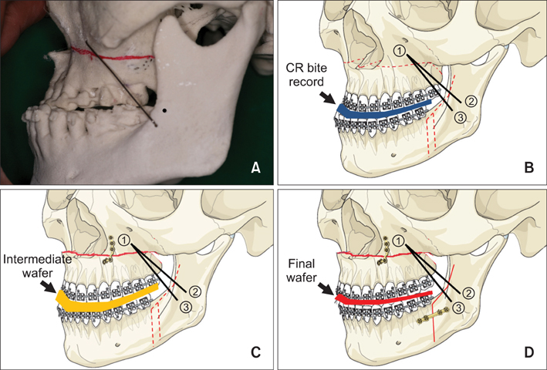
- Why do we do wafer??? 1- It helps the surgeon to position the jaw exactly. 2- We leave it for a period after the surgery as it helps in stability (the patient bites on it to adapt to the new position).
- If we want to do one jaw surgery we do a single wafer.

Role of orthodontist:
- Pre-surgical (before the surgery).
- Post-surgical (after the surgery). 3- Retention (After taking the braces off).
1- Pre-surgical:
- Examination, diagnosis, and treatment planning.
- Four Pre-surgical aims:
a- Relief crowding.
b- Align and level the arches.
D-Decompensation.
C- Arch coordination.
a- Relief crowding:
- Extraction: The extraction pattern is different than extraction for camouflage (we will talk about it in decompensation).
b- Align and level:
- Fixed appliances (stainless steel not ceramic because ceramic is brittle). - We want to correct the teeth in the vertical plane and incisors level.
c- Decompensation:
- We remove any compensation ( A-P, vertical, transverse).
- Skeletally class II (division I and II), due to compensation the upper incisors are retroclined so we procline them, the lower incisors are proclined so we retrocline them.

- Skeletally class III due to compensation the upper incisors are proclined so we retrocline them, the lower incisors are retroclined so we procline them.
- If there is no enough space we go for extraction. As we said the extraction pattern is different, for example class III we don't extract the lower 4s, we extract the upper 4s because we want to do decompensation and retrocline the upper incisors so by extracting the upper 4s we provide space for retroclining the upper incisors. If there should be extraction in the lower arch we extract the lower 5s.

Why do we remove the compensation???
- We want to move the jaws to a position near the normal one, if there is any compensation it will prevent jaw movement.
- We move the teeth until they reach the position in the normal angles (109 degrees upper incisors with maxillary plane, 93 degrees lower incisors with mandibular plane) like if there is no compensation.
- Example: class III patients the upper incisors are proclined, reversed overjet (overjet -1 mm), if we move the jaw in the surgery we move it 2-3mm only to get a normal overjet. If we remove the compensation there will be enough movement to move the jaws to their normal position. Compensation interferes with the positioning of the jaws to the normal position.
d- Arch coordination:
- Arch shape and width are planned so that it doesn't interfere with the surgery.
- As you remember in functional appliances if there is a skeletal class II patient when we posture the mandible forward the wider part of the mandible will occlude with the narrow part of the maxilla and this results in crossbite, so we put expansion screws in the functional appliance like twin block.
- It is the same in the surgery, class II problems when we move the lower jaw forward this will result in a crossbite so we might choose to expand the upper arch pre-surgical

2- Post-surgical:
- Usually the patient comes back after a month from the surgery.
- Usually we use elastics to finalize the treatment (finishing step).
- This step should not take more than six months.
- We don't remove the braces during the surgery because they help in wafer fixation (They have a role before, during and after the surgery)

Surgical procedures:
* Single jaw surgery:
- Maxillary procedures :
1- Le fort 1 "most common in the maxilla". 2- Le fort 2. 3- Le fort 3. 4- Segmental procedures.
- Mandibular procedures : 1- Sagital split osteotomy. 2- Genioplasty. * 1+2 the most common in the mandible. 3- Sub-sigmoid. 4- Body osteotomy. 5- Sub-apical osteotomy
Fixation after the surgery:
- In the past they used to place stainless steel wires “inter-maxillary fixation” for 6 weeks (the mouth should be closed during this period), the patient used to be on soft diet, uses straw to drink.
- In 90s the rigid fixation started “titanium plates with screws”.
- Advantages: 1- it is more comfortable to the patient and he doesn’t heve to close his mouth for 6 weeks and eat soft diet and use straws for drinking. 2- Earlier function for the patient.
- Sometimes we may use the wires again in cases when something called “splat” happens (something wrong or a complication goes in the surgery or the split is not done in a proper way), but in general it is much less us

Relapse:
- It is the same as the one happens in conventional orthodontic treatment.
- In some cases it may be serious that the patient goes back to her/his situation before the surgery.
- There are many factors to justify the relapse:
1- Surgeon's factors:
- Poor planning:
- Also the size of the movement:
- The direction and path of movement:

- Maxillary impaction “up” is the most stable one.
- The maxillary expansion is the least stable, because of cheek collapse.
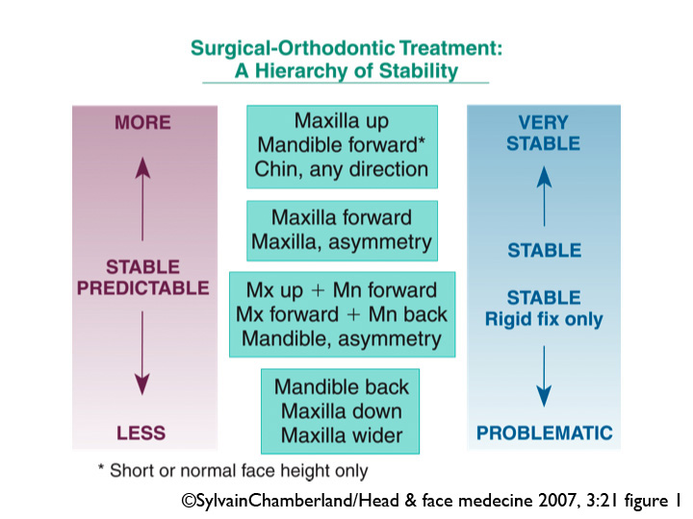
d- Inadequate fixation.
2- Orthodontist's factors:
a - Also poor planning.
b- Size of the movement: moving teeth beyond their biological limit tends to relapse
c- Direction and path of the movement: - Extrusion is usually not stable. - Also certain habits may affect the stability.
3- Patient's factors:
a- Patient cooperation is very important.
b- Certain anomali

Benefits and Risks of Orthodontic treatment.
- Benefits
Proposed benefits:
- Function : mastication and speech.
Mastication; malocclusion very rarely causes a problem in mastication
In terms of speech; the patients usually adapts to malocclusion very easily, the only things that are a bit difficult to adapt to are; AOB, lip trap, Severe class III, and cross bite.
2-Dental health : Improving TMJ problems- Impacted teeth -Caries/Periodontal disease -Trauma
3-Esthetics
3-Psychological well-being.

- Why are we concerned with crossbite?
1-May cause TMJ problem: by dispalcemnt/altering the mandibular movement.
- Causes attrition;
- posturing the mandible sideways so it may cause the mandible to grow on one side resulting in facial asymmetry.
- In Mixed dentition if patient is displacing to one side either to the right, left or forward the teeth will erupt in the new position

- Risks
Intraoral risks:
- Crown damage:
Enamel trauma - Decalcification(WSL)
- Root damage:
Pulp damage - Soft tissue damage - Root resorption

White spot lesions(WSL)
- 50% of all patients will have at least one WSL at the end of the treatment.
- They looked at caries risk and they found that the overall incidence of caries didn’t increase between people who have braces and those who don’t have braces however caries risk moved from posterior teeth to anterior teeth and from interproximal to smooth surface?
- Most affected are upper canines and lateral incisors, lower canines and premolars.
Prevention of WSL:
- Proper patient selection
- Patients’ education.
- Topical fluoride MW, varnish, bonding agent
- Tooth mousse(MI paste CPP-ACP)
- Reduce excess composite around the bracket to reduce areas of bacterial stagnation.

Treatment:
- Small lesions will resolve spontaneously by remineralization from calcium and phosphate found in saliva.
- LOW concentration of topical fluoride: Why low? What happens is that WSL is not just a surface lesion but also its inside the enamel so if you use a high conc. fluoride the outer surface will get calcified/ hard without the calcification of the subsurface so low conc. will cause calcification from the inside to out.
- Tooth mousse.
- Tooth whitening
- Acid/pumice microabrasion
If cavitated; restorative intervention

Root resorption
- It only happens due to iatrogenic dentistry
Expected root resorption is 2mm in maxilla and 1 mm in mandible
- It happens in incisors> canines. Worst is U2>U1>U3>L3>L1>L2.
- Rarely compromises the longevity of the teeth.
Risk factors:
- Blunt/pipette/single rooted teeth.
- 2-History of trauma
- Treatment mechanics:
-Fixed > removable appliance
-Rectangular arch wires
-The distance that the tooth will move,
-High forces
-Intrusion
- Treating an impacted canine might cause resorption to the lateral incisor.
- 5-Duration of treatment

Bacterial endocarditis(systemic risks):
Patients with prosthetic valves are at high risk since some of the appliances do manipulation to the gingiva and also trauma can be caused by some part of the appliance

