EVA SYSTEM
- Most efficient and least traumatic instruments for correcting overhangs or overcontoured proximal alloy or resin
- These files are made of Aluminum in the shape of a wedge protruding from a shaft.
- Reciprocating handpiece.

*** What are the conditions you give antibiotics for?
If there was a spread for any disease gives antibiotics
Indications:
1) Aggressive periodontitis
2) Severe generalized chronic gingivitis
3) Necrotizing gingivitis if there were systemic signs such as fever and malaise
However if we had a fistula we don’t give antibiotics cause fistula means that there is already drainage
4) Uncontrolled diabetes or immune compromised

*** Features of the Ideal antibiotic:
- Selective to the targeted microbe.
- Doesn’t have side effects.
- Safe.
- Doesn’t induce resistance.
- Able to stay in the body for a good amount of time to eliminate the condition. 6.Cheap.
**** a combination therapy is better regarding periodontal issues
The best combination is :
Metronidazole + amoxicillin covers a good spectrum and less resistance and gives better attachment gain.
*** Why not just antibiotic?
Because the effect will be temporary, because the cause of the disease would still be there, so the effect would be short term, so you should always do your procedures along with antibiotics once needed

*** the American academy of periodontics did a guide line says: if for instance you did a scaling and root planning for a tooth and the pocket depth was 5 mm or more , and it's still bleeding this might be an indication for a local antibiotic especially if it was in a localized area , like 2 pockets so why to give systemic .
We only give systemic if it were generalized or for instance we had one quadrant full of pockets.

One of the used localized antibiotics is tetracyclic fibers , these fibers contain tetracycline you put them in the pocket. The problem is these fibers are non resorbable their existence causes local factors such as inhibition of attachment so they are no longer available
So they came up with doxycycline gel concentraton of 10% (atridox ) so they discovered that when putting a gel into the pocket , it gave the same results but resistance occurred unlike tetracyclic fibers that had no resistance.
Metronidazole a viscous material that hardens once it sets in the tissue , it reacts with the tissue , concentration is 25% applied once weekly for 6 weeks
The problem with all those local antibiotics is the multiple follow ups with the patient , the resistance , and most importantly is it really coast effective

*** local antibiotics vs. systemic antibiotics, which is better?
Systemic side effects are worse
However generalized are cheaper and less follow ups and better in generalized conditions
Localized however has higher concentration in the targeted tissue (better), so it’s a matter of balance
*** in severe cases you can give 400 mg of metronidozole , if the patient is allergic then give ciprofloxacin instead of amoxicillin

Now let's talk about Host Modulation Therapy (HMT)

Diseases are driven by both the bacteria and the body, so why don’t we manipulate the body?
The concept behind this is to try to control the defence mechanism of the body.
For instance we know that prostaglandins, interleukins...etc control inflammation and the drugs that inhibit it such as ibuprophen cause peptic ulcer so you can’t use the drug all the time to control the inflammation cascade.
Bisphosphonate for instance stays in the bone for a long time and reduce osteoclast (this drug is given for osteoporosis)
They discovered that tetracycline inhibits osteoclast but the problem is you can't give an antibiotic for a life time, so they made a drug called sub antimicrobial doxycycline, it doesn’t have any antimicrobial effect it just down regulates MMPs
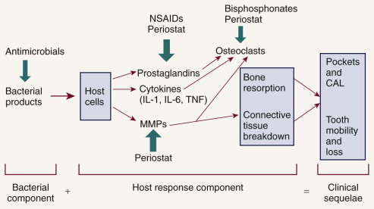

Orthodontics can aid in perio, for instance in crowding teeth or tilted molar, if you upright it, it will solve the problem, diastema also once closed will decrease the inflammation in the gingiva.

reevaluation
in re evaluation we see :
Less plaque
Less pocket depth
Bleeding is less
When to refer your case ?
More than 5 mm pocket ( cause when a pocket is that deep it means the crest of bone is about 7 mm apical to the cementoenamel junction, therefore only about half the bony support for the tooth remains.

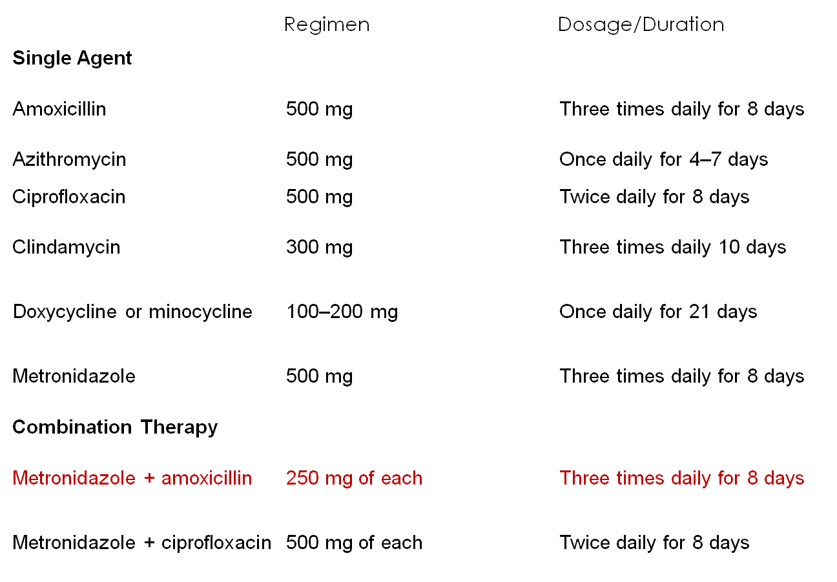
TABLE 47-2 -- Common Antibiotic Regimens Used to Treat Periodontal Diseases*
Systemic antibiotics

Periodontics sheet 18
Antimicrobials consists of antiseptics and antibacterial agents (antibiotics), but antiseptics (eg. Mouthwash) are a separate entity which they are commonly known as disinfectant (such as lozenges).
There is no substitute for a toothbrush. Antiseptics and antibiotics are not a substitute for a high standard oral hygiene. There are specific indications for using antiseptics and for prescribing antibiotics.
Evaluation of antimicrobial agents: there are some properties of good antiseptic and antimicrobial agents.
- Specificity:
- Efficacy: The antimicrobial agent selected must be effective against
- Substantivity
Aims of anti-plaque agents: we have certain goals in manufacturing antiseptic and antimicrobial agent:
- Should inhibit microbial colonization of the tooth surface and subsequent development of plaque.
- Should eliminate plaque already present by dissolution or alteration to form less pathogenic plaque
- Should inhibit the calcification of the plaque to form calculus

*** We have two types of mouthwashes nowadays: The first one gets adsorbed after rinsing 10 ml of this mouthwash for 30 seconds, and gives us an effect of 12 hours once we spit it (the only mouthwash that have this property). And that’s why we prescribe it twice daily, in the morning and at night before bed time.
Other mouthwashes have a transient effect which means that there will be no effect at all once we spit it.
*** Some are of insufficient concentration to kill bacteria and if their concentration is increased they damage epithelial cells
***Mouthwashes are only of use on supragingival plaque and therefore for preventing and controlling gingivitis in risk patients. Antiseptic agents are not indicated for daily use and are used only with risk patients. Risk patients means that no matter how much they brush their teeth, there will be areas having plaque and are risk of a disease.
Risk patients: post surgery, handicapped, mucosal conditions "erosive/ulcerative" and prior to ultrasonic scaling

Enzyme preparations: preparations of antiseptic agents as mouthwashes:
- First generation compounds.
a) Antibiotics like amoxicillin, but nowadays they use the amoxicillin in combination with something else to make it more effective
b) Phenols are weak antiseptics
c) QUACS (quaternary ammonium compounds)
d) Sanguinarine: Not used anymore.
1st generation compounds reduces the plaque scores by 20-50%.
2) Second generation compounds.
a) Bisguanides eg. Chlorohexidine gluconate.
Some common examples:
1) Phenol based preparations:
Listerine: Same as slides.
2)Quacs: Same as slides.
3)Bisguanides: Same as slides.

Chlorohexidine Data:
Poor systemic absorption means for example if someone drank by accident 10 ml with a concentration of 2%, it does not cause harm at all.
*IT IS THE MOST EFFECTIVE ANTI-PLAQUE AGENT TO DATE..
*IT BINDS TO ACIDIC PROTEIN GROUPS EG: PHOSPHATE SULFATE, DICARBOXYLATE.

* THE CXD ADSORBS TO EPITHELIUM AND TOOTH SURFACES, IT MAY ALSO BIND TO BACTERIAL CAPSULES

*THERE SHOULD BE 1\2 Hr BETWEEN BOTH, RINSING AND BRUSHING. EITHER OF THEM FIRST. TO AVOID THE ANTAGONISM BETWEEN THE CATIONIC AND ANIONIC EFFECTS.
*The min conc. of CXD required to be effective as a plaque inhibitor is 0.12%,0.2%. Both are true.
*The min time for CXD that it should be kept in the oral cavity during rinsing (for the effective plaque control) is 30 sec, 30 secs of 10 ml.
The unwanted effect of CXD:
-the CXD gives us stains as if the patient was a smoker (dark stains) but doctors still prescribe it because its advantages outweighs its disadvantages so we prescribe it for 2 WEEKS ONLY not for lifetime and we should tell the patient that there'll be staining and it'll be REVERSIBLE.
- It leads to DESQUAMATIVE GINGIVITIS which is a type of HYPERSENSITIVITY to CXD (gluconate)
- Altered taste sensation to salty tastes is a short term complication only.
NOTE: the maximum time for the use of this drug is 2 WEEKS.
- Reports of parotid gland swelling are rare and easily reversible

Preferred Drugs:

- TETRACYCLINE : It's one of the best drugs ever found, The dose of the Tetracycline is 250mg 3 times per day
- METRONIDAZOLE (FLAGYL) : IT'S NOT AN ANTIBIOTIC! It's a synthetic drug
we use it extensively for
A) DESQUAMATION. B)ACUTE NECROTIZING ULCERATIVE GINGIVITIS C)PERICORONITIS D)ACUTE CONDITION.
*It's not allowed to be used with ALCOHOL.
*It's not allowed to be used with WARFARIN.
The Dose: We as PERIODONTISTS we give 500mg 3 times daily, this is the adult dose, the dose depends mainly on the weight and age of the patient, the sex is not usually related unless the lady is pregnant.
Pediatrics; 125mg or 62.5 mg, 250mg, 500mg.

- AUGMENTIN : Amoxicillin(250)+Clavulanic acid(125) a dose of 375mg (250+125), the dose of 625mg is given twice or trice daily

Periodontics sheet19
Furcation invasion (FI)
FI can be seen radiographically if it’s advanced enough “grade 1 is not”, i.e. there is enough bone loss. FI can be on molars and maxillary premolars “mostly the first”. Maxillary molars have three furcations “mesial, distal, and buccal”.
Etiology:
It is dental plaque, FI is a part of the periodontal problem bit it affects a tooth that has furcation.
There are factors that make furcations more susceptible to have bone loss:
1-anatomic factors
2-developmental anomalies
3-age “gradual attachment loss is a part of the aging process”
4-local factors “like: overhangs”
Most commonly affected furcation is the distal of maxillary first molar
In diagnosing FI there are aspects that need to be found which are:
1- There is actual FI
2- Level of attachment
3- The shape of the bone defect
***To detect FI Naber’s probe is used “it’s graded for every 3mm, because the level of classification that’s used changes every 3mm”
***FI means that the probe must go horizontally under the roof of the furcation.
***The degree of FI should be measured from the entrance of the furcation “not from the gingival margin”
***Another way to examine FI, is radiographical, but the FI should be verified clinically
***There is periodontitis if all of the following are present
1-proximal attachment loss
2-local factors
3-bleeding on probing””
*** In FI there is attachment loss
***Anatomic factors that affect the susceptibility of a tooth to get FI: “in periodontitis patients”
1- root trunk length “shorter means more susceptible”
2- root length
3- root morphology
4-entrance of furcation: about 80% of furcation entrances is smaller than 1mm which makes it smaller than the instruments tip, and this makes cleaning it more difficult, so modified instruments or ultra sonic tips should be used.
5-radicular grooves on the root surface from the furcation site “especially on mandibular molar” which makes is therapeutic challenge because these areas must be cleaned also.
6-cervical enamel projection: extension of enamel covering the root surface and extending on the root trunk and in most of cases it reaches the entrance of the furcation and in some of them it actually go inside the furcation area.
Hamp classification is the classification that’s used for FI and it measures the horizontal bone loss, so it gives us an idea about the shape of the bone defect. On the other hand, Tarnow and Fletcher classification doesn’t only measure the horizontal bone loss it also measures vertical bone loss.
Hamp classification
Class 1 less than 3 mm horizontal invasion in to the furcation
Class2 more than 3mm invasion but not through and through
Class3 through and through invasion
Treatment:
1- root instrumentation
2-facilitate maintenance
3-prevent attachment loss and stabilize the disease
4-obliteration of furcation defect, by bone regeneration
Non surgical therapy:
1-Oral hygiene: OH in the area of FI is challenging, there are several aids that makes it easier like; Perio aid ,proxa brush, rubber tips.
2-scaling and root planning: effective in class1 and accessible class 2, “accessible means that the furcation is not in the proximal area”.
Ultrasonic instrumentation is more effective in FI treatment than hand instruments.
Surgical therapy:
1-Osseous resection.
2-Regenerative surgery
3-Root resection
4-Extraction
5-Dental implants

Sheet #20
Gingival Enlargement
What causes “Gingival Enlargement"?
Gingivitis , abcess , Drugs (that cause enlargement), tumors (fibroma, papilloma, pyogenic granuloma, …. Localized enlargement) or false enlargement
another name Gingival over growth, and in the past it called generalized hyperplasia -
It's either generalized or localized.usually it can be marginal, papillary, diffused, or it can be discrete (an isolated lesion) like tumors

***Normally the gingival is pink, firm, the size is within normal limits, scalloped contour, feathere-dged. While in inflamed gingiva you can see edema, the contour is obscured, no featheredge anymore.
- Inflammatory enlargement:
the most common cause of enlargement is inflammation not drugs , (basically the chronic one), it can be acute or chronic{the most common}

*** sometimes other types of enlargement can be combined with inflammatory, especially if there was swelling and plaque control was difficult so eventually we’ll get inflammation so the enlargement get even worse and even larger and this is called combined enlargement.
Histological section:
It’s an inflammatory lesion so you expect to see many chronic inflammatory cells infiltrate, (occupying most of the connective tissue), 2) the connective tissues is quite thickened, 3) the entire epithelium is quite thick.
Mouth Breathing
is unique feature for special kinds of chronic inflammation that causes enlargement,
- Usually it is red, erythematous with shiny surface, and limited (localized) to the area that is exposed to air (Maxillary anterior area) ,, especially in patients with incompetent lips.
- There is a mouth breathing line that separates the inflamed from the non inflamed area (exposed from non exposed).

- Drug Induced gingival enlargement

- Associated with some anticonvulsants; phenytoin (epilepsy patients), immunosuppressive agents; cyclosporine, calcium-channel blockers (for hypertensive patients).
Few facts that you need to know:
- It can happen in mouths with little or no plaque, and may be absent in mouths with heavy plaque so there are no ground rules here.
- Inflammation is it a prerequisite of enlargement? Maybe, some say that there are some fibroblasts that are sensitive to phenytoin if there is inflammation, if there is no inflammation we won’t get this kind of response (Fibroblasts are less active). and this is maybe because of genetic predisposition and usually when it is surgically removed, it recurs. So the best solution is to substitute the drug with another, and see the outcome after 6 months.
Treatment?!
Maintenance of Oral hygiene , it well reduce the inflammation, then try to change the drug, it will go back to normal within few months, if the physician didn’t accept to change it , we do surgery – gingivectomy procedure
- Genetic (HEREDITARY) or idiopathic gingival overgrowth

- Mostly in young age, teensgers. sometimes you find brothers having the same problem. High recurrence rate. GE associated with Tuberous sclerosis: triad of epilepsy, mental deficiency and cutaneous angiofibromas
plaque may be an initiating factor.

- ASSOCIATED WITH SYSTEMIC DISEASES or CONDITIONS( less common)

It caused by either: plaque with factors that magnified the symptoms(hormones, nutritional deficiency, allergies..etc) or with other things that you have nothing to do with as leukemia

- Enlargement Influenced by the following factors:
  - Hormonal, like in pregnancy ( has more sever inflammation , redness and swelling ) and puberty,, ( so the plaque is the initiator but not the cause of the severe inflammation)=> called conditioned
  - Nutritional
  - Allergic
Pregnancy Most common in the 3rd trimester

Clinical features:
It might be
- Marginal gingivitis: ( the most common ) up to70% of pregnant women have severe gingivitis, (bright red or magenta, soft, friable, easily bleeds).
- May be generalized.
- Tumor like enlargements (pregnancy tumours) ,, it is not a real malignant tumor , it is a granuloma

**The pregnancy tumor occurs usually during the first trimester, it’s dark red bcuz it’s vascular lesion, so bleeding is a problem, Enlargement is more common interproximal , in interdental areas and it gets flattened bcuz of the cheek, (grows laterally). it can be either sessile or pedunculated, , it’s a mushroom like flat lesion. it’s usually painless and not invasive ( do not degrade the bone ),, Again this is not specific to this case.

When u treat it?
You have to be conservative in treatment, don't do any surgeries, always start with prevention; oral hygiene, scaling and polishing, try not to let the gingiva grow,
Tell the patient to wait until birth, if the patient can’t tolerate it, excise it.
Puberty; enlargement in puberty happens in both females and males.
Enlargement in Vit C deficiency , Rare, Scurvy, swelling and marginal inflammation.
Allergic , plasma cell gingivitis( not really a swelling ) maybe due to a tooth paste allergy and it is not limited to interdental and marginal gingive , it affect the whole gingival and not related to plaque accumulation , , or desquamated gingivitis.

Systemic diseases that cause gingival enlargement ( as mentioned not related mainly to plaque )

*Leukemia
*Granulomatous diseases:
such as crohn's disease , TB , sarcoidosis
- Wegener’s granulomatosis:
necrotizing fascitits,
Oral features: ulcers, enlargement, tooth mobility, exfoliation and delayed
healing response.
- Sarcoidosis

- Neoplastic enlargement (gingival tumours)

Either 1) benign tumors it can be fibroma , papilloma , giant cell granuloma , gingival cyst

Or 2) malignant
- Carcinoma
- Malignant melanoma.
Take a biopsy to know

- False Enlargements

Manegemnt :
- Chronic Inflammatory:
- OHI, Scaling and root planing
2-Surgical removal
- Leukemic:
  - You have to be Conservative to not cause a lot of bleeding
  - Antibiotics ( prophylactic ) before and 48 after (give a 3 days course of antibiotics 1 day before and 2 days after treatment (since they have a high risk of infections & bleeding)

- Pregnancy:
- prevention/early removal of local irritants
- Gingivitis: Scaling and RP
- Timing: after the delivery, lesions should be removed surgically only if interferes with function or aesthetics
- Treatment of gingival disease should be done as early as possible.
- Periodic dental visits
- Full exam and radiographs after delivery.

- Puberty:
- Be Conservative , don't give antibiotic even if it sever inflammation

- Drug induced

- OHI
- CHX (chlorohexidine) rinses, to decrease plaque load, cause it’s really hard to go underneath
- SCRP , (scaling and root planning).
- Possible drug substitution
- Professional recalls , need to be seen a lot
- If persists and ivolve the bone Surgical removal (Gingivectomy or flap procedures depending on area involved, presence of osseous defects and limited keratinised gingiva.
- Maintenance, the most important step is because there is a high risk of relapse, especially if the patient got lazy, it will surprise you how fast it grows back.

