The periodontal flaps :
Periodontal Flap is a section of gingiva and/or mucosa, surgically separated from the underlying tissues to provide visibility of and access to bone and root surfaces, such as those associated with deep pockets or furcations.
Objectives of surgical procedures :
- Improvement of the prognosis of teeth and their replacements .> We can access the area and debrided it and remove the infected tissue , if there is bone resorption , we can fill it back again >> to improve prognosis . ( so rather than extraction ,we try to keep tooth)
- Improvement of esthetics.
- The surgical phase consists of various techniques that can be used for the pocket therapy and for the correction of related morphologic problems, namely mucogingival defects.
Goals of the flap procedures :the things that I want to achieve after the surgery
- To expose root surfaces that are not accessible, such as those associated with deep pockets or furcations, in order to improve the efficiency of scaling and root planing.
- The surgical reduction or elimination of the periodontal pocket (resective pocket surgery).
- The induction of adaptation and new attachment and bone regeneration in periodontal pockets (regenerative pocket surgery).
- The correction of gingival and mucogingival defects and deficiencies.
* in gingivitis : sulcus depth is normal .
* in periodontitis : junctional epithelium is lost
*-furcation come with bone loss , so recession will happen
*the surgical phase consist of various techniques that can be used for pocket therapy and the related morphological problem mainly for gingival defecte.g:recession .
* first aim in pocket therapy : to reduce the depth of pocket .
*in apically displaced flap >> we replaced the flap not to its original place ,but apically to its original place >> by this we achieve reduction in pocket depth .
*2 types of flap : 1- to reduce and eliminate pocket 2-to regenerate the tissues.
pocket reduction surgery :
- Resective: gingivectomy, apically displaced flap and undisplaced flap with or without osseous resection.
- Regenerative: flaps with grafts, guided tissue regeneration, and coronally positioned flaps.
Correction of anatomic –morphologic defects :
- Plastic surgery techniques to widen attached gingiva: free gingival grafts, etc…
- Esthetic surgery: root coverage, and re-creation of gingival papillae.
- Preprosthetic techniques: crown lengthening, ridge augmentation, and vestibular deepening.
# free gingival graft :
i.e : we will take tissue from a donor sites and then we place it (cover) new root or multiple cervical areas.
#ridge augmentation :
In case of a resorped ridge :1- open the flap and augments the lost tissue .2- return the flap to its poison coronally not apically ( to close the bone ) so we will get a new ridge by which we can retain the partial or complete denture .
# Pt with ridge resorption but still acceptable to put the complete denture but sulcus is shallow ( not sufficient for a full retention ) >> so we can deepen the vestibule to increase the vertical dimension of the ridge and enhance the retention of complete denture .*note:U don’t touch the ridge at all but using a surgical knife to cut the vestibule so we achieve higher vertical dimension and higher retention .
Classifications of flaps :
1.According to the thickness of the flap( depending on amount of tissue that decide to be removed,whether bone is exposed or not, ) | 2.According to the Placement of the Flap at the end of the procedure | 3. According to the Management of the Papilla
a.Full Thickness Flaps (Mucoperiosteal Flaps): All the soft tissues including the periosteum is reflected to expose the underlying bone. The procedure is indicated when resective osseous surgery is contemplated | A.Non-displaced flaps: When the flap is sutured in its original position (access flaps). used in root planning just to access the pocket . | - a.Conventional Flaps: splitting the papilla into facial half and lingual or palatal half. Conventional flaps include modified Widman flap, the undisplaced flap and apically displaced flap.its used when The interdental spaces are too narrow to permit the preservation of the papilla.  - When there is a need for displaced flaps.
b.Partial or Split-Thickness Flaps (Mucosal Flaps): Reflection of only the epithelium and a layer of the underlying connective tissue, the bone remains covered by a layer of connective tissue including the periosteum. It is indicated when the flap is to be positioned apically or when the Dentist does not desire to expose bone. | b.Displaced flaps: The flap is sutured in a more apical (apically positioned flap) or coronal position (coronally positioned flap) or laterally to its original position.  . | b. Papilla Preservation Flaps: entire papilla is incorporated into one of the flaps. interdental papilla reflected as one piece lingual or labial .

Palatal flaps cannot be displaced Because the palate is keratinized tissue (unattached gingiva ) so if operator doesn’t place it in its original position ,it will never heal again.
Usually when we do flap starting with initial cut distally to attached interdental papilla.
The same thing now we open the flap but still attached in the lingual and labial surface of the tissue depending on the space between teeth :
- If it is tight >split ( separate the labial papilla from lingual ) the interdental papilla .

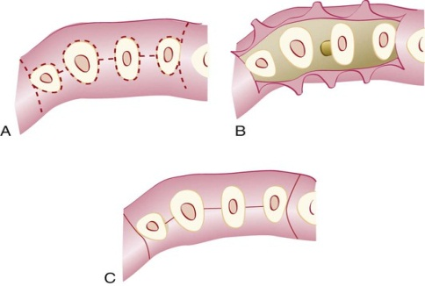
- if there is a space between all teeth ; i.e ( the interdental papilla is wide to split )>> surgically remove interdental papilla to one side ether lingual or buccal ,after we finish then return the interdental papilla to its place .

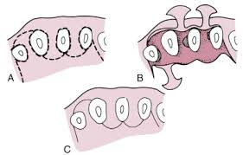
As a conclusion to this classification :
-split the interdental papilla >>when the teeth are tight
preserve interdental papilla>>when the teeth are spaced .
i.e : when operator done a surgery ,the interdental papilla still as one piece ( get it from one side to the side of the flap as a full papilla then after finish replace it and suturing ) .
INCISION TYPES:
Horizontal incisions are made along the gingival margin either laterally to the margin (internal bevel incision) or in the pocket (crevicular incision): | Vertical incisions or oblique incisions
- Internal bevel incision = reverse bevel incision:  - Is the basic incision allowing the flap to be reflected to expose the root and alveolar bone. It starts at a distance of 0.5-1mm from the gingival margin and extends full depth to the alveolar bone, don’t place the knife in the socket .  - -direction of the knife toward the teeth not toward the tissue, | - Vertical or oblique releasing incision can be used at one or both ends of the horizontal incision.  - If the flap needs to be displaced, the incision(s) needs to extend beyond the muco-gingival line.  Incision(s) should be made at the line angle of a tooth to avoid incising over the root or the papilla
B. Crevicular Incision (intrasulcular incision):
Is the second incision that will enable with the first internal bevel incision the removal of the part of gingival tissue located in between the two horizontal incisions.
- -is the second incision after internal bevel incision
- -place the knife at the bottom of the pocket and move from one side to anther and cutting the base of the sulcus .
- - directed to the bone margin

C. Interdental incision:
Is the third incision (Orban knife is usually utilized for this incision) that is done after slight elevation of the flap with a periosteal elevator introduced in the internal bevel incision line.
- -- It is performed after the elevation of the flap to remove the interdental tissue that remained after making the first two incisions .
- - As we did in gingivectomy , insert the orban knife to release interdental papilla .

- As a conclusion We start with internal bevel incision (initial incision ) at 0.5-1mm then pressurize the knife until we reach to the crest of the bone in single cut single bush , then do cervicular incision to the bone then release and interdental incision .

- 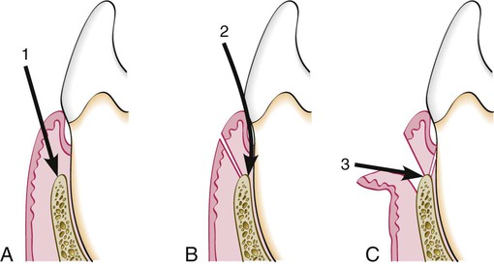
- A) internal bevel incision .
- B) cervicalar incision .C) interdental incision
- *why oblique cut ?
- To preserve the interdental papilla , if it is perpendicular it will split the interdental papilla >>recession
- *we usually start the incision from distal to mesial to improve the visibility.

