Perio sheet 5

“Periodontal Flaps”

What we achieve by doing any type of periodontal flaps is the following:
- Reduction or elimination of pockets
- Increasing accessibility to the subgingival areas to perform a meticulous root planning
- Expose the area to perform regenerative techniques

One of the steps of periodontal surgery after scaling, polishing and oral hygiene instructions, and anesthesia is “Incision”:
In conventional flaps or papillary preservation flaps, only one incision is done “crevicular incision” in which the knife is directed towards the crevice (the sulcus depth); because we have to preserve tissues as much as possible in order to regenerate the lost PDL. However, in all other types of flaps a second “horizontal incision” and a third “interdental incision” are done in addition to the first crevicular incision.

Flaps
- Modified-Widman Flap
One of the most commonly used flaps because it doesn’t take time, so accurate.
- Why to use this type of flaps?
it’s an access-flap: Only to gain access in order to do meticulous root planing and pocket lining removal with direct vision but it doesn’t remove the whole pocket wall.
- Healing:
this won’t eliminate the pocket or regenerate anything but when we remove part of the pocket lining that contains the infected part of the sulcus (granulation tissue) and provide direct vision for meticulous root planing then return the flap back to its original place, re-epithelialization and mild recession would result leading to shrinkage/reduction of the pocket depth and subsequently healing of the pocket.
- Steps of any flap/ Modified-Widman flap specifically:
1-Calculus removal
2- Flap surgery: after 2 weeks from calculus removal for healing purposes.
3- Re-attachment: not new attachment.
4- Healing

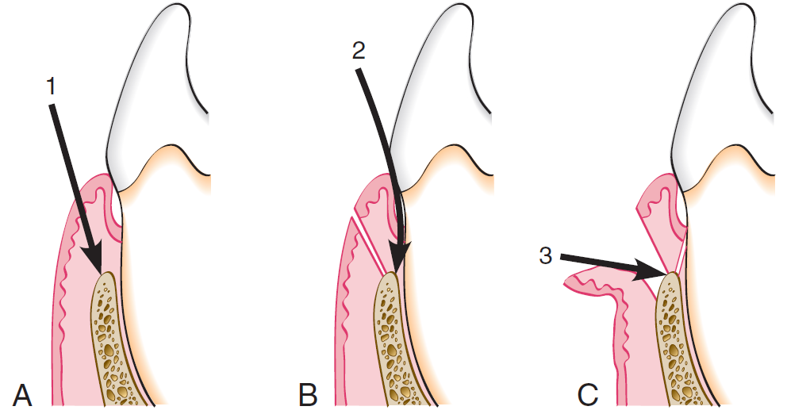
The figure shows the initial incision (inverse bevel) to the alveolar crest 1.5-2mm away from the gingival margin.
We insert the knife until it touches the crest of the bone, we remove the pocket lining/granulation tissue. Then horizontal incision is performed.

Then we perform the third incision “interdental incision”, the papillae are cut from the labial side or both the labial and the lingual sides bisecting them, which aids in pocket lining removal and meticulous scaling.

When done we do interrupted-sutures; to ensure the complete closure interdentally between the two interdental papillae (lingual and labial).

In this type, we remove the pocket lining only from ABOVE the crest of the bone.

- Displaced/Repositioned-Flap
Placing the flap either more apically or coronally in relation to its original position to treat the mucogingival defect.
Apically displaced (repositioned) flap: returning the flap more apically. Removing pockets and increasing the attached gingiva are achieved by this.
- Steps:
1-Initial therapy: scaling, polishing and so on…
2- The initial incision horizontal, crevicular, interdental except for the regenerative technique its only crevicular. Here we go up to 2mm or slightly more because in this case we’re displacing the flap and eliminating/reducing the pocket.
3- Then we reflect the flap completely and do Osteoplasty because pockets are associated with bone resorption which is never found with a uniform manner on the tooth surface.

When returning the flap, the mucogingival margin should be parallel to the bone architecture to preserve the biological width.
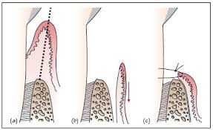

- Undisplaced Flap
Means opening the flap and returning it to its histological position.
In “modified Widman flap” and “apically-repositioned flap” we only remove the lining where the scalpel is inserted till it touches the crest of the bone.
In “undisplaced-flap” it’s lateral to the crest of the bone.
In undisplaced-flap we do surgical gingivectomy to remove the excess amount of tissue.
Indication: when bone needs to be removed, in crown lengthening.

In gingivectomy using electro-cautery
Indication: used in cases of drug-induced gingivitis, in which the amount of tissue removed is supragingival to the marginal lining.

Flaps for Regenerative Surgery
- Conventional Flap
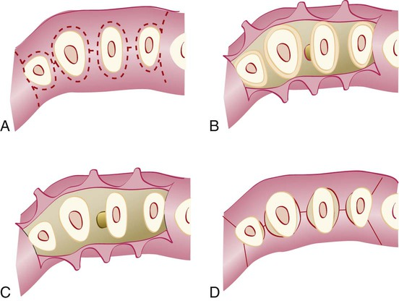
- The flap is made using only crevicular or pocket incisions, Used when there’s no space interdentally.

- Papilla-Preservation Flap
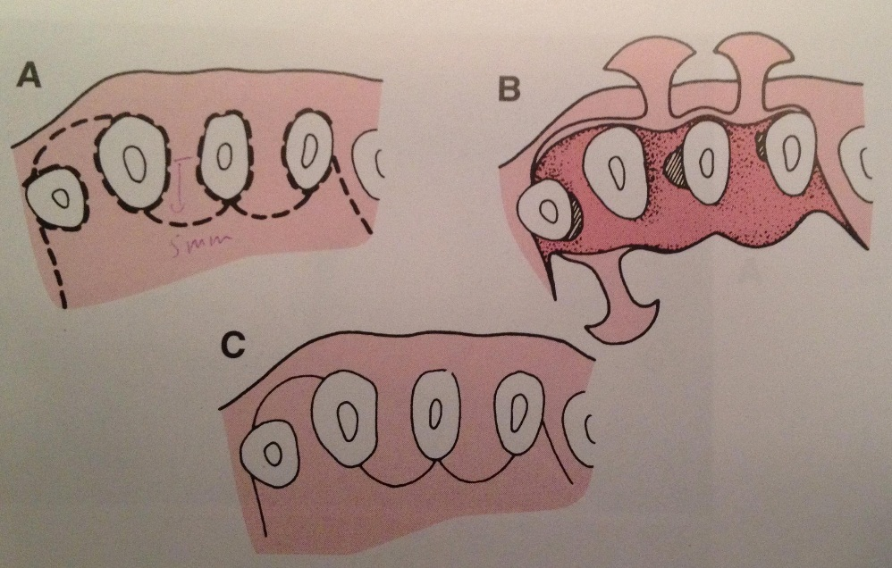
Used when there’s a space.

