**Tooth preparation for RPD**

Lecture #21

* **Preparation for RPD is carried out for:**

1- Establishing guiding planes.

2- Modifying unfavourable survey lines.

3- Providing rest seats.

4- Creating retentive areas.

5- Might involve some occlusal adjustment.

* Must be planned on articulated casts after being surveyed.
* topical fluoride should be applied to reduce caries risk of the modified enamel surfaces.
* **Guiding planes:** Two or more parallel axial surfaces on abutment teeth which limit the path of insertion of a partial denture. May occur naturally but most commonly need to be prepared.
* Functions of guiding plane:

1-Increase stability: by resisting displacement of the denture in lateral directions other than along the planned path of displacement

2- Reciprocation: A guide surface allows a reciprocating component to maintain continuous contact with a tooth as the denture is displaced occlusally.

* Achieved by reciprocal arm or plate placed opposite to the retentive tip.
* Reciprocal element should be above survey line.

3- Prevention of clasp deformation

Guide surfaces ensure that the patient removes the denture along a planned path (1). Preventing tiltinig or rotating the denture on removal (2), causing clasps to flex beyond their proportional limit, which will lead to:

1. Fatigue>>fracture.
2. Traumatic forces on the teeth
3. Clasp become non-functional.

4- Appearance: “anterior abutments”

Intimate contact between saddle and tooth>> natural appearance

* Anterior saddle has *posterior tilt.* Which gives you undercuts relative to the common path of displacement >> extra retention and you can cover the gaps anteriorly and so improve esthetics.

Preparing guide surfaces:

* Guide surfaces are usually prepared, somewhat imprecisely, by eye , using the study cast we have prepared on.

As a check on the accuracy of the prepared guide surface:

Alginate impression > 2nd study cast > placed on surveyor >parallelism is checked “using analysing rod”

* A more precise approach >> use of jigs constructed on a prepared study cast and transferred to the mouth, either to control the positioning of the handpiece or to check on the location and amount of enamel reduction.
* Remove minimal, uniform thickness of enamel “not more than 0.5 mm” using diamond burs
* Cylindrical concept: follow the contour bucco-lingually and occluso-gingivally “not flat surface to prevent reaching dentine”
* 3mm vertically, and as far as possible from the gingival margin.
* Guiding plane on abutment teeth supporting distal extension base is minimized to achieve stress breaking effect. “1.5-2 mm”
* Lingual GP is done for : 1- reciprocation. 2- other components of the RPD like putting cingulum rest seats.
* Guiding plane: on tooth / guiding plate: metallic component of RPD
* Functions of the rest seat:

1. produce a favorable tooth surface for support “ transfer forces from horizontal traumatic (labial migration and loss of support), to vertical forces along the long axis ( no movement and more efficient support)”
2. prevent interference with the occlusion “premature contact”

rest seats should not be prepared on the supporting cusps “to maintain stable intercuspation”

1. reduce the prominence of the rest “prevent collection of food particles and less irritating to the patient”

* Occlusal rest seats in *Posterior teeth*
* reduction in the height of the marginal ridge by about 1-1.5 mm >>to ensure an adequate bulk for mechanical strength of the rest.
* Triangular in shape with the apex towards the center and base towards marginal ridge.
* Angle less than 90 between the floor of the rest seat and the guiding plane.
* saucer-shaped >>to allow an amount of horizontal movement of the rest to dissipate some of the energy developed by occlusal forces. “box-shaped rest seat >>damaging horizontal loads on the abutment tooth”
* 2/1 the distance BL and 3/1 the distance MD for PM “ 4/1 for M”
* To check that sufficient enamel has been removed the patient should be asked to occlude on a strip of softened pink wax “measure using a probe”
* In double acer be very careful never to break the proximal contact.
* Channels onto the buccal surface could be prepared to prevent occlusal interference
* You may need to recontour the opposing tooth.
* On *Anterior teeth*
* An inverted cone or a cylindrical diamond bur with a rounded tip should be used.
* A spherical instrument tends to create unwanted undercuts.
* Cingulum rest seats: better esthetic, more centered towards the midline

1. Inverted v: (max. canines> man. Canines> rarely incisors) , no sharp angle, 2-3 mm MD
2. Cingulum ledge: more gingivally located
3. Ball: less support and thickness, rarely used

* Incisal rest seats: (man. Incisors and canines), when we have no prominent cingulum. “rest seat in composite applied to the cingulum area of the selected tooth, or to bond a cast metal cingulum rest seat to the tooth is an alternative”
* Depression is prepared on the lingual surface to accommodate the minor connector
* Unfavorable survey lines
* High survey line >> clasp too close to the occlusal surface, this leads to:

1. Occlusal interference
2. Interfere with mastication
3. More noticeable by the patient
4. Deformation of the clasp “on insertion, the clasp is prevented from moving down the tooth by contact with the occlusal surface, the clasp is bent upwards.”

When Shaping the enamel to lower the survey line: 1- clasp placed more gingivally . 2- provides a 'lead-in' during insertion, causing the clasp to flex outwards over the survey line as planned.

* Creating retentive areas
* we need at least 0.25 mm under cut for proper retention
* if we don’t have it we can create it by :

1. enameloplasty under the survey line “small dimple”
2. recontour the tooth surface using composite, broad area not a spot composite. “durable, effective and conservative”.

Lecture#22

**Secondary impressions**

tooth supported RPDs

* forces Transmitted form the rest > tooth > PDL “ no force would reach the mucosa of the edentulous span”
* can be constructed from a single stage anatomic impression, either with stock or custom tray.

1. *Dentate stock trays* can be: (no preference between them)

Plastic: disposable, come in different sizes

Metal: sterilized, more rigid

Choose the tray> put adhesive> alginate up to the border of the tray> take a small amount of alginate on your fingers and wipe the surfaces of the teeth and the area of the rest seats, embrasures between the teeth, guiding planes to prevent air bubbles entrapment> take the impression> inspect it.

Used in class 3 kenndy.

1. *Custom tray*: (light cure or self cure acrylic, perforated for mechanical retention)

Can be used in class 3 but its easier to use stock tray

Should be used in class 1 kenndy

Impression materials: any elastic material: silicones (light or medium body but not heavy body because we want details) , polyether, polysulfide and alginate.

Tooth-mucosa supported RPDs “distal extension”

* abutment tooth will move within its socket and PDL according to the fibers surrounding it
* Muco-osseous Tissues are more displaceable approximately by 25 times than dento-alveolar tissues

Factors affect the support for the distal extension:

1. Contour and quality of the residual ridge: *Ideal ridge :* 1. Rounded and developed 2. Dense CT “not fragile like diabetic pts” 3. Good cortical bone that covers relatively dense cancellous bone
2. Extent of residual ridge coverage by the denture base: maximum coverage will be more important if you have more resorption in the ridge.
3. Type and accuracy of the impression registration:

We have two types of impressions: 1. Anatomic form. 2. Functional form.

1. Accuracy of the fit of the denture base. closely adapted fit without compression
2. Design of the RPD framework: indirect retention is a requirement for distal extensions. indirect retainer prevent sinking of the major connector in the floor of the mouth which will result in an injury.

The designcan also predict the future resorption for the patient or trauma.

1. Total occlusal load applied.

Impression techniques:

1. Anatomic impression: “in class 3 kenndy”, at rest, without displacement

One stage impression using elastic material.

anatomic impression for class I will result in the following:

* 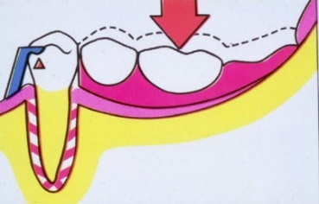Rest will act as a definite stop
* Limited movement near the abutment
* Distal end able to move freely – receive the most occlusal load
* Torque to the abutment teeth
* Bone loss on the distal end of the ridge due to increased compression
* Cantilever action of the distal extension base against the abutment teeth - Loosening of the abutments “due to bone loss distal to the abutment”

1. Functional impression: “distal extension”, under function, applying pressure causing displacement. “tissues will be displaced at rest so we will not have huge displacement at function”

Distortion under tissue displacement may be as a result of:

* the viscosity of impression material
* insufficient thickness of the impression material ( like when taking alginate impression without enough spacing)

in class 1 we use dual impression technique : to record the tissue that supports the distal extension RPD in its functional form and relating them to the remainder of the arch (teeth ) in its anatomic form .

The more the mucosa displaces under function the more rebound there is likely to be . if we have done full displacement to tissues during impression:

* at rest the tissues will be mildly displaced by the denture
* at function the patient will feel the distal extension high in occlusion due to the rebounding effect

Impressions for Distal Extension are taken either:

1. at impression stage

disadvantages:

* If the clasp action is sufficient to maintain the denture base in its intended position, This may result in compromised blood flow with adverse soft tissue reaction and bone resorption.
* If clasp action is not sufficient to maintain that functional relationship of the denture base to the soft tissue, this will result in floating denture with premature contact and patient dissatisfaction.

1. at metal framework stage

3 types of functional impressions classified historically:

1. MCLEAN, in 1936

* 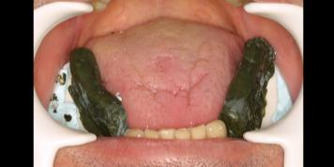 The first to introduce dual impression technique.
* Special tray for edentulous area only> border molded> block of green stick as wax rim on the occlusal part “used to let the patient bite on them to get the functional impression using silicone or ZOE”.
* To relate this functional impression to teeth: *pick up impression* using stock tray and alginate impression material
* Disadvantage: the impression was taken under occlusal load “tissue are displaced to the maximum” .so the denture will cause maximum displacement of tissues all the time >> decrease blood supply leading to necrosis and resorption.

1. HINDELS,1952

The same as mclean but:

* the impression is taken without occlusal load “no green stick blocks at the occlusal part”
* We made openings in the stock tray “used for pick up impression” corresponding to the edentulous areas
* Slight Finger pressure applied through holes in the tray to the underlying anatomic impression of the edentulous areas.
* result: impression showing the anatomic position of teeth, and functional position of edentulous area without complete displacement.
* Disadvantage: inaccuracies “how much finger pressure is done, have a chance of tissue rebound”

1. Altered cast technique: introduced by Applegate, 1955, used in clinics nowadays

* The impression for the edentulous area is taken under selective pressure technique at the metal framework stage where the Rests are seated in place and have a stable reference.
* Selective pressure technique: impression to the primary supporting areas are taken under pressure to promote their contribution to support, and in the secondary or non-supporting areas I put wax on the cast because I want to do spacing “ to minimize the forces directed to these areas which are more susceptible to pressure-induced resorption.”
* Clinical Steps: make a tray for the distal extension area according to selective pressure technique > border molding > make sure the metal is properly seated > take the impression using ZOE or elastic “it will automatically give the displacement needed”

Lecture#23

**Metal framework try in , alter cast technique ,and occlusal registration for RPD**

**Metal framework try in**: 75% of RPD frameworks don’t fit perfectly.

Preclinical Inspection

* Check the accuracy of the framework design
* Framework should fit master cast. If it does not, probably will not fit intraorally
* Framework should cause no abrasion on the cast
* Rest seats fully seated
* All retentive, reciprocal arms, proximal plates, superior portion of lingual plates and all maxillary major connectors should be contacting the casts (spaces will collect debris causing caries and gingival irritation).
* Major & minor connectors:

Should have adequate distance from abutments (hygiene)

Proper proportions (rigidity, hygiene)

Minor Connectors should have butt joint finish line, slightly undercut for acrylic resin and also of sufficient thickness.

1mm relief over saddles for acrylic.

* Clasps have uniform taper
* Framework should be highly polished
* No pits, nodules, scratches or sharp edges (stress concentration and might injure mucosa).

Framework Adjustment

* Reduction can be undertaken with:

Heatless stones, Diamond burs, E-Cutter burs, Coarse stones, Shofu coral stones, Carborundum disks.

* Polishing can be undertaken with:

Carborundum points & wheels

Final polish - Shofu brown & green points

* excessive force and generation of heat might destroy the framework.

Clinical Adjustment

Initial assessment: comfort of framework, no active engagement of abutments “clasps should be passive”, casting fit similarly intraorally and on the cast “otherwise the final impression is incorrect”

1. *Incomplete seating* of framework is a common problem that causes discomfort, damage to soft tissue and bone. *Caused commonly from:*

. Under rests

. Rigid portions of direct retainers

. Interproximal portions of lingual plates

. Interproximal minor connectors

. Shoulder areas of embrasure clasps

For adjustment use an indicating medium “with pressure over rests not over saddles”:

* **Aerosol sprays (occlude):**
* **Adv.:** thin, accurate, not easily displaced
* **Disadv.:** can dissolve in saliva, difficult to remove, can't tell how far from seating (2D)
* **Disclosing wax:**easiest material to use.
* **Adv.:** sets immediately, inexpensive, shows how far from seating (3D)
* **Disadv.:** stick to teeth, can be destorted.
* melt it --- apply it --- try to seat the denture then wait until it sets --- inspect the area
* **Silicone indicating medium**
* **Adv.:** 3D, minimal distortion
* **Disadv.**:expensive “use minimal amount”, sets slowly (2min), can tear

*differentiate between normal contact “retentive tip, guiding plane” and abnormal ones.

*we should have Complete seating with gliding sensation and no grating or snapping “denture easily removed and placed by the patient”

2- Use PIP to detect *soft tissue impingements* “place with moderate pressure”.

3- Framework is fabricated on an unmounted cast > *occlusal interferences* is common

Articulating paper marks poorly in highly polished metal, so roughen the metal slightly or see the opposing contact.

Adjust U and L frameworks individually then put them together “eliminate interferences between them”.

*If occlusal rest thickness is ≤ 1.5 mm after adjustment, rests will be subject to fatigue and possible fracture

With heavy contact > additional tooth preparation “for rests”, or lower the Hight of contour “for retentive arm” and remake

Last resort > reduce opposing cusp.

Don’t relieve clasps “alter flexibility and fracture resistance” > adjust with plier

**Altered cast technique**

* Compressibility of denture bearing mucosa= 2mm or more / and of PDL = 0.13-0.18 mm

Purpose:

- Reduces the support differential between ridge and abutments

- Provides a more accurate relationship between abutments & ridge

- Improves load distribution and denture stability

- Corrects peripheral adaptation

Indications: (Less necessary in maxilla)

- Class I & II RPDs, Extensive Class III & IV cases

- Framework most likely to be adjusted in the future (relining and rebasing)

- Tooth mobility + compressible mucosa

Technique:

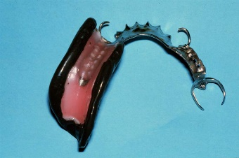- Insure well-fitting of the framework. Wax relief over the ridge “1mm”

- A custom tray is fabricated over the framework. “periphery 2-3 mm short of the vestibule, stable upon functional movements” >border moulding

- remove wax spacer > put adhesive “10-15 min”

- Polyvinyl siloxane (light or medium body) or zinc-oxide eugenol can be used.

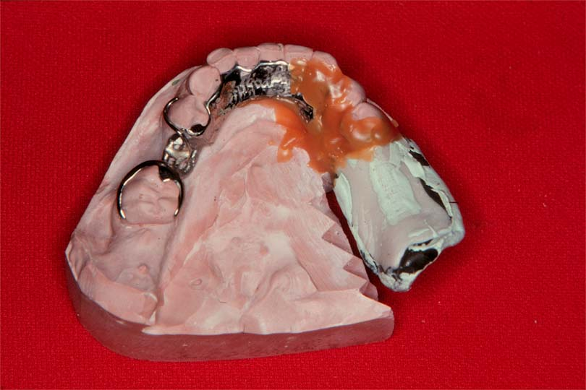- apply pressure over rests. No pressure should be applied on saddle “This might cause spring back and lack of tissue contact”.

- Residual ridge is sectioned from the original cast

- Ensure no contact between impression & cast

- Place retentive grooves in cast

- Sticky wax in place

-beading and boxing >Pour new ridge areas in different color stone

Problems:

- If tray is added carelessly, it can alter passive relationship between framework and teeth

- Excess impression material under framework, might cause incomplete seating

- If inadequately sealed, stone over teeth, can’t articulate model

* an alternative procedure involves rebasing the denture >this might create premature contact posteriorly.

**Jaw relation registration:** we do it for:

harmonious relationship with all oral structures .

provide a masticatory apparatus that is efficient and esthetically acceptable.

even distribution of occlusal forces to all supporting structures.

control the undesirable effects of rotational or torqueing forces on the prosthesis.

prevent any deflective contacts of the teeth during centric or eccentric closures “to prevent pathological changes of supportive structure and neuromuscular mechanism”

vertical jaw relation: between fixed point “maxilla” and movable point “mandible”.

Rest vertical dimension(RVD): mandible is at rest

Occlusal vertical dimension(OVD): occlusal rims or teeth are in contact.

Inter occlusal distance (FWS): distance between occluding surfaces of maxillary and mandibular teeth when mandible is at rest“in natural dentition = 2-4 mm in PM area”

* If stable occlusal contacts are provided by the remaining natural teeth, the existing OVD and CO relation should be recorded.
* If one of the arches is edentulous or the opposing teeth do not provide stable occlusal contacts, OVD has to be measured as follows,

**RVD – OVD = 3 - 4 mm**

We don’t change OVD in partially edentulous patient unless:

1-Symptoms of diminished OVD exist such as tired aching muscles, unexplained pain in the head and neck region, shortened nose-chin distance.

2. Excessive Free way Space or ‘over-closure’ of the jaws.

**\***Wearing of the teeth does not mean that OVD should be increased – unless the free-way space is greater than 4mm.

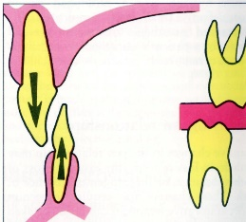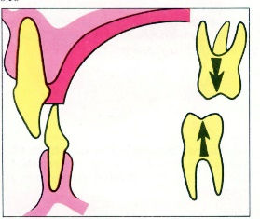To alter the OVD:

Increase the existing OVD temporarily by fabricating an acrylic resin occlusal overlay appliance in maximum intercuspation.

Restore the desired OVD permanently with the help of fixed and removable prosthesis (made simultaneously) after physiologic acceptance from the pt.

Horizontal jaw relations:

Centric Relation: the most retruded position of the mandible to maxilla at an established OVD. (bone to bone relation, repeatable and constant throughout life).>> used with distal extension RPD, or when the opposing arch is edentulous.

Centric Occlusion: the relation of the mandible to maxilla in the maximum intercuspation of the teeth. (teeth to teeth relation) >> used when cusps on remaining natural teeth can guide the mandible back to this position,

In more than 90% of people, CO is 0.1 - 2mm in front of the CR.

- Most accurate method for inter occlusal records requires use of stabilized occlusal rims over acrylic record base.

- 1mm of space exists between the opposing teeth & the rims, for the occlusal recording material to be added, which could be:

1. ZOE. 2- plaster impression material. 3-compound. 4-polyether. 5- polyvinyl siloxane. 6- wax.

- Three widely separated tripod points of occlusal contacts are necessary to relate the 2 casts accurately. These contact points may be tooth to tooth or tooth to interocclusal recording material.

- Care must be taken to avoid any pressure being applied on the soft tissue under the record bases to avoid any inaccuracies.

The face bow: is an instrument used to record the spatial relationship of the maxilla to some anatomic reference (transverse horizontal axis) and then transfer this relationship to an articulator.

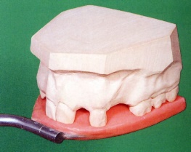- more important in partially edentulous patient than CD to avoid deflected contacts in the remaining teeth

Basic steps: we use semi adjustable articulator

- we place wax in the fork and Prepare tooth indentation.

- Locating the ‘arbitrary’ Hinge Axis:  
Place an indelible pencil mark 13 mm in front of the posterior margin of the tragus of the ear, on a line between the tragus of the ear to the outer canthus of the eye.

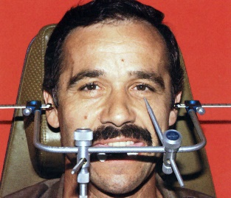- Orientation of the face-bow to bitefork & reference points. those might differ with different facebows.

- mount the maxillary cast, then according to the occlusal record you took, mount the lower.

Do not alter existing occlusal scheme except to remove a pathologic process.

- Selection of an occlusal scheme is multifactorial

- Emphasis should be placed on protecting the natural dentition rather than correcting the edentulism

- If lateral guidance is needed, strive for canine guidance if present and sound

* + Helps to reduce lateral forces
  + Promotes a more vertical chewing cycle
  + Allows for greater selection of occlusal morphologies

- Establish group function or unilateral balanced occlusion if canines are missing or week.

- Do not permit Nonworking contacts on natural teeth unless they oppose a CD in balanced occlusion

Lecture #24

**Acrylic dentures**

Co/Cr RPD

properties: strength, rigidity, obtain support and retention from teeth, can be casted in thin sections > flexible

Indications: good oral hygiene, wide distribution of abutment teeth

Advantages: less bulky, flexibility >engage undercut to obtain retention from teeth

Disadvantages: metal “unaesthetic”, expensive “due to the need for casting”, and time consuming

Procedure: 1ry casts mounted and surveyed > design > preparation > 2ry impression poured with reinforced dental stone > duplication of the master cast by investment material > make wax design > casting > metal try in > bite > teeth try in > insertion.

Acrylic partial dentures:

- mucosa borne (no support from teeth)

- entirely of acrylic resin (brittle >need large section)

- no rests or metal, only clasps.

Advantages: low cost, easy to construct and modify.

Indications:

* reline will be needed “immediate denture”
* remaining teeth is of poor prognosis, extraction and addition will be needed. “transitional denture”
* Young patient. “growth of jaws and development still proceeding”
* Interim denture is required to increase vertical dimension
* Few isolated teeth remaining.

**Examples of acrylic partial denture:**

Every denture:

Restricted to upper arch.

Should have ALL these characteristic to be named every denture:

* Point contact and wide embrasure (open design) between natural and artificial teeth to 1-reduce lateral stresses. 2- more hygienic
* Balanced occlusion “free-occlusion” and articulation to reduce lateral stresses
* Borders are at least 3 mm from the gingival margin
* Distal stabilizers: contact the distal surface of the last molar to prevent distal drift of the posterior teeth with consequent loss of the contact points. *“not clasps, they don’t engage the undercuts , they are just (wrought SS)”*
* Flanges are included to assist the bracing of the denture.

*Closed design: widespread contact between the saddle and abutment tooth > more plaque retention.

*Open design: small contact close to the occlusal surface with generous clearance at gingival margin.

Advantages: open design > hygienic denture which is retentive and stable and minimises damage to the supporting and surrounding tissues.

Disadvantage: used in bonded saddles only. But even where the most distal tooth is missing, 'Every principles' can still be incorporated into the denture design “without calling it every denture”.

-An accurate impression is required to establish the point contact between the teeth.

-the technician will put the stabilizers at the insertion time.

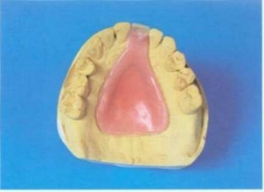Spoon denture: A simple acrylic denture made to replace one or two anterior teeth. It derives its support entirely from the anterior ridge and palate.

There should be:

1. wide well formed palate
2. sufficient anterior clearance between the lower incisors and the ridge.

*Used for young patients temporarily as they are still growing.

Advantages: cheap, easy to construct and modify.

Disadvantages:1- weak, sometimes made bulky for strength which may not be acceptable to the patient.

2-small, thus may be swallowed or inhaled. “acrylic is radiolucent, will not be detected on x-ray > use radiopaque resin to limit medico-legal liability.”

Procedure: only one impression is needed > shade and mould of tooth is taken > second visit will be the insertion.

Modified spoon denture: More stable and more acceptable (less risk of ingestion).

The Design Rely on frictional contact between the connector and the palatal surfaces of some posterior teeth OR adding wrought wire clasps.

**Acrylic lingual plate versus wrought** **lingual bar connector**

Acrylic lingual plate: technically less demanding, increase support

* Easy to construct and modify, less costy.
* cover the gingival margins and may cause damage by: mechanical stripping of the gingivae, interdental wedging, encouraging plaque formation on teeth.
* obtain relief by blocking out the dentogingival junction, in addition to any interdental spaces on the cast. “minimal relief to prevent overgrowth of gingiva”

Wrought lingual bar: its preferred where there’s sufficient space

* does not cover the gingival tissues. It is also stronger and less bulky
* more technical cost
* constructed from preformed wrought ss bars that can be cold worked to conform to the arch form lingually.

Acrylic partial dentures rely on the use of cohesive and adhesive forces of saliva, also depend on intimate contact with soft tissue and well extended flanges as in CD.

we can add clasps to improve the retention:

* easy to place. can be adjusted at the chairside to help increase the retention.
* If not correctly placed relative to the survey line, they may cause gingival damage and will increase plaque accumulation. If the clasp arm is not correctly adapted it may also cause ulceration in the sulcus.
* The clasp is placed after the trial denture stage has been completed as its positioning will not be stable in wax.

**Delivery and insertion**

At delivery appointment check:

1. soft tissue adaptation.

**Contact:** 1-Denture base. 2- Maxillary major connector, except where crossing the gingival margins.

**Relief:** 1- Mandibular major connectors. “soft tissues in mandible is more delicate” 2- Minor connectors and proximal plates. 3- Bar clasps. “only its origin”

*areas of undercut must be relieved.

Procedure for tissue surface adjustment: 1-*visually and digitally* for sharpness and roughness. 2-apply *PIP.*

If pressure on extension base cause elevation from tooth contact, reline is indicated.

Procedure for periphery adjustment: in the mouth *visually*, or using *disclosing wax,* activate or ask the patient to move simulation *functional movement*.

Abutment tooth adaptation: 1-The rests should demonstrate a complete and stable seating. 2-other components should demonstrate the required contact with the abutment teeth.

Retention: retentive components require adjustment to provide optimum retention.

2- Analysis of the occlusion and articulation

Maximum intercuspation, bilateral simultaneous contact posteriorly at rest, appropriate occlusal contact at excursive movement

Adjustments: tooth-borne RPD > can be adjusted intraorally.(confirmative relation)

Tooth-mucosa borne RPD > adjustment requires clinical remount (not intraorally), because of displaceability of the tissue supported extension.

3- Specific instructions on: the care of RPD.

Brush using soft brush, don’t squeeze the denture, don’t use toothpaste or abrasive cleansers.

Cleaning agents: hand soaps, denture paste, soak cleansers “not NaOCl > to prevent corrosion and bleaching.”

The patient should be advised not to adjust Their RPD

Care of oral tissues: 1- Sulcular brushing with a soft toothbrush

2- Flossing, interproximal brushes

3- Brushing the soft tissues adjacent and covered with the denture using soft brush.

4- Rinses may be beneficial.

5- Fluoride, may be useful for patients who demonstrate increased risk for caries.

*\*The patient should be able to place and remove the denture in proper way “finger pressure, not to bite into place”*

Wearing the partial denture: 1-Bulk: days to weeks to accept RPD.

2-Speech: reading aloud.

3-Mastication: smaller portions of softer foods.

4-Saliva: initially.

*denture should be removed several hrs daily “bed time” to facilitate tissue health, exception:

1-RPD that splints hypermobile teeth. “will be difficult to wear it again”

2- RPD that maintains OVD.

4- Periodic evaluation “maintenance”

A-periodontal:

1. recall intervals: 2-4 months for active perio disease, 6-12 months without active perio disease

*shorter intervals initially after RPD delivery.

1. Plaque control instructions
2. Evaluate periodontal health, especially abutments
3. Periodontal treatment as required

B-restorative:

1. Tooth examination: Caries, defective Restorations.
2. RPD examination: Extraoral :fracture of components, wear of artificial teeth

Intraoral: support, retention, stability, occlusion and articulation.

**Post placement adjustment**

We depend on patient subjective evaluation, clinical examination “visual, soft tissue examination, articulating paper”, adjustment “PIP, indelible pencil may be used”

Clasp modification “for retention” can be achieved.

Supporting cusp “maintain VD” : premature contact in ICP only > deepen the fossa

Premature contact in ICP and lateral movement > reduce the cusp.

Working side interference: BULL rule “Buccal cusp of Upper, Lingual cusp of Lower”

Protrusion: premature contacts eliminated by grinding the distal facing inclines of U teeth and mesial facing inclines of L teeth

Non working side interferences on the supporting cusps> reduce the area of interference

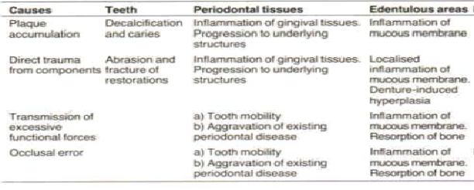damage that may result from wearing a partial denture